

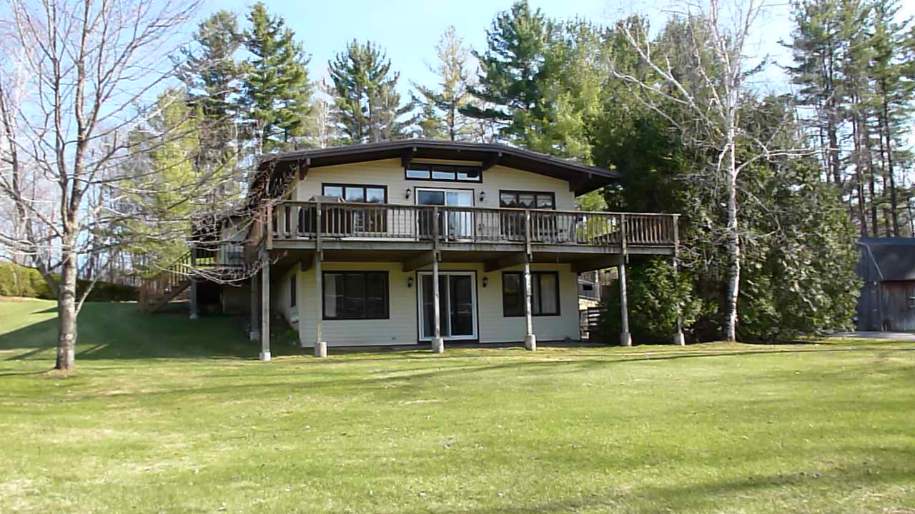

**Country Perfect in Pownal!**

990 Barber Pond Road, Pownal, VT 05261

$335,000

Spacious living with a bonus. This very well maintained contemporary home has a full lower level apartment or simply use it as additional living space. With over 2,800 square feet of finished living space there’s plenty of room for any living needs from large families to a separate apartment. The upper level is an open floor plan dining, kitchen and living with wood burning fireplace, huge deck facing the view and besides the master suite with full bath and walk-in closet there is also a hot tub room and another full bath plus two bedrooms on the upper level. On the lower level is the family room with fireplace and wood stove insert, another kitchen, ¾ bath and additional rooms plus the garage. Outside you’ll enjoy the spacious mostly level yard with fruit bushes and trees, the separate small barn/garage and shed. Comfortable, ready to move into, this is a great property to call home. Priced at the assessed value and way below the appraisal and the former offering price these owners are ready to move!

Upper Level

Great Room: 15’ x 28’; Birch Cabinet, Blue Stone Raised Hearth Stone Wood Burning Fireplace; Carpet, Tile and Laminate Flooring; Sliding Glass Door to 10’ x 42’ Deck and 6’ x 20’ Side Deck (Both with Pressure Treated Lumber)

Dining Area: 9’6” x 12’; Side Door to Deck; Closet; Slate Floor

Kitchen: 9’ x 8’; Galley Style; Ceramic Tile Floor; Double Bowl Stainless Steel Sink; Wood Cabinetry; GE 4-Burning Electric Range; Newtone Interior Exhaust Fan, Hood and Light; GE Refrigerator;

Additional Kitchen Space: 9’4” x 8’; Side Door to Deck; Staircase to Lower Level

Hall: Washer/Dryer Alcove with Connections; Pantry Closet; Slate Floor

Master Bedroom Suite: 15’6” x 11’6”; Wall-to-wall Carpet; 7’6” x 5’6” Walk-in Closet with Shelving and Clothes Racks

Master Bath: Linoleum Floor; Vanity Sink with Oak Base Cabinet; Linen Closet; Fiberglass Tub/Shower

Full Bath: Vanity Sink with Oak Base Cabinet; One Piece Fiberglass Tub/Shower; Linen Closet; Door to Hall and Hot Tub Room: 7’3” x 12’4”; Electric Heater; Linoleum Floor; Hot Tub

Bedroom 2: 12’ x 15’6”; Wall-to-wall Carpet; Closet

Bedroom 3/Office: 15’8” x 12’; 2 Closets; Wall-to-wall Carpet

Lower Level

Entry: Door to Garage; Door to Lower Living Area

Kitchen: Formica Countertop; Double Bowl Stainless Steel Sink; Linoleum Floor; Formica Cabinetry

L-Shaped Room: 24’ x 10’ + 17’ x 15’; Wall-to-wall Carpet; Raised Brick Hearth and Fireplace with Wood Burning Wood Stove Inset (Better-N Bens’ Included); Walkout Slider; Door to Entry Hall; Door under Deck

Room: 11’ x 8’; Closet; Ceramic Tile Floor

Room: 11’ x 8’10”; Closet; Ceramic Tile Floor

¾ Bath: Shower; Pedestal Sink; Linoleum Tile Floor

Utility Room: Weil McLain Boiler (11-29-05); Boilermate Hot Water Tank (11-29-04; Shelving; 275 Gallon Oil Tank (2000)

Hall to Garage: 8’6” x 6’; Wall-to-wall Carpet

Garage: 1 Car; Heated and Insulated; Electric Overhead Opener; Well Pressure Tank; Kenmore Water Softener; 200 Amps Electric Panel; Floor Drain

**GENERAL INFORMATION**

|  |  |  |  |  |  |  |  |  |  |  |  |
| --- | --- | --- | --- | --- | --- | --- | --- | --- | --- | --- | --- |
| Year Built: 1973 | | | Floors: Carpet, Tile, Laminate, Slate | | | | | Total Sq. Ft: 2,800 | | | |
| Foundation: Concrete | Siding: Vinyl | | | | Roof: Membrane | | | | | Windows: Anderson | |
| Water: Well | Sewer: Septic, 1000 gal | | | | Heat: 2 Zone Baseboard HW | | | | | Hot Water: Off Boiler | |
| Zoning: Residential | | Possession: At Closing | | | | | Assessment: $224,800 | | | | |
| Tax Rate: Homestead | | Tax Year: 2013 | | | | | Taxes: $3,935.37 | | | | |
| Book: 117 | Page: 324 | | | Span #: 495- 156 - 10985 | | | | | Property ID: 003-27 | | |
| Lead Paint: Unknown | Smoke/CO Detectors: Yes | | | | | Exterior Lighting: Yes | | | | | Cable TV: Yes |

**DISCLOSURE**: PROSPECTIVE BUYERS ARE ADVISED THAT HARSCH ASSOCIATES IS SERVING AS SELLER’S AGENTS.. FOR FURTHER INFORMATION ON LICENSEE’S DUTIES AND RESPONSIBILITIES REFER TO DISCLOSURE FORM. THE INFORMATION PROVIDED BY LICENSEE WHETHER IN THIS DOCUMENT OR ORALLY IS SUBJECT TO POSSIBLE ERRORS OR OMISSIONS AND WHILE BROKER & LICENSEE MAKE EVERY REASONABLE EFFORT TO INSURE THE ACCURACY OF ALL INFORMATION, NO GUARANTEES OR WARRANTEES EITHER EXPRESS OR IMPLIED ARE MADE AS TO ANY INFORMATION PROVIDED ON REAL PROPERTY, MARKET CONDITIONS OR ANY ASPECT OF A TRANSACTION WITH LICENSEE OR BROKERAGE FIRM. THE LICENSEES INVOLVED ARE NOT RESPONSIBLE FOR MISSTATEMENTS OF FACTS, PRIOR SALE, AND CHANGE OF PRICE OR WITHDRAWAL FROM THE MARKET. ALL PROSPECTIVE BUYERS ARE ADVISED TO CAREFULLY VERIFY TO THEIR SATISFACTION ALL INFORMATION OF MATERIAL IMPORTANCE TO THEM. LICENSEE HAS NOT MADE ANY REPRESENTATIONS OR WARRANTIES AND HAS NOT VERIFIED AND WILL NOT VERIFY THE ACCURACY OF SELLER’S STATEMENTS. MEASUREMENTS ARE APPROXIMATE.

