For Sale

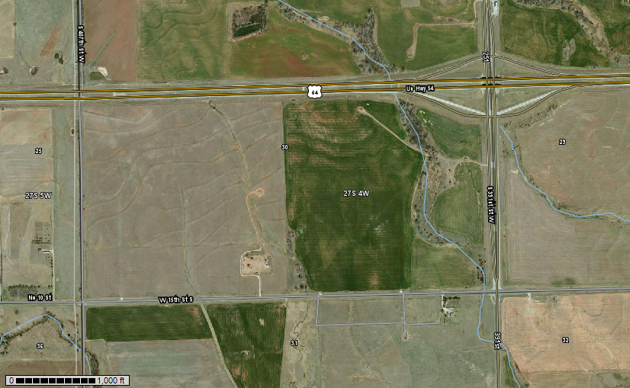

20 acres located west

of Cheney on old 54 Hwy

just into Kingman County.

**391st**

At the intersection of 391st W and old 54 hwy (15th St.) go 1 mile West to property.

**Old 54 Hwy**

Blacktop frontage and electricity is available.

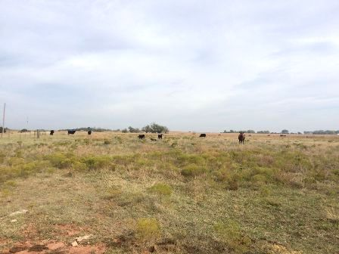Asking $79,500.00

Taxes: $8.71

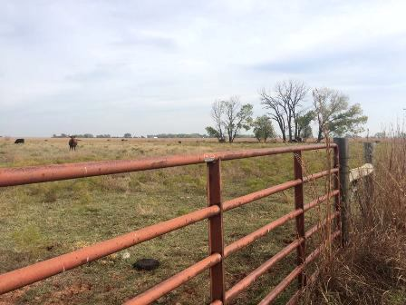

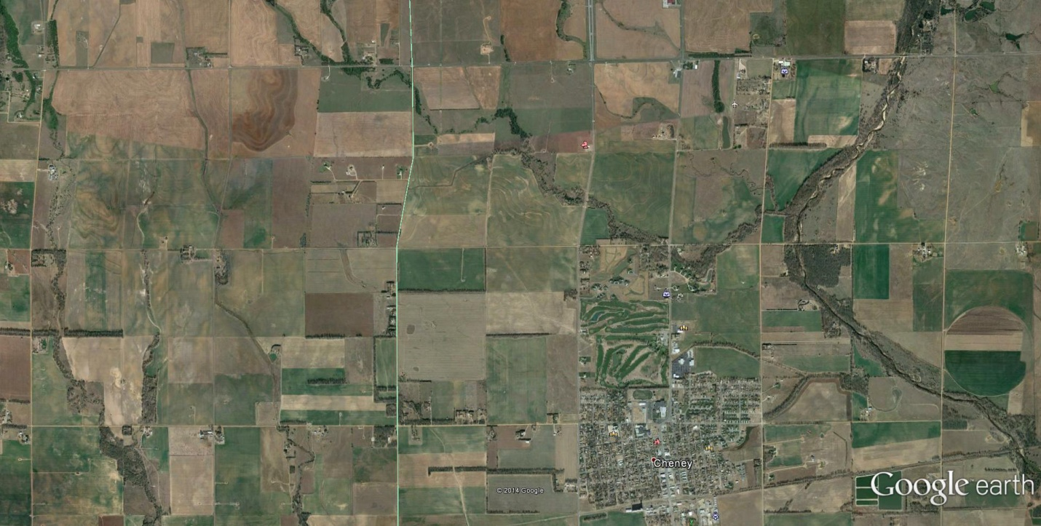

**Subject Property**





**Cheney**

**Katie Ternes**

**12140 W. K-42 Hwy**

**Wichita, KS 67227**

**316-524-8345**

**katie@genefrancis.com**