-RANCH FOR SALE-
Leopard Creek Ranch
1,205 +- Acres of Prime Hunting and grazing Land, 8 mi. SW of George West, Beautiful Leopard Creek, excellent water well, Pipe cattle pens, electricity, paved frontage on HW 59, large neighbors, excellent roads & views, huge original growth mesquite trees & native brush! These places are becoming rarer each day!
Priced to sell $2,395/acre
TexasRanchBrokerage.com (361)813-8761


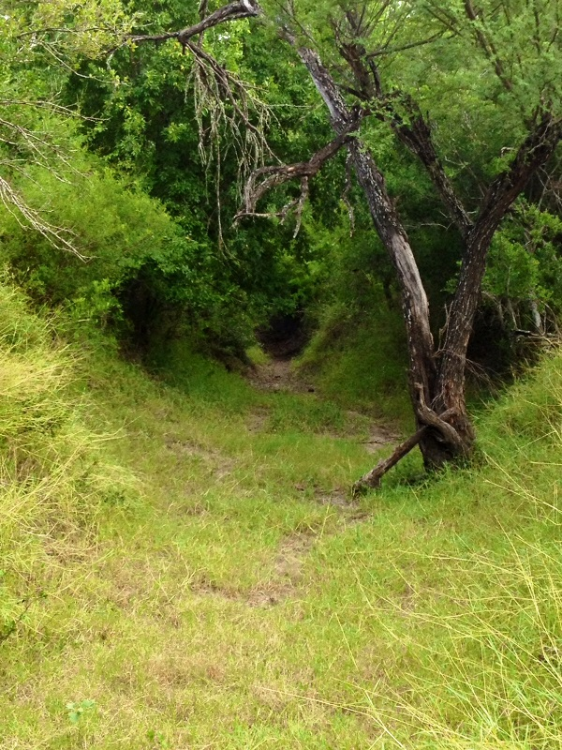

TexasRanchBrokerage.com (361)813-8761
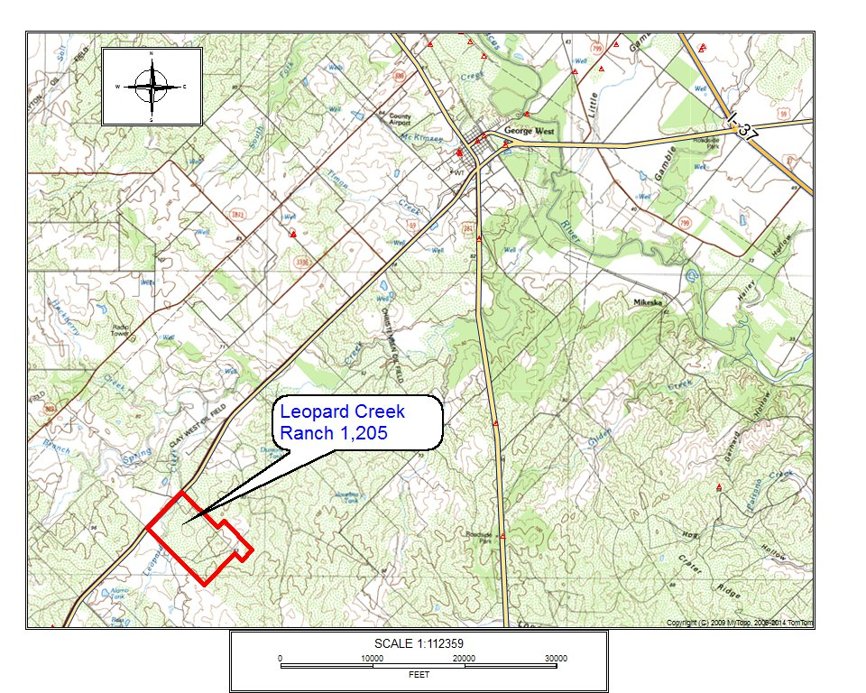


TexasRanchBrokerage.com (361)813-8761
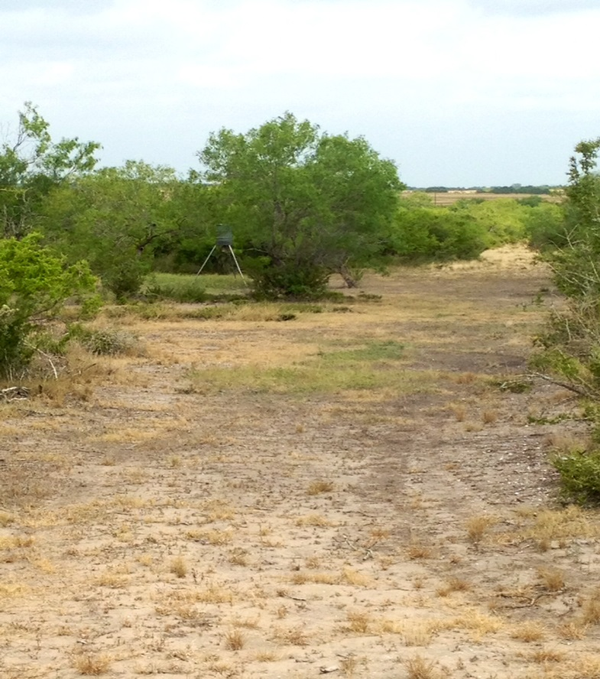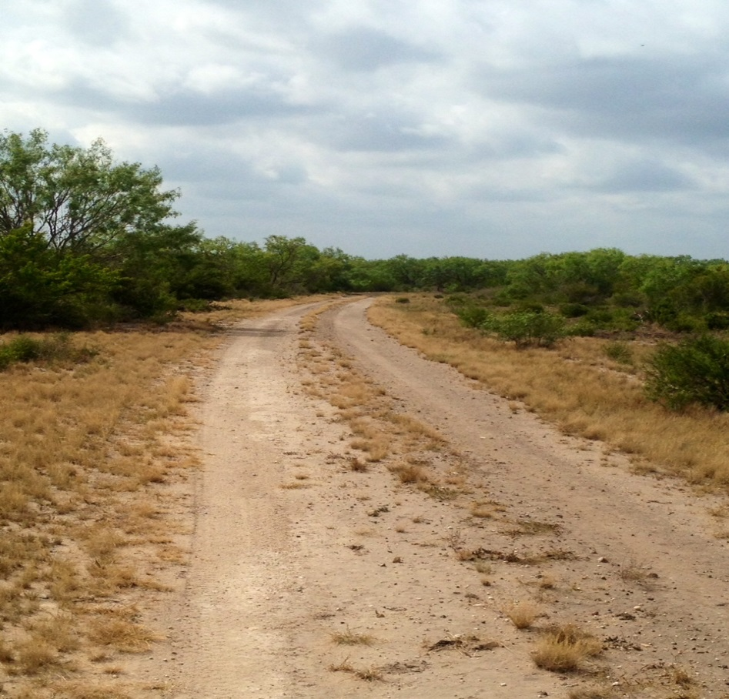
TexasRanchBrokerage.com (361)813-8761

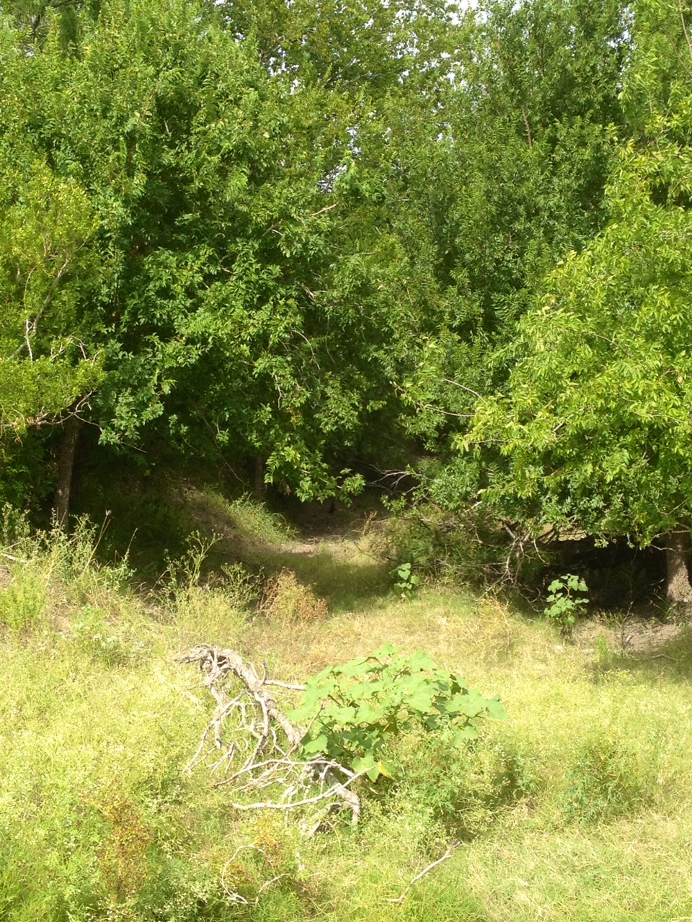

TexasRanchBrokerage.com (361)813-8761
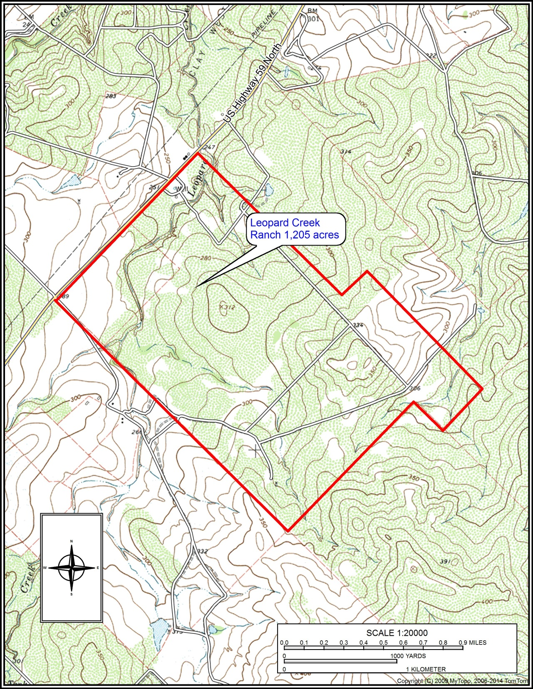
TexasRanchBrokerage.com (361)813-8761
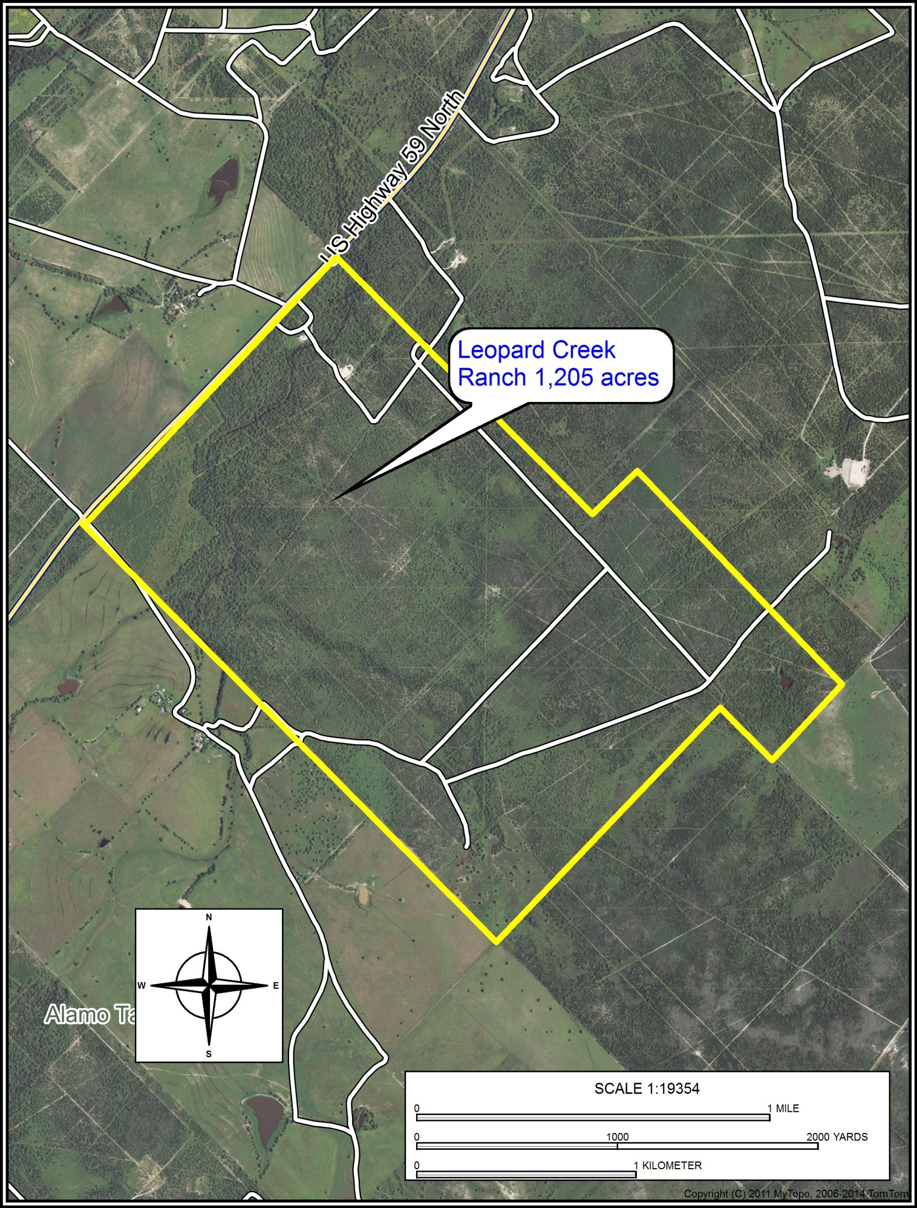
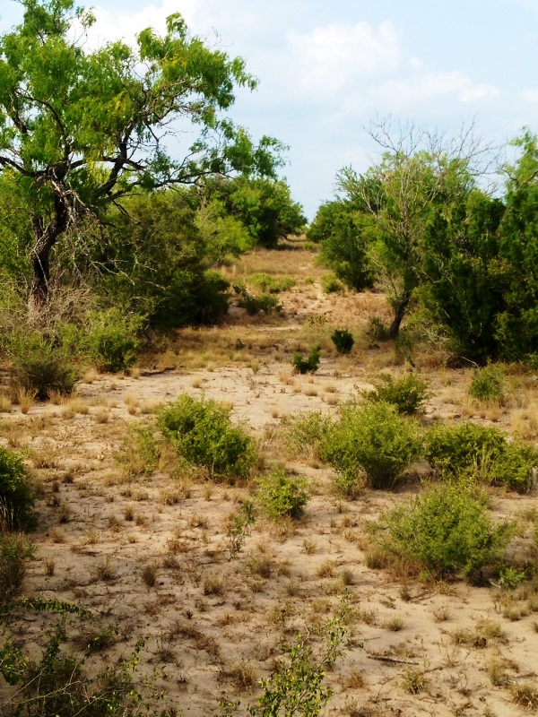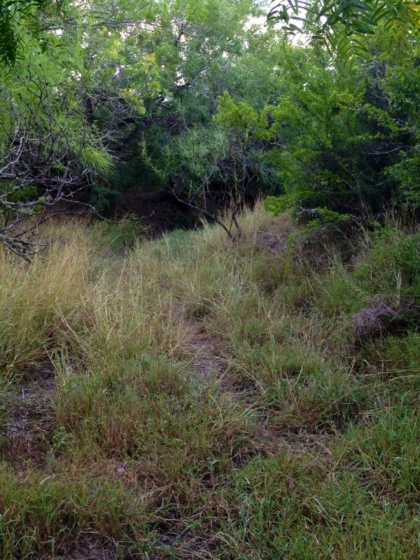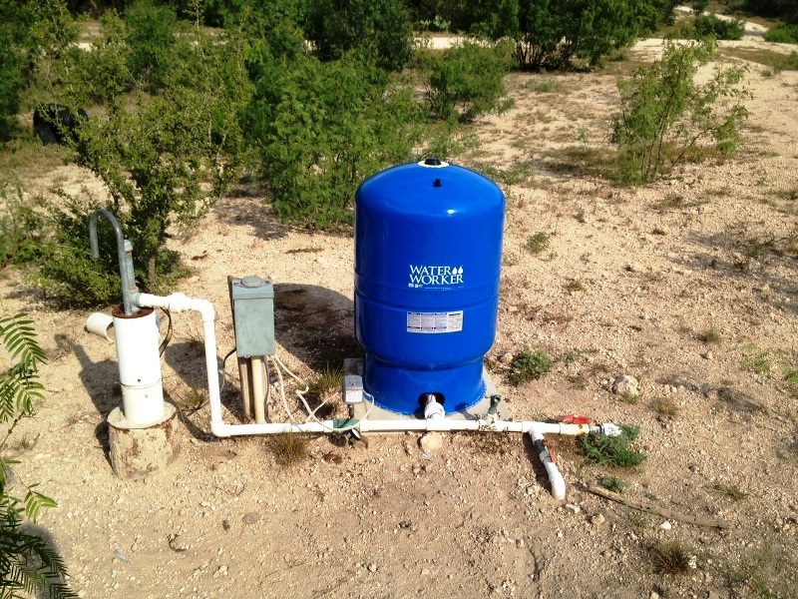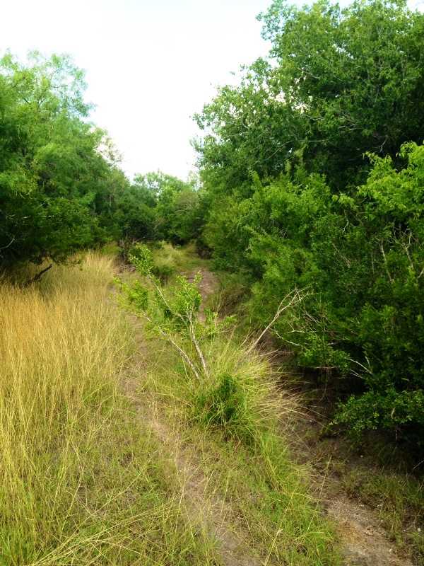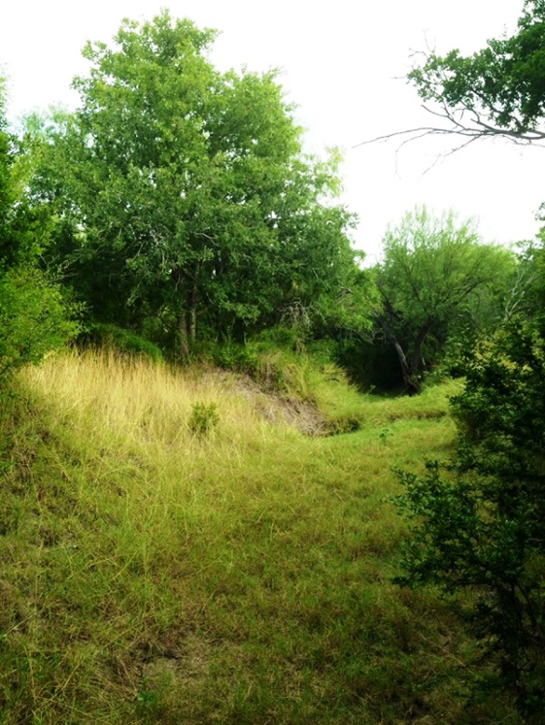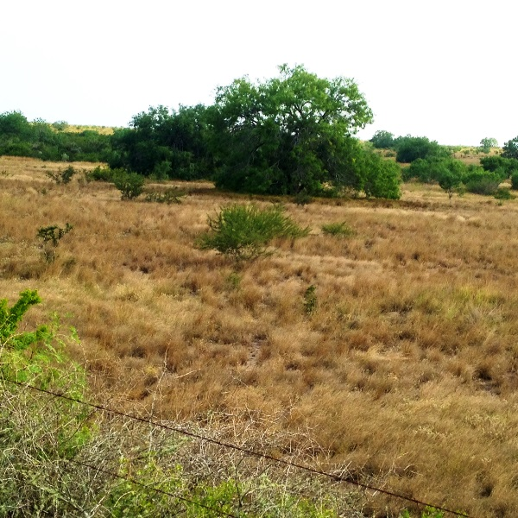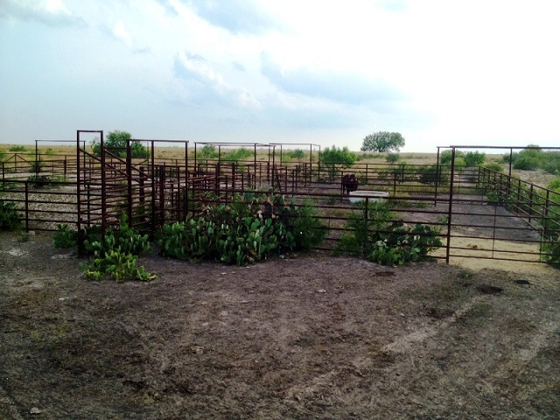
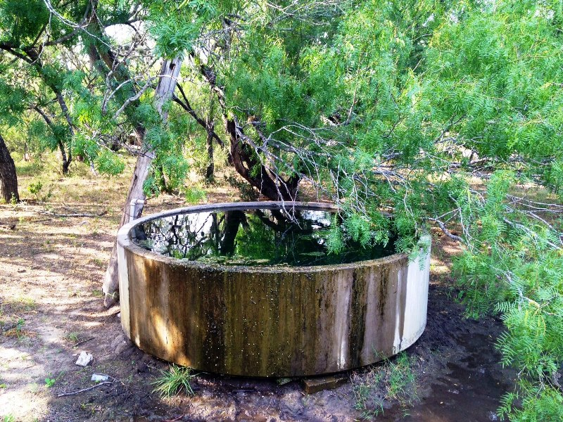

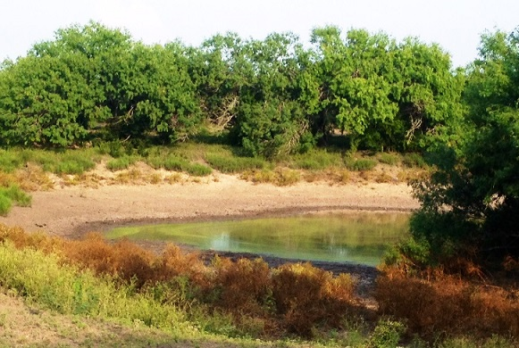

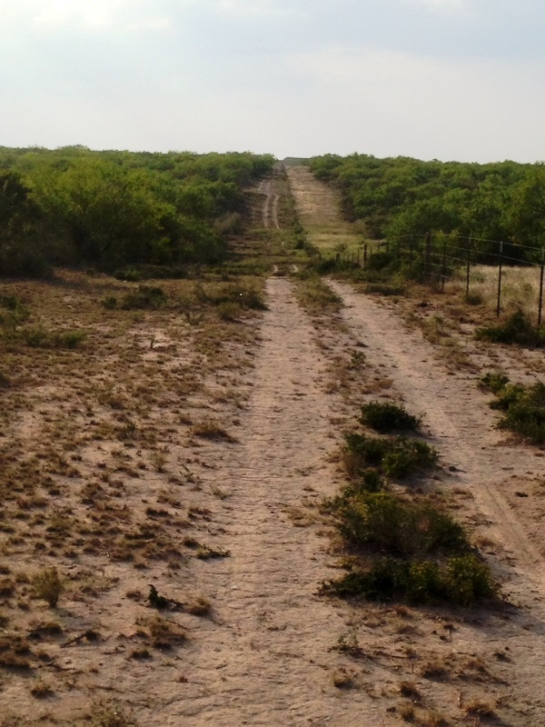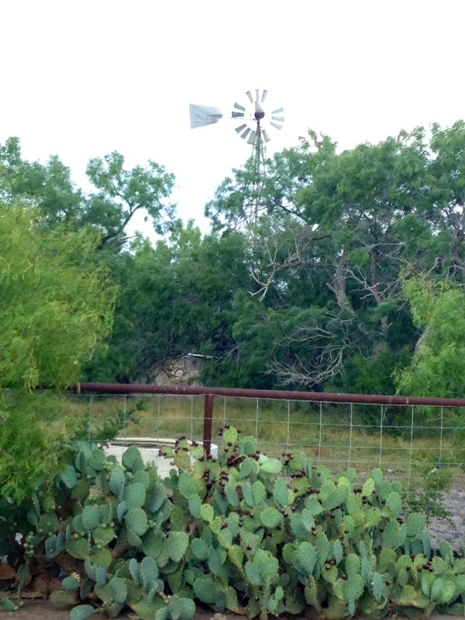

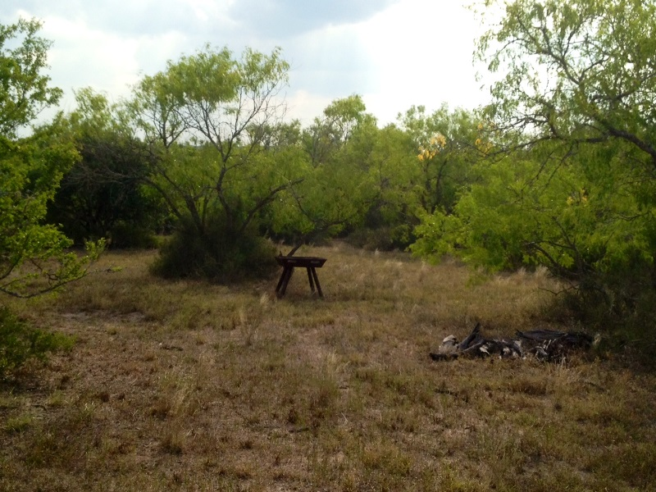

COMMENTS: This ranch has some of the prettiest native brush and trees you can find in the South Texas area. Big rolling hills with good sandy loam soils and excellent wildlife of all types are found here and the neighbors are large. If you want to buy a ranch that can be sculpted to fit your vision of the perfect place- look no further. Priced to sell at $2,395/ac

Disclaimer: This information was obtained through sources deemed reliable. However, Tom W. Davis, Broker, and the owner in no way warrant or guaranty its accurateness. Buyer should confirm all data prior to contracting to purchase. This property is offered subject to prior sale, change in price, and withdrawal from the market without notice.

For further information and showings contact:


Tom W. Davis, Broker
P.O. Box 643
George West, Texas 78022
(361) 813-8761 Cell (361) 449-3632 Fax
twd@texasranchbrokerage.com

