**Secluded Country Home**

1024 CR 273 – Cameron, TX

Central Texas- Milam County

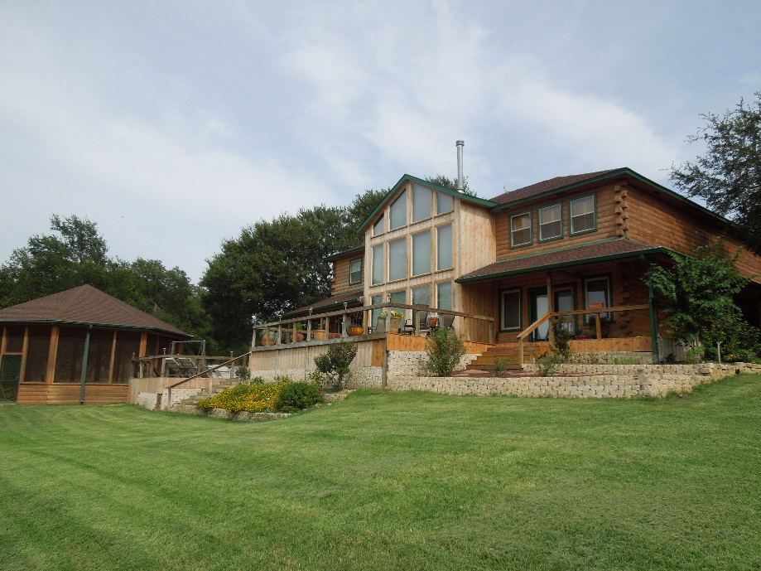

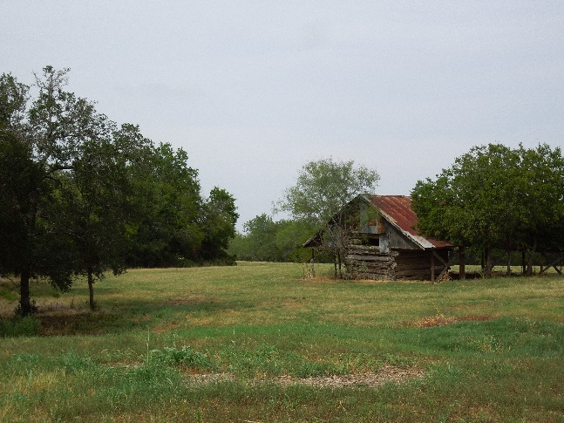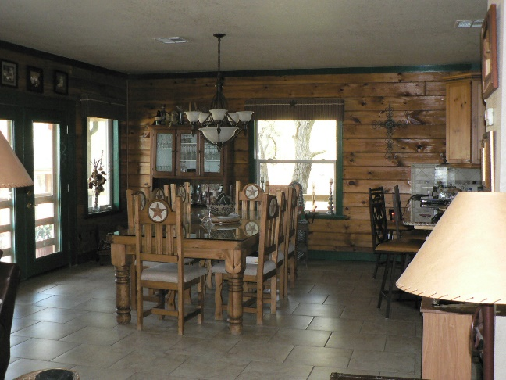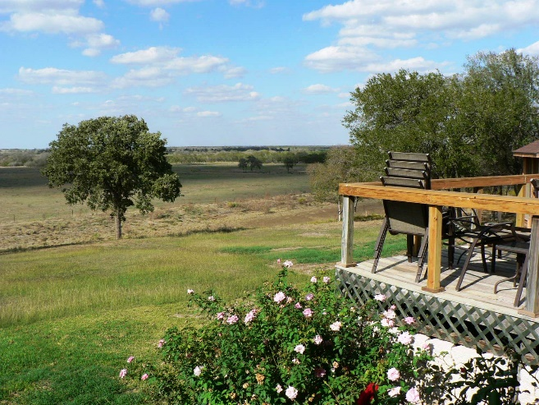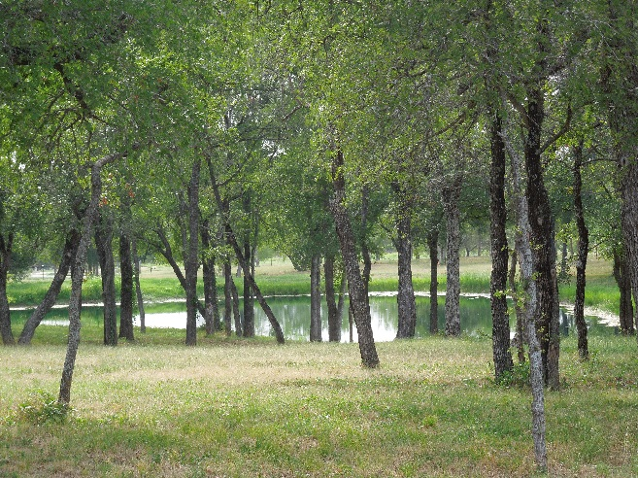

Appx. 240 Acres, 4 ponds (most stocked), Little Pond Creek frontage and frontage along county road 273. Mostly native grasses, acres of wooded coverage with lots of native wildlife, and a beautiful custom log home with extensive garage/storage facilities and bonus room.

 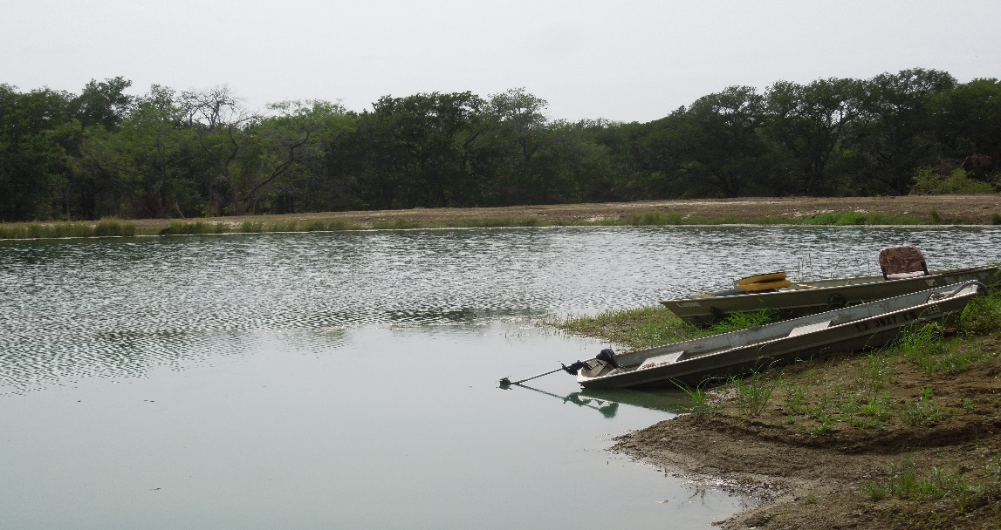

**Two Story Log home** – 4,511 sf, 7 bedrooms , 3.5 baths, office, game room area, with over 1,200 sf of covered wrap around porches and attached breezeways, and open decking and a 30’ screened gazebo. Concrete circle and paved driveway, sprinkler system, security system, gated entry, high fenced garden area, fantastic view and more. Quiet, private and secluded!

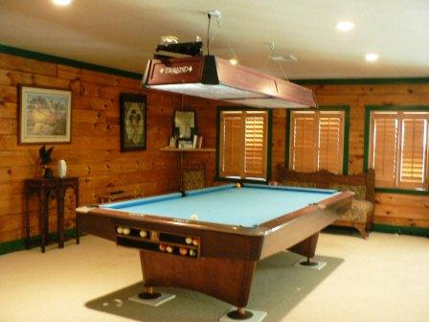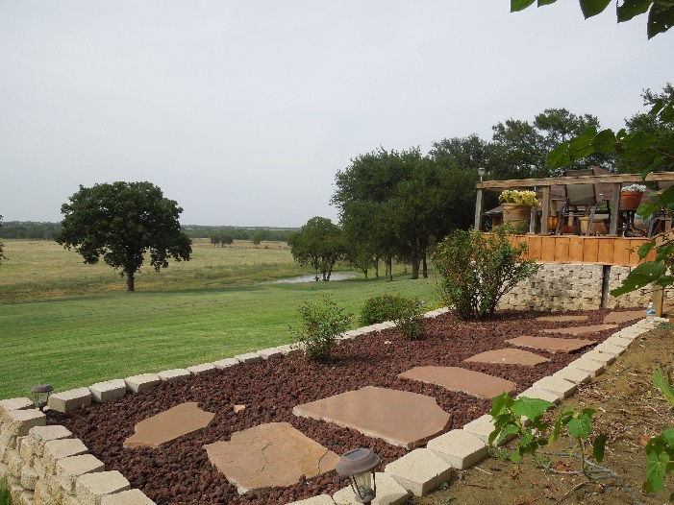+

Kitchen features custom cabinets, granite counter tops, and all new stainless steel appliances.

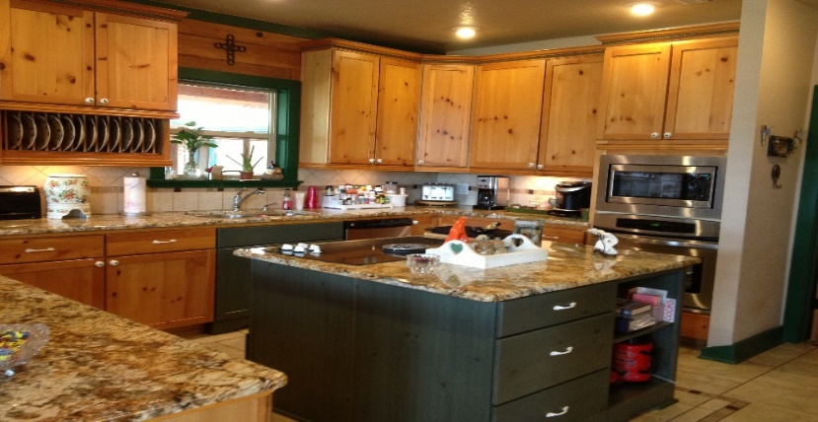

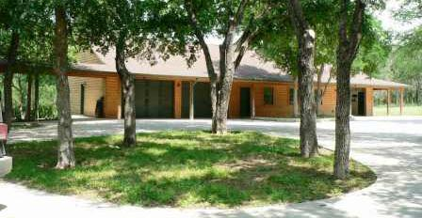

33’x24’ 2 car carport with 9’ enclosed storage area (all log siding to match the house)

31’x77’ garage (includes a 2 car garage and 31’x30’ climate controlled bonus room/storage area, built in cabinets, huge walk-in closet and ½ bath (also with log siding to match house)

Centrally located in Milam County, just Northeast of Cameron in Jones Prairie. Only about 45 minutes to Bryan/College Station or Temple, little over an hour to Austin or Waco, 2 hours to Houston, and just at 3 hours to DFW or San Antonio areas.

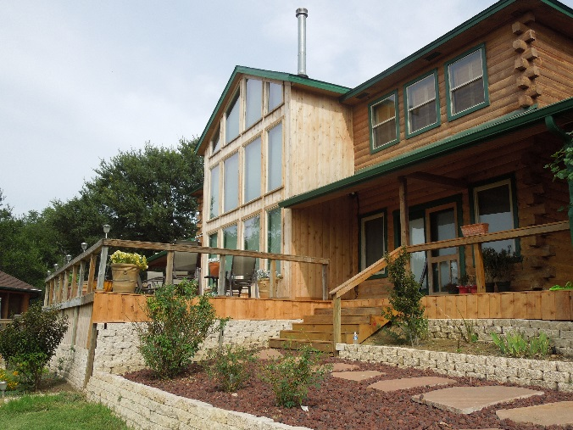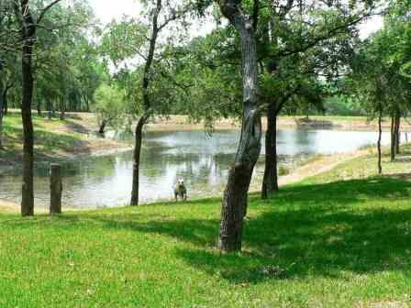

Stocked ponds, native whitetail deer, duck, dove, hog and an occasional turkey frequent the property and provide for added recreational pleasures. With this division the property is only partially fenced, but what is fenced is in excellent condition.

Call today to schedule your personal tour of this beautiful ranch property.

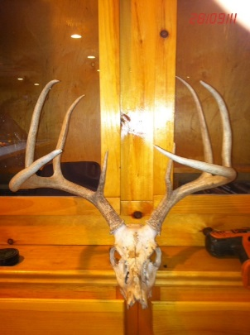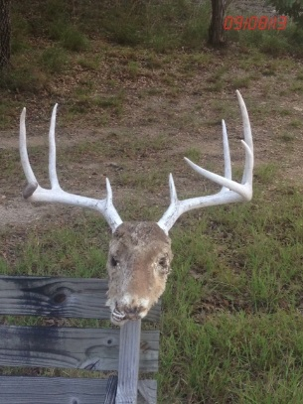**NOTE:**

Offered acreage amount (240 acres) is negotiable.

This is part of a 1,400+ acre working ranch.

A new survey would be required, so if more or less

Acreage is desired, it could be adjusted.

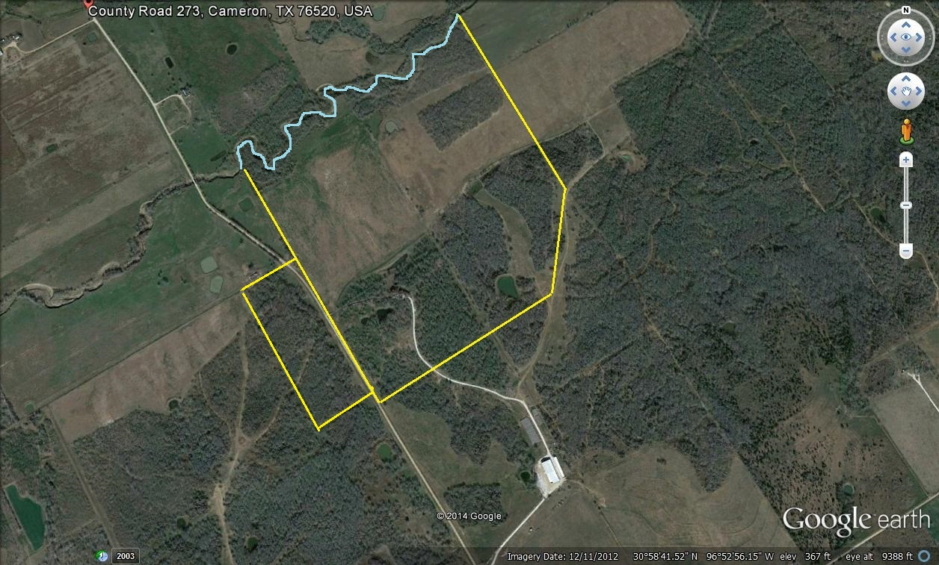

$ 1,900,000.00

