
LANDMARK REALTY
OPEN HOUSE
6 PROPERTIES-1 DAY!!

MARCH 2, 2014
NOON-2PM

Office: 573-378-4641
TOLL FREE: 800-978-4641

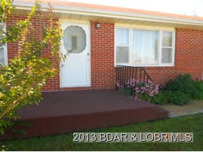
614 East Third St, Stover
3 Bedroom, 1 Bath, 1134 Square Feet

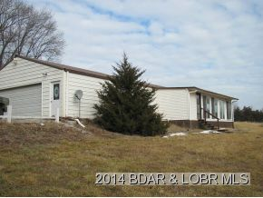
1067 Wildrose Lane, Stover
1 Bedroom, 1 Bath, 1300 Square Feet

DIRECTIONS ON BACK OF
<----------------- FLYER

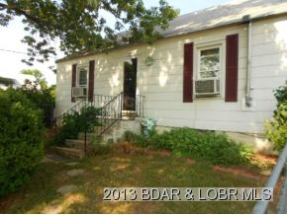
300 Cedar St, Stover
3 Bedroom, 1 Bath, 1200 Square Feet
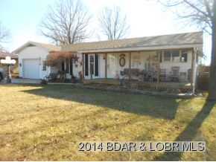
202 Park Ave, Stover
3 Bedroom, 3 Bath, 2000 Square Feet
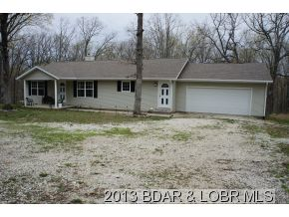
28026 Hwy J, Versailles (Stover School Dist)
3 Bedroom, 2 Bath, 1585 Square Feet
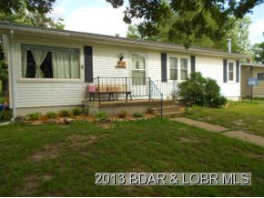
606 North Oak St, Stover
5 Bedroom, 2 Bath, 2340 Square Feet

