**Presents**

**McBoyz**

**Property**

**Offering Statement**

**TABLE OF CONTENTS**

1. Project Summary 3, 4

2. Property Maps and Photos

-Area map 5

-Local Map 6

-Site Map 7

-Parcel Map 8

-Opal Service District Land Use Map 9

**PROJECT SUMMARY**

**Description -** 70 acres of open rolling farmland that fronts on US Route 17 in Opal Virginia located in Fauquier County. There are four parcels of land that are contiguous creating the property for sale.

The properties combined are roughly rectangular in shape and run from the southeast to northwest. The northern property line runs from the North to southeast along the US Route 17 southbound entrance ramp. The Southeast side of the property is bordered by and has direct access to VA Route 663 aka Covingtons Corner Rd. This is the most convenient access to the property from Route 17. From that entrance to the east is immediate access to US 17 and to the southwest on VA 663 is access onto US 29.

The property on the north is bordered by VA Route 811 aka Fayattesville Dr. From there is direct access to US 29 to the southwest. The neighboring property to the Northeast at the Route 811 entrance includes a few small industrial butler buildings with currently operating businesses run from them. The neighboring property to the west is comprised of mainly open farmland and a few single family homes. There are three small existing dwellings that vary in condition from habitable to uninhabitable on the main property. There are a few existing mature trees and a couple small farm ponds located on the site. An existing 15” sanitary sewer traverses the site and there is a sanitary sewer tap that transfers with the property.

**Location** - Opal Virginia

**Property Size –** 70.00 Acres

**Tax GPIN** – 6980-55-6404 - 29.4609 acres

6980-54-8595 - 5.2416 acres

6980-65-1522 - 8.2877 acres

6980-54-2899 - 27.0098 acres offered by Lynx Realty, Inc.

**Existing Improvements –** 3 dwellings: 1 onRoute 811, 2 facing on Rte 17

**Existing Utilities –** Sanitary Sewer

**Price –** Make Offer

**Offers Due by -** August 1, 2013

**Terms –** Cash or Financing

**Deposit -** TBD

**Settlement -** TBD

**Zoning -** A1

**Status -** Available

**Topograhy -** Gently rolling from southeast to northwest with grand vistas.

**Commission –** 2.5% to the Selling agent

**Comments** - This is an incredible opportunity for a large developer to obtain a great real estate asset by purchasing a strategic and highly visible property at a low cost per acre. The property has great access and very high visibility from US Route 17, a major thoroughfare in Fauquier County. The convenient vehicular access to both VA State Route 29 and Route 17 make this large piece a great value. The site abuts the new US Route 29/17 bypass ramp along Route 17 giving it fantastic exposure to the commuter and through traffic. The site is prime for the possibility of a mixed use development. The existing vehicular access through the site and the existing 15” sanitary sewer helps the possibility of a future mixed use development and the overall value. The topography is outstanding with beautiful gentle rolling fields with vistas from the East and the West.

This property has convenient access to 2 of the larger major traffic arteries in Fauquier County. There are thousands of commuter and through traffic that pass by the property coming from Gainesville to the north, I-95 from the south and Charlottesville from the South. There is also a Southern Fauquier transportation planned Bealeton Virginia Rail Express (VRE) station to the south approximately 2 miles from the site.

Contact - ***Chris Foley*** [**Seajf1@gmail.com**](mailto:Seajf1@gmail.com) **c 540.905.3941**

Area Map

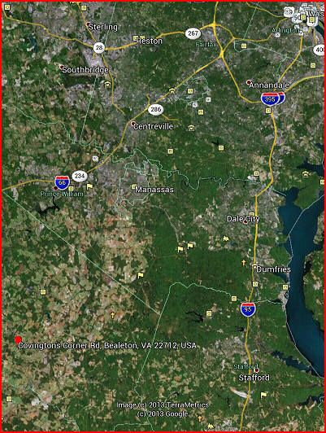

For illustrative purposes only – not to scale

Local Map

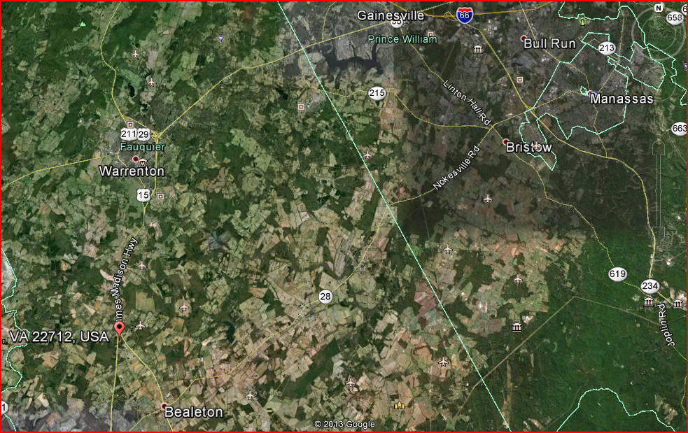

For illustrative purposes only – not to scale

Site Map

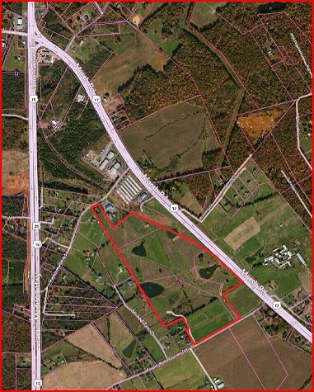

For illustrative purposes only – not to scale

Parcel Map

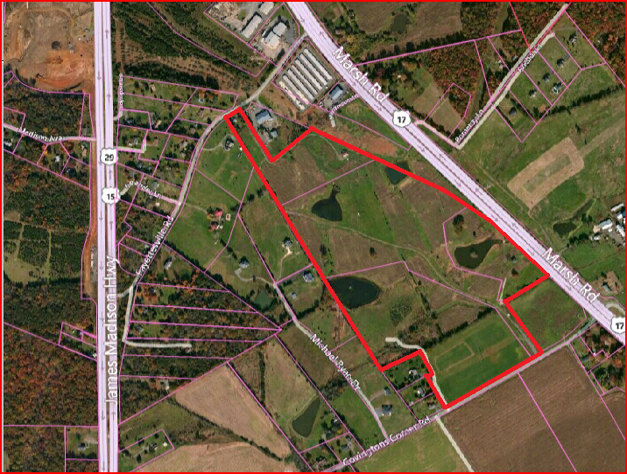

For illustrative purposes only – not to scale

Opal Service District Map

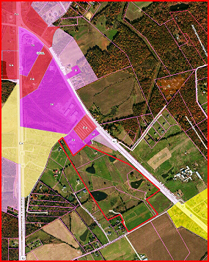

For illustrative purposes only – not to scale

From the Fauquier County Government Website