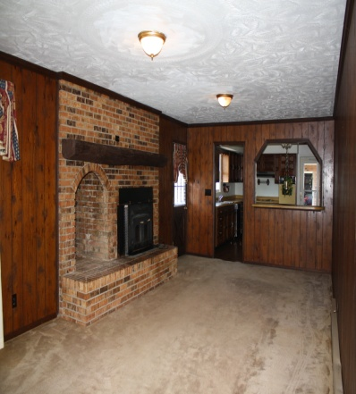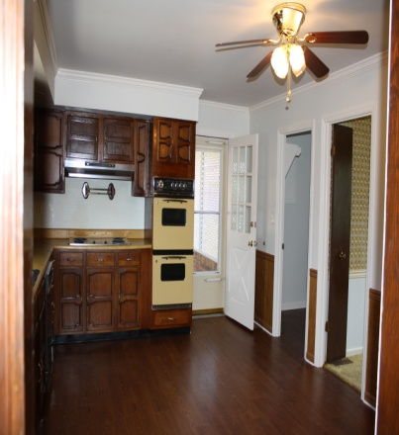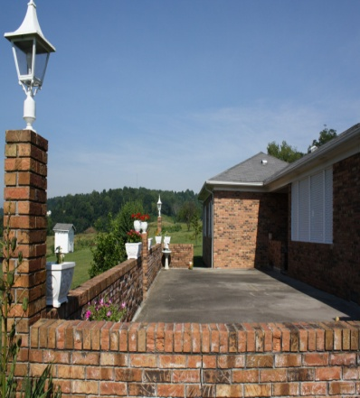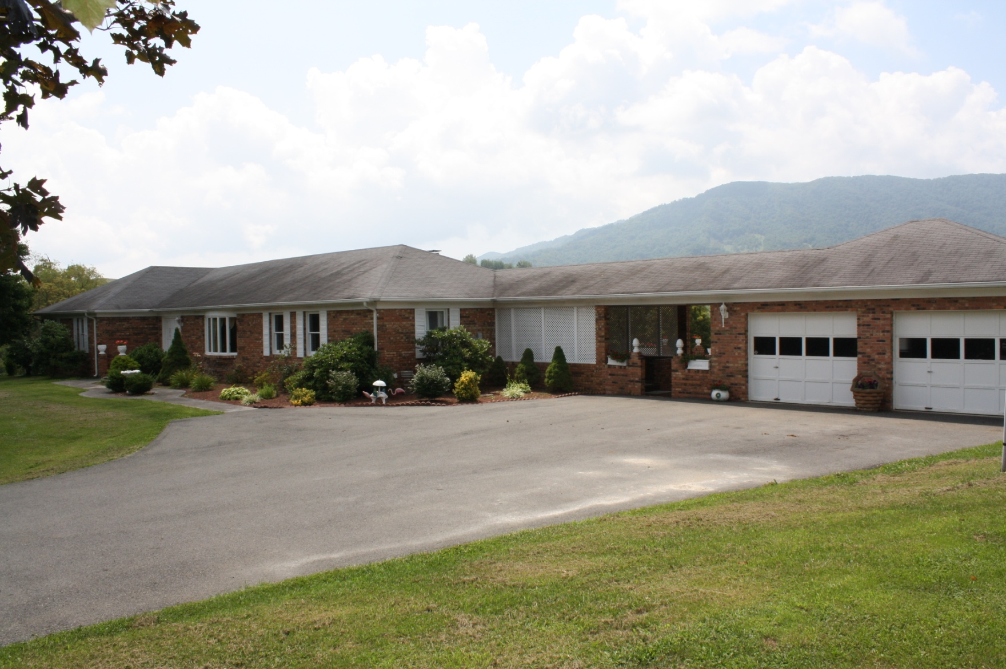

For

**SALE**

***Ranch Home with Lots of Extras!***

***$219,000***

*Please call to arrange a private viewing* Bee Stuart, Broker/Owner **540-529-6389** www.lebanonvarealestate.com

1438 Elk Garden Drive Elk Garden, VA

Single Family Property

Year Built: 1977

4 Total Bedroom(s)

2 Total Bath(s)

Approx. 2112 sq. ft.

Approx. 3.5 acre(s)

Large Yard

Brick Fireplace

Garden Area

2 Car Garage

Spacious Patio

Gorgeous View

Huge Den

Landscaped Yard

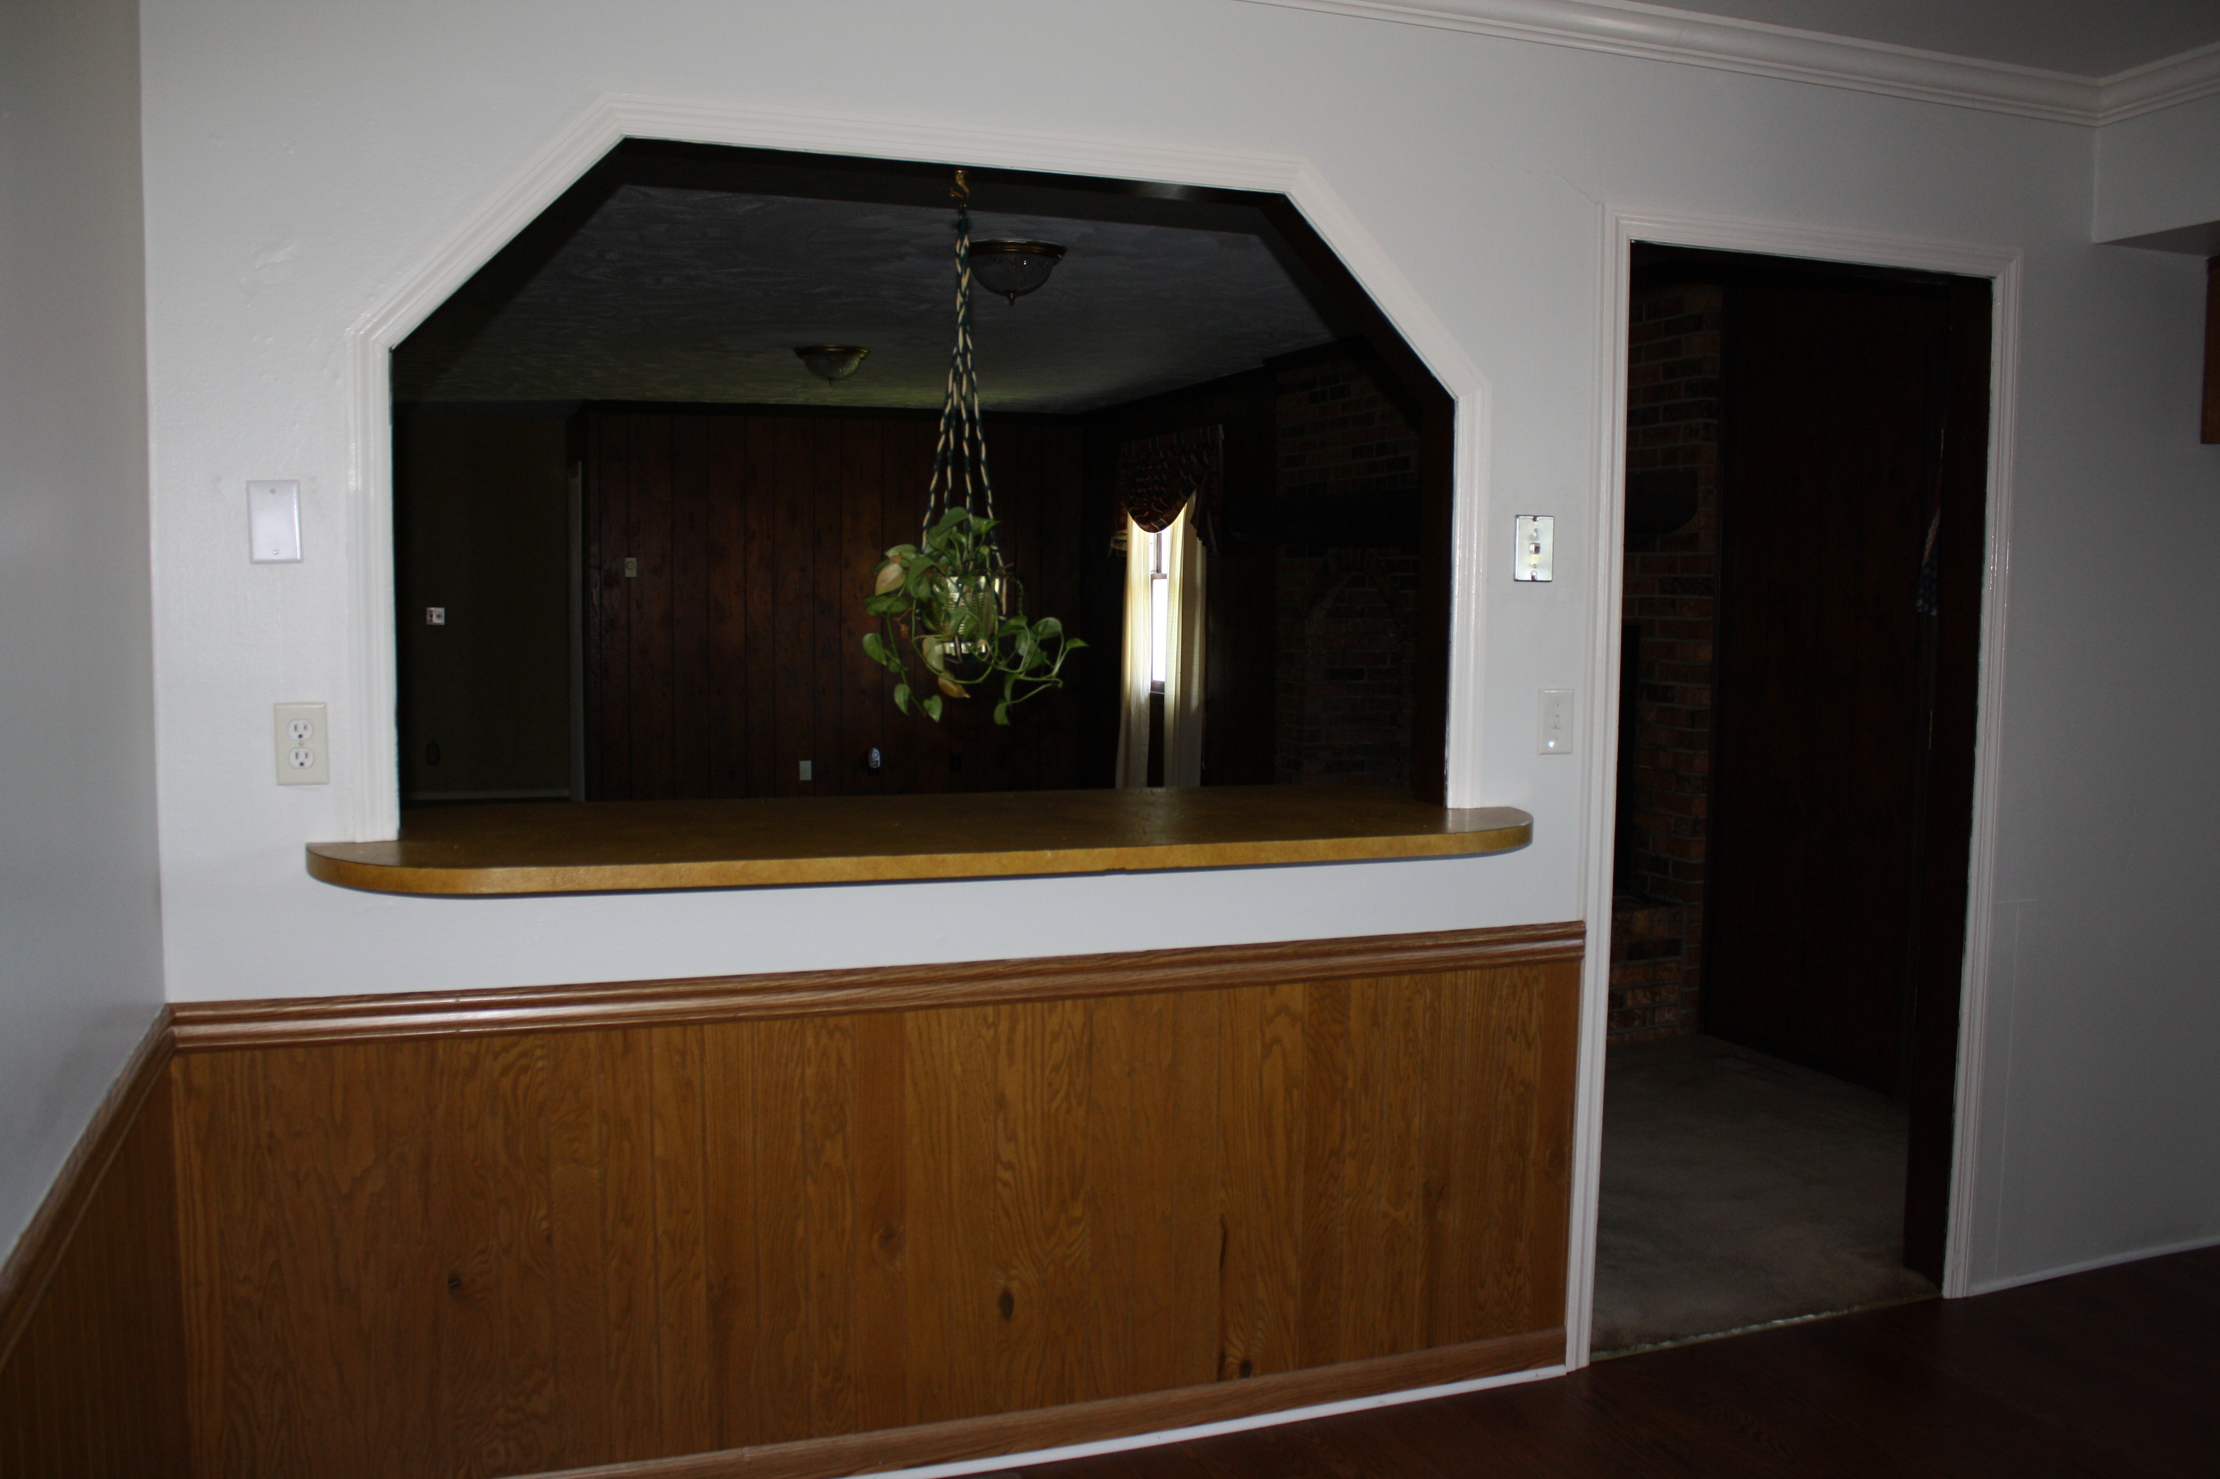



Stuart & Associates, Realtors

307 West Main Street

Lebanon, VA 24266