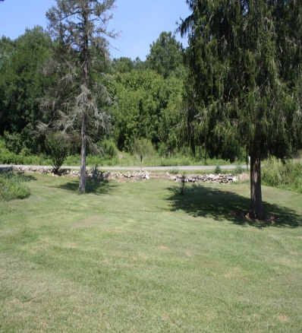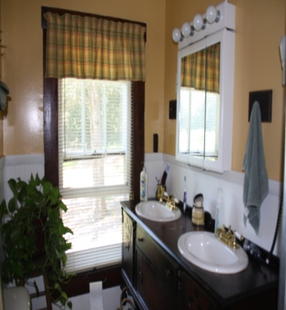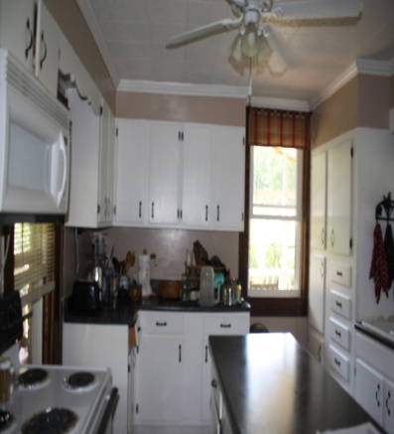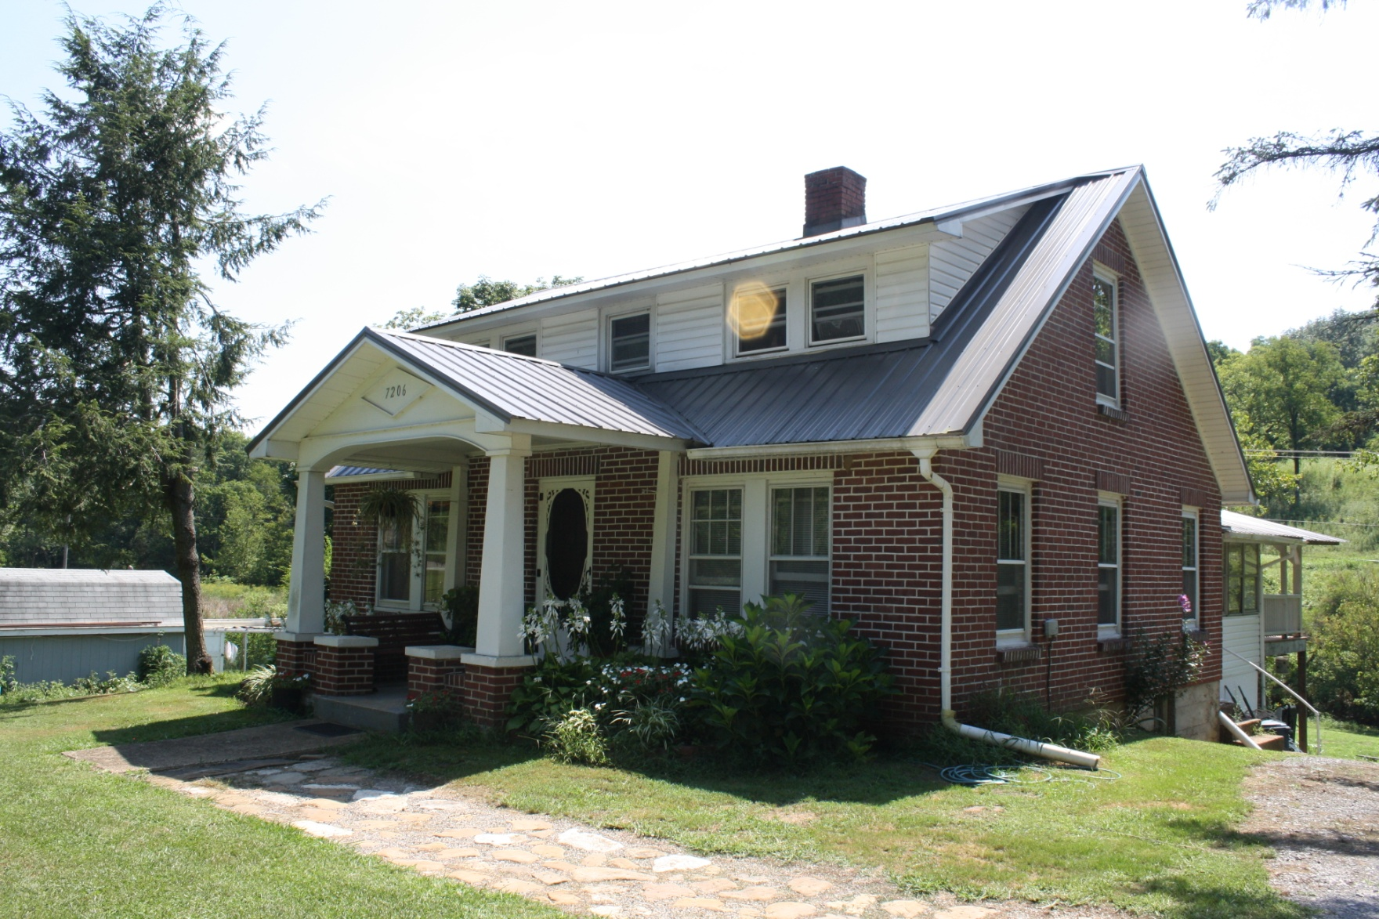

For

**SALE**

***Beautiful Brick Home!***

***$115,000***

*Please call to arrange a private viewing* Bee Stuart, Broker/Owner **540-529-6389** www.lebanonvarealestate.com

7206 Moccasin Valley Road Lebanon, VA

Single Family Property

Year Built: 1939

4 Total Bedroom(s)

2.5 Total Bath(s)

Approx. 1564 sq. ft.

Approx. 1.63 acre(s)

Metal Roof

New Kitchen

Creek side

Hardwood Floors

Basement

Wraparound Porch

Tile Floors

Tilt Windows

Ceiling Fans

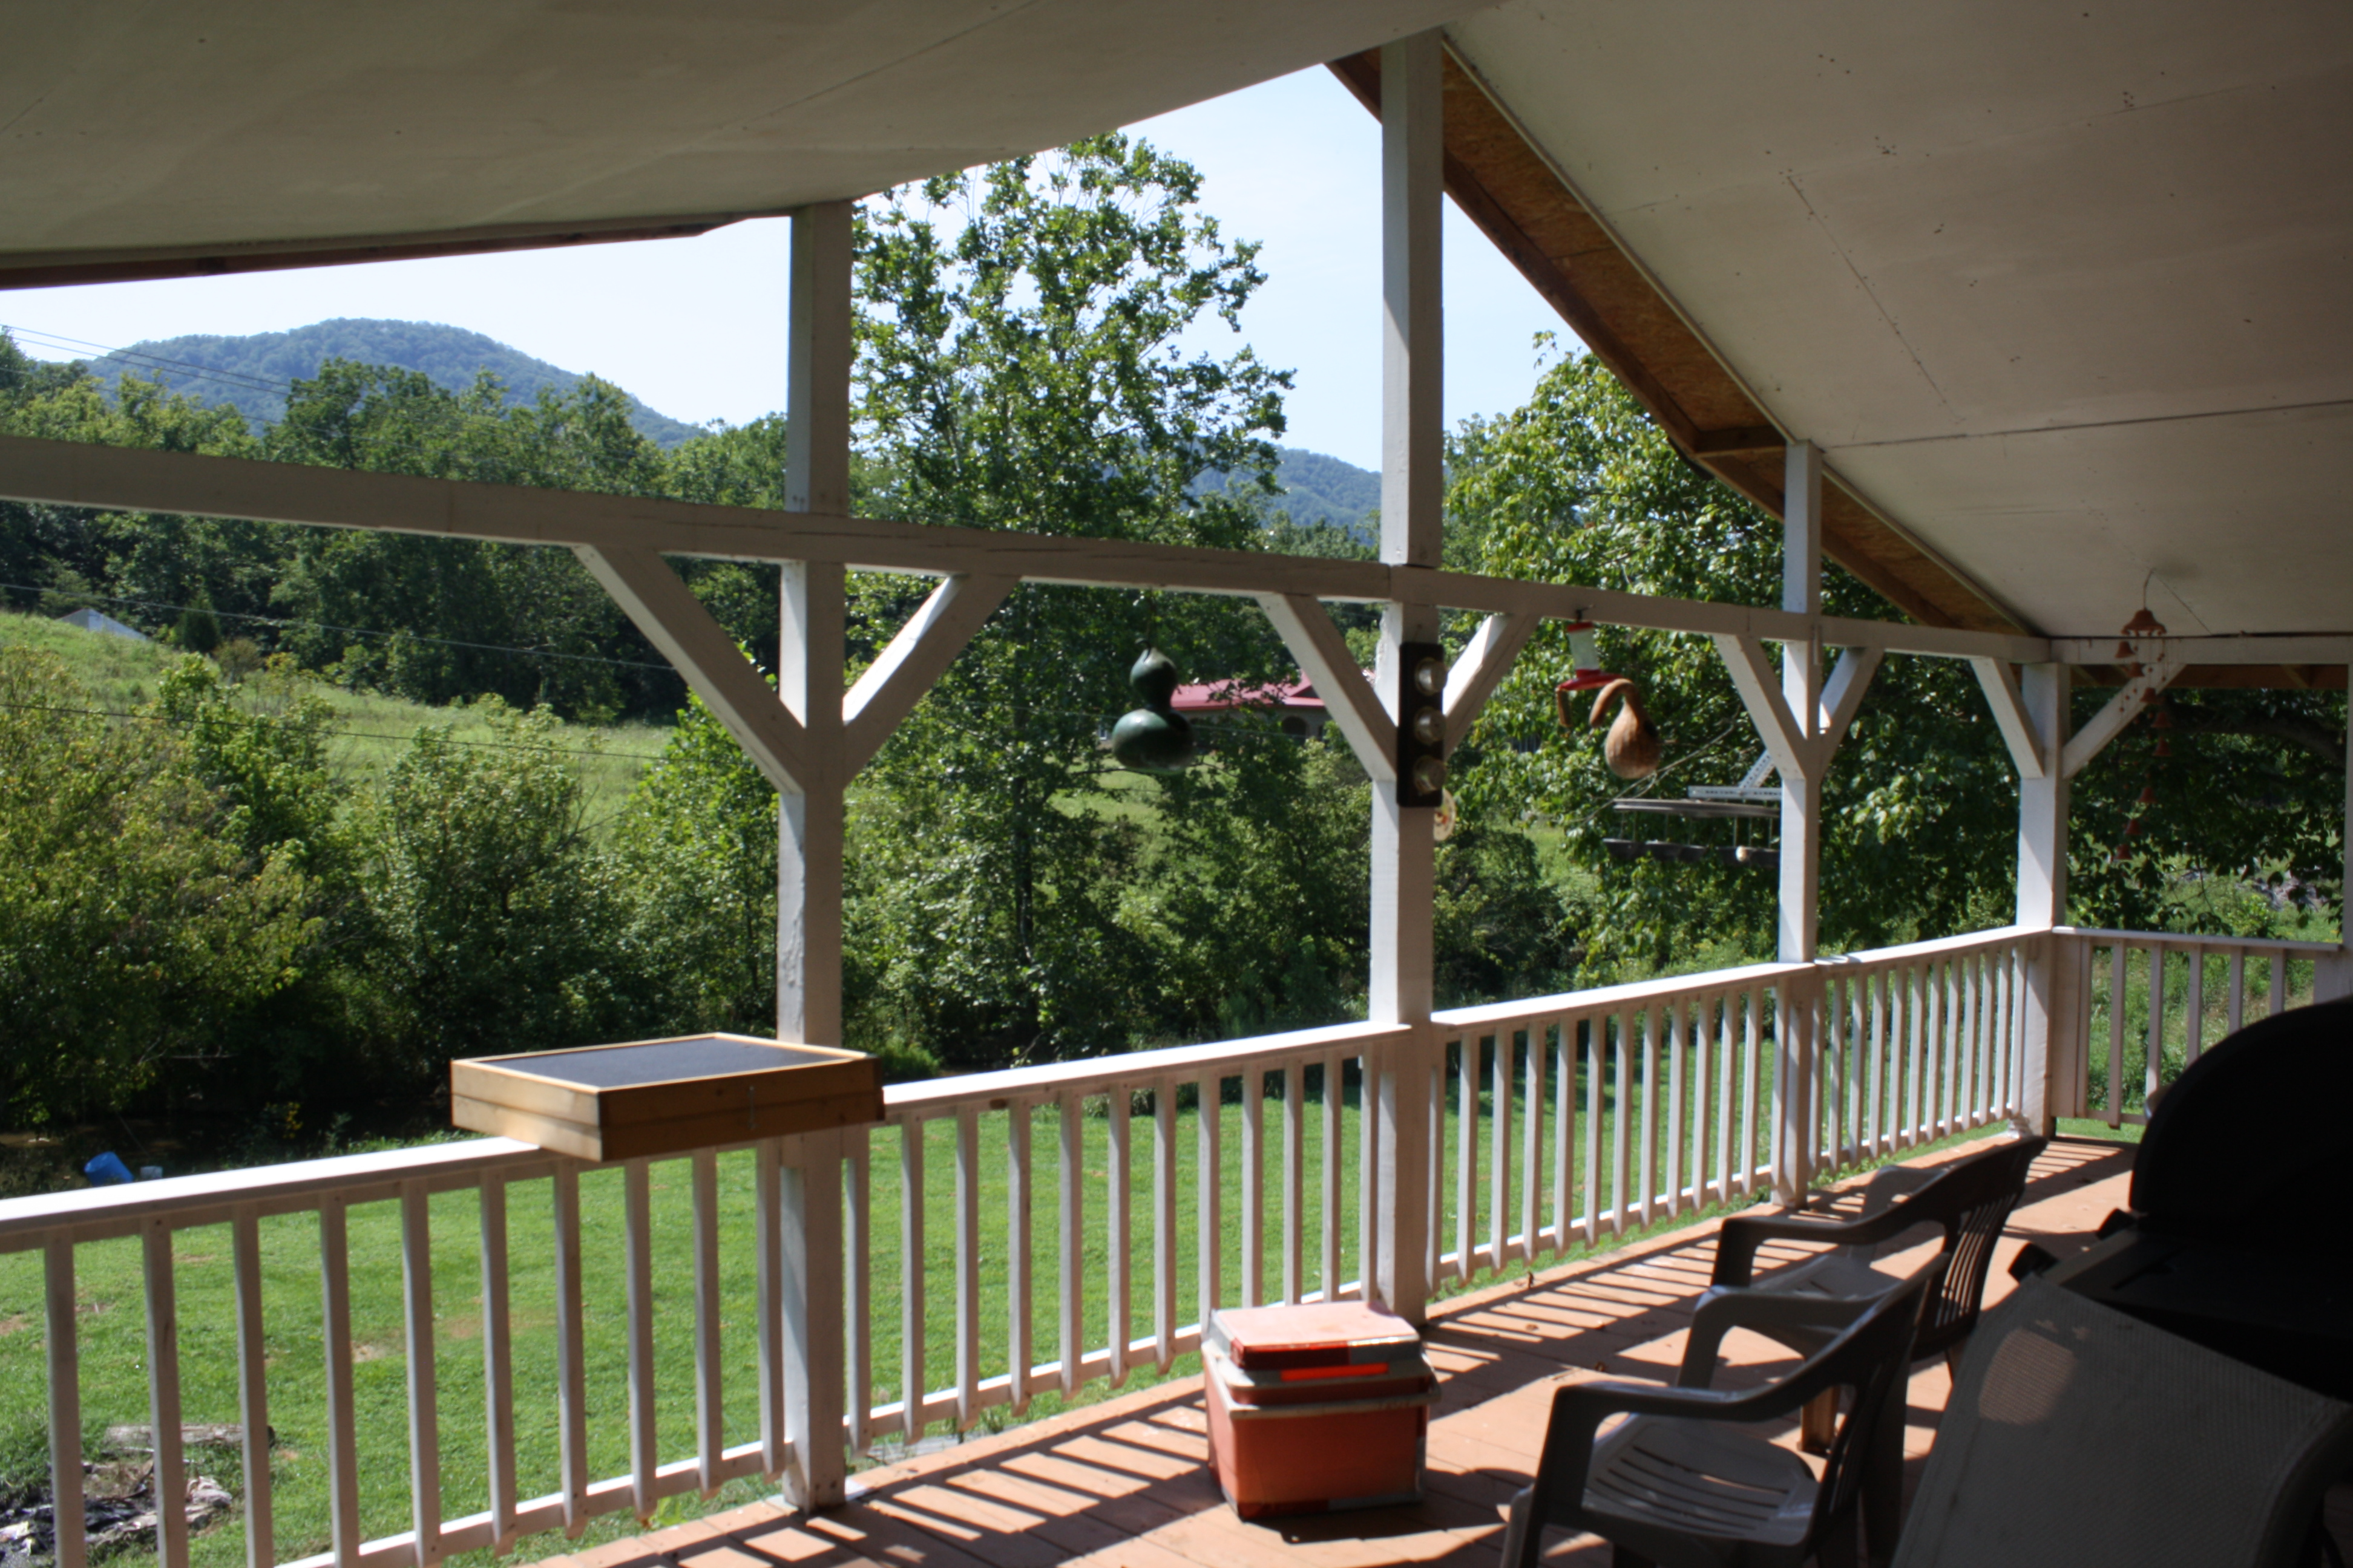



Stuart & Associates, Realtors

307 West Main Street

Lebanon, VA 24266