**Secluded 9 acres with 3/2 Country Home**

**12586 Post Oak Lane- Hearne, TX 77859**

**Just South of Hearne (Mumford Schools optional)**

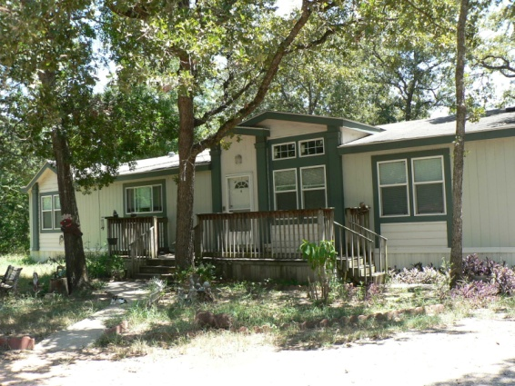

**Great secluded and quiet, country home on just over 9 acres. Spacious, 2,048SF 3/2 home with roomy master suite. Features a large bathroom with garden tub, separate shower, double vanity and double walk-in closets. Large country kitchen with island and breakfast bar, large family room and dining area and utility/mudroom entry.**

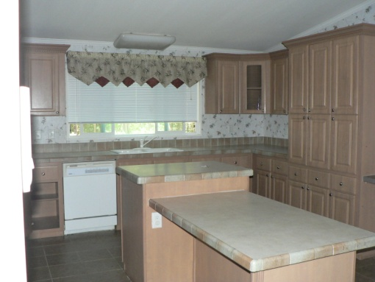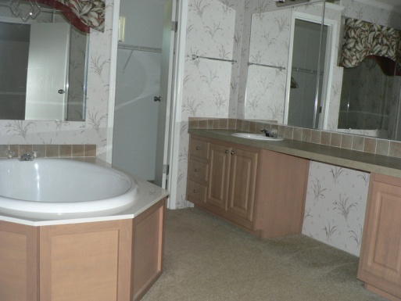

**Lots of built-ins, covered back porch, open front deck, barn/workshop, outbuildings, pond, fenced area for livestock and more.**

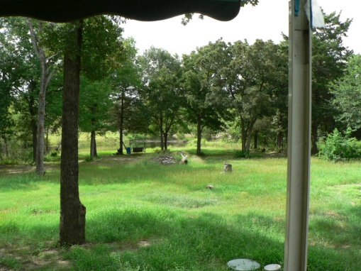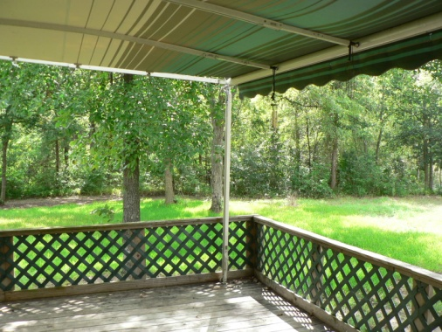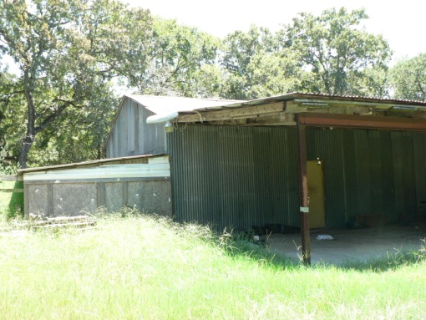

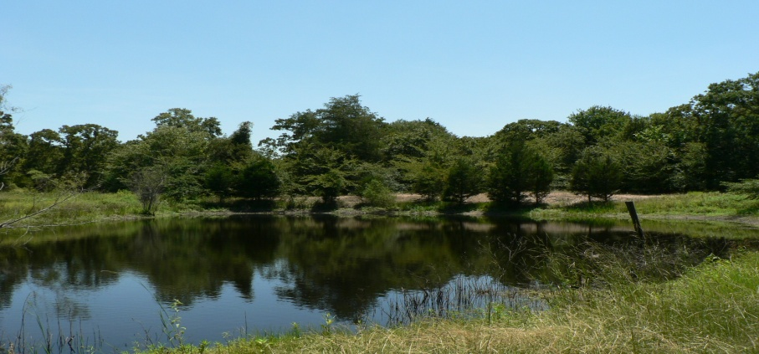

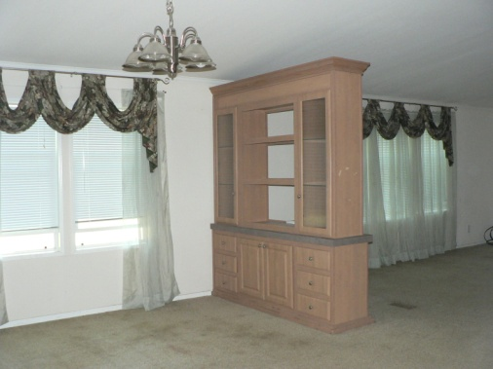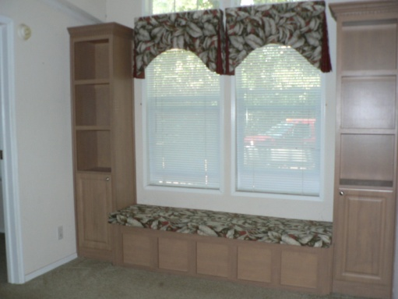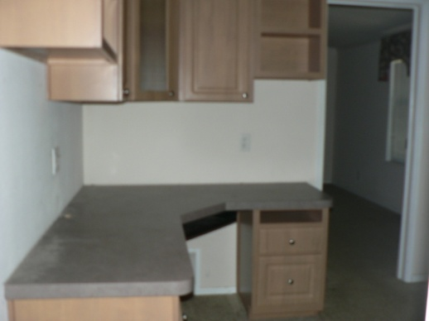

**If quiet country living and seclusion is what you are looking for, then this is your spot !**

**Give us a call to schedule a tour……….**

**Priced to sell at $ 115,000.00**

**Located in Robertson County…………. 2009 Taxes $1,730 Co. & School**

