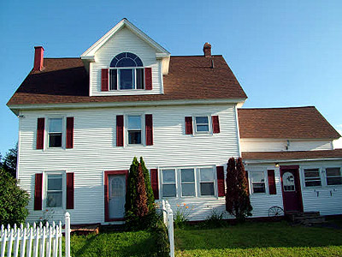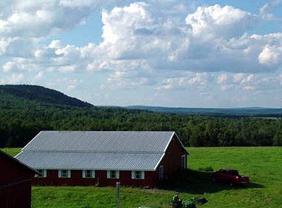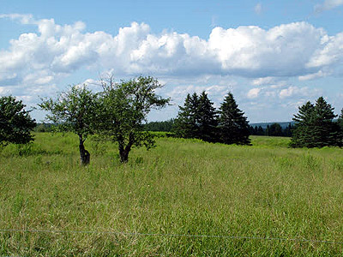
 Visit www.mooersrealty.com!
Listing #7796
Location: 35 Bates Hill Road Town: Linneus Lot Size: 88 Acs.+- Legal Description: North side of the Bates Hill Road, Township of Linneus; more particularly described in book 3459, page 96 in the S.A. Registry of Deeds; tax map 11, lot 8.
Borders Road Surface Frontage Borders Water Front Frontage
Bates Hill Road Gravel 1,500’+- Gary Brook 2,000’+-
Two ponds!
If Not On Highway, Distance To Nearest: 8 miles to US Route 2A Sewer: 1,000 gallon concrete School Bus: Door Schools: Grade: 8 miles High: 8 miles Distance To Lakes: Many in the area! Which Ones? Nickerson, Drews, Grand & many others! Nearest City: Houlton, 10 miles Distance To
Shopping: 5, 10 miles Land: Level to rolling Pasture/Cleared: 35 acres+- (hidden field could be cleared for more) Wooded: Balance mixed woods Power: Yes Phone: Yes Water Type: Drilled well Home Style: Victorian Age: 1890 Stories: 2 ½ Total No. Of Rooms: 14 No. Of Rooms 1st Floor: 6 2nd Floor: 6 3rd Floor: 2 Sq. Ft. Of Living Space: 3,800 S/F+- Bedrooms: 6 Sizes: 30x20, 13x12, 12.5x12.5, 15.5x10, 12x9 No. Of Baths: Two full baths! Half bath! Kitchen Size: 21x16 with Corian tile! Wainscoted ceiling! Ceramic and marble countertop! 16x6 pantry! Dining Room Size: 18x12 with bird’s eye cabinet! Parlor Room Size: 20x13 Living Room Size: 22x19 with hookup for fireplace! Kind Of Floors: Oak, tile, carpet, vinyl How Heated: Oil hot air; Greenwood high efficiency boiler Water
Heater: Electric Basement: Full basement Cost To Heat: 1,500 gallons+- (DR); 600 gallons (DR) Taxes: $1,500+- Size/Type Porch/Deck: Open front porch! Glass rear porch! Garage: Attached double garage! Describe Unique Features: Over 88 acres! Incredible views! Raise critters, crops or hobby farm! Unique woodwork! Stained and frosted glass! Open sun porch! Vinyl siding! 200 amp electric! Near golf course and many lakes! Watch the video … http://www.youtube.com/watch?v=heu1ZCiL68A! 80x60 barn with indoor riding arena, box stalls! Extra 5-bay machine shed/pole barn, extra utility shed with cement floor! Ready to farm or use for storage! Highly efficient outdoor wood boiler (over $17,000 to buy/install … extremely efficient)! Quiet side road! Apple orchard! More information and photos here!
Price: $269,500. Down Payment: Cash Owner Financing: No Reason For Sale: Other interests
Possession Date: As agreed Other Buildings & Personal Property Included: Refrigerator, electric stove (being replaced), dishwasher, dining room chandelier (being replaced), jet heated tub, portable sauna not staying
Showing Instructions: With Mooers Realty Broker, 207-532-6573; By appt. only

