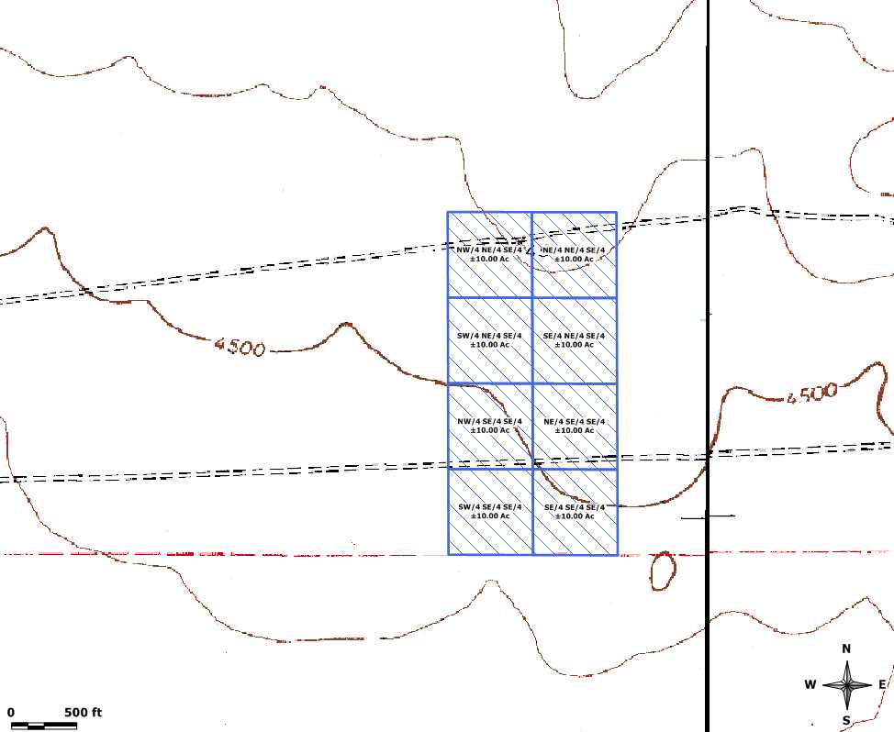

Contour Interval = 10 feet

All information provided here is based upon data from the owner, Texas General Land Office, Texas Natural Resource Information System, and the Texas Railroad Commission, and may not be exact. An exact location can only be obtained through a surveyor and this property has not been surveyed as of this date.

