Free 24 Hr. Recorded Information
1-800-592-2997
Then Enter the Recording Number to Hear Current Price and More Information
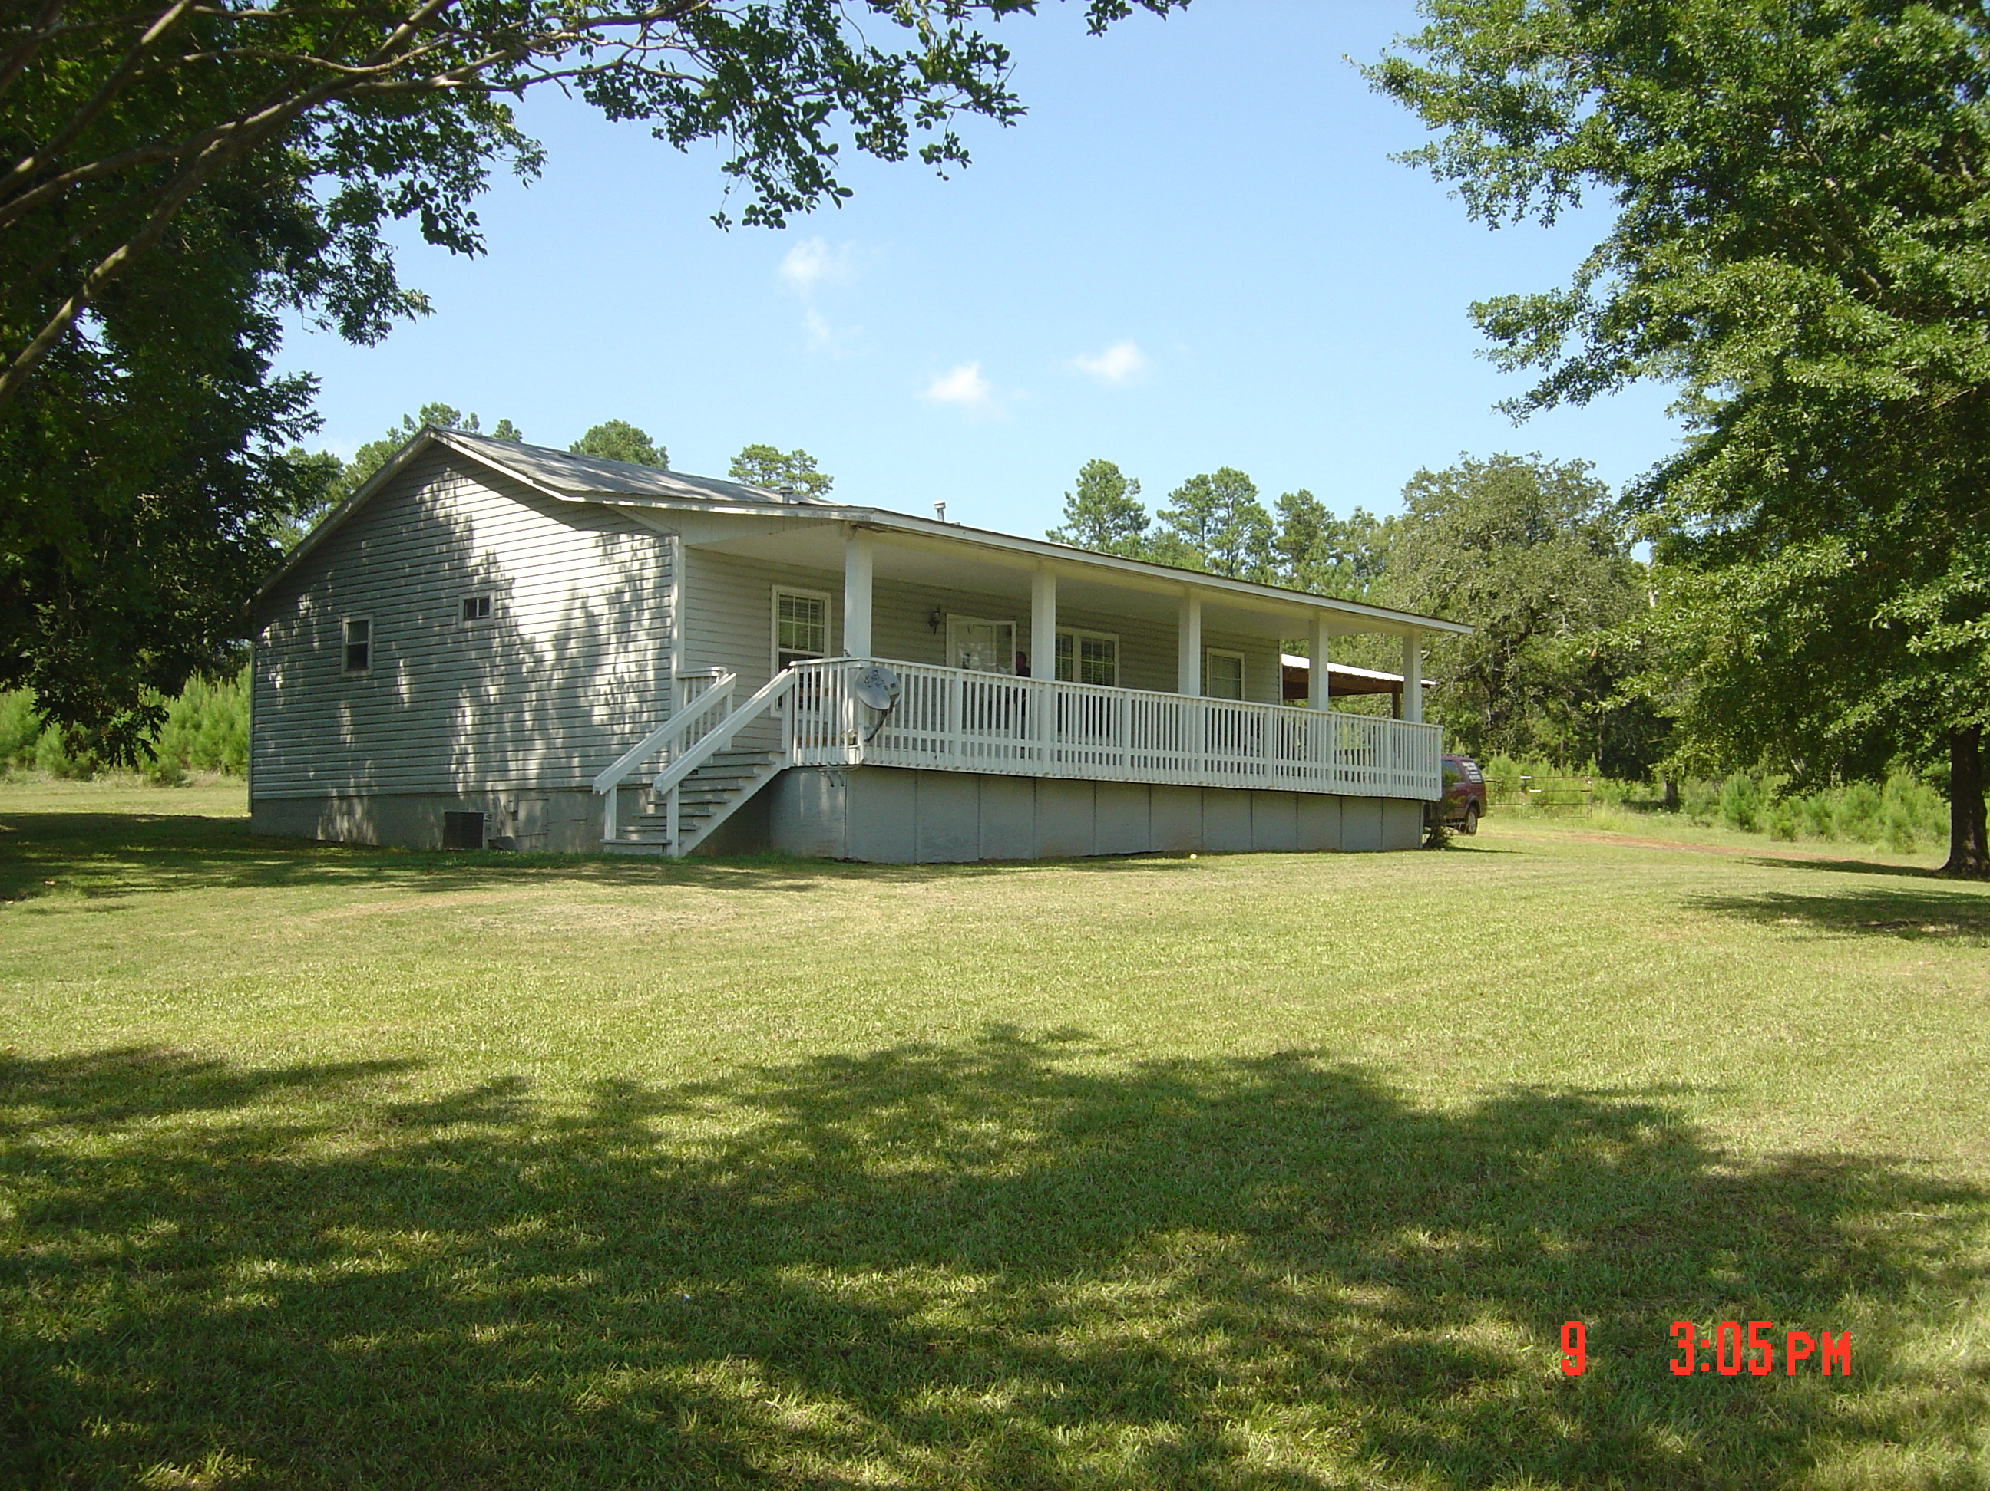Exterior
Shot

- Central A/H | - Hemphill ISD
- Septic System | - 2 Carport
- G-M Water | - Ponds
- Comp. Roof | - Unrestricted

*For more information and current pricing call 1-800-592-2997 toll free and enter ext. 1908.



Terry L. Vaughn
Toledo Bend Express Realty
246 Sabine Street

Hemphill, Texas 75948

