 |  |  |  | MLS#02591064
 |  |  |  | OWNER: |  |  | Grady L. Fleming
 |  |  |  | SALES PRICE: |  |  | $149,900 |  |  | LOCKBOX: | Yes
SALES, LEASES, RESIDENTIAL, COMMERCIAL, FARMS & LANDS |  |  |  | ADDRESS: |  |  | 24 Velma Drive
14 JACKSON STREET  NEWNAN, GEORGIA 30263  SINCE 1948 |  |  | TELEPHONES:  NEWNAN - (770) 253-6990  FAX - (770) 253-6843  EMAIL - www.lindseysrealtors.com | LISTED BY: |  |  |  |  | Lisa Jennings
 |  |  |  | TO SHOW: |  |  |  |  | Courtesy call, lockbox
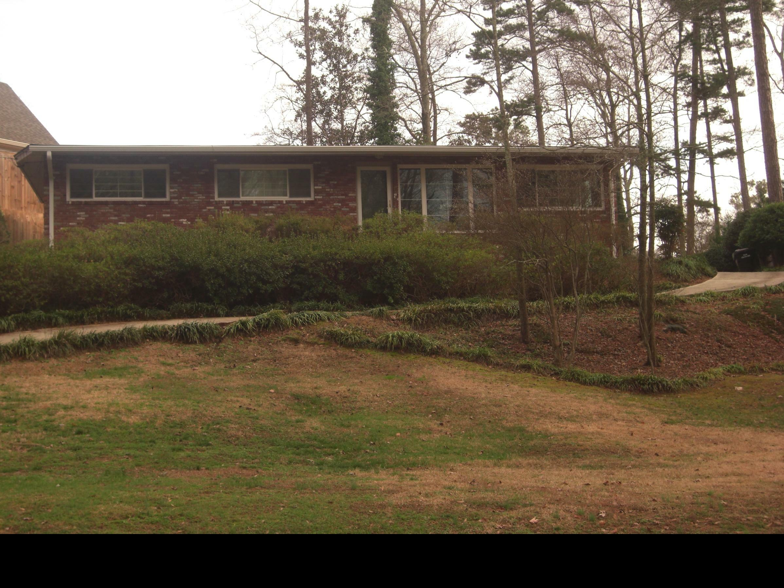 |  |  |  | KEY ON BOARD: |  |  |  |  | No
 |  |  |  | POSSESSION DATE: |  |  |  |  |  | Negotiable
 |  |  |  | TYPE CONSTRUCTION: |  |  |  |  |  | Brick
 |  |  |  | APPROX. SQ. FT. |  |  |  |  |  | 1200+/-
 |  |  |  | STYLE: |  | Ranch
 |  |  |  | EST. AGE: |  | Blt 1957 |  |  |  | NO. ROOMS: |  | 5
 |  |  |  | NO. BRS: |  | 3 |  |  |  | NO. BATHS: |  | 2
 |  |  |  | KITCHEN: |  | Has breakfast area, hardwood floors & island, dishwasher, disposal, range, refrigerator, washer and dryer to remain!
 |  |  |  | OTHER ROOMS: |  |  |  |  | Living room / dining room combo
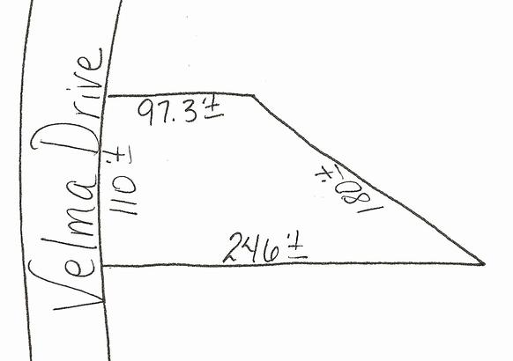 |  |  |  | BASEMENT: |  |  | Crawl space
 |  |  |  | GARAGE: |  |  | Parking area
 |  |  |  | HEAT & AIR: |  |  | Central nat gas heat, central elec a/c
 |  |  |  | WATER & SEWER: |  |  |  |  | City water & sewer
 |  |  |  | MISC: | Privacy fence in backyard. Hardwood floors and berber carpet. Screened porch on back.
 |  |  |  | ZONING: | Residential |  |  |  |  | LEGAL IN FILE: |  |  | No
 |  |  |  | TAXES: | City - $126.61, County - $662.39 ‘08
DIRECTIONS: |  | From downtown take Jackson St (Hwy 29) North, left onto Parks Avenue, right onto Velma Dr, #24 on the right.
NOTE: Although every effort has been made to provide accurate information, some of the above was supplied by others and therefore we do not guarantee or accept responsibility for the above. Price and terms subject to prior sale and change without notice.
PHONE NO.  TO SHOW: | Courtesy call, leave message, lockbox  Grady – 770-616-3983

