JUNGE ROAD PROPERTY

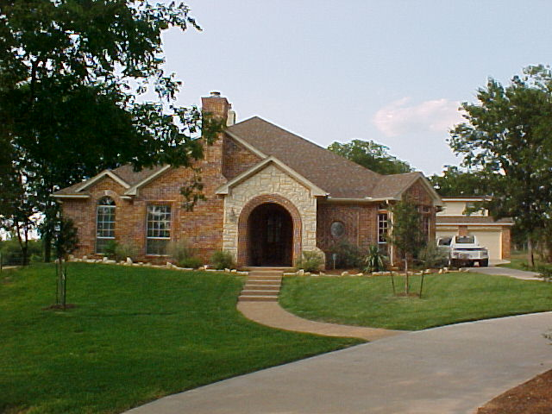

LOCATED AT 398 JUNGE ROAD, THIS PROPERTY IS WELL OFF THE BEATEN PATH, BUT VERY CONVENIENTLY LOCATED JUST SOUTH OF CLEBURNE, TEXAS OFF STATE HIGHWAY # 174. THERE IS ALSO A DEEDED ACCESS EASEMENT ONTO THE PROPERTY FROM HIGHLAND ESTATES BY WAY OF HIGHLAND ROAD. THIS PROPERTY HAS SO MUCH TO OFFER AND SO MUCH POTENTIAL FOR FUTURE DEVELOPMENT.

CALL RICK FOR YOUR PERSONAL SHOWING TODAY.

RICK CUMINS

BROKER/OWNER
CUMINS REALTY
504-C N. RIDGEWAY DRIVE

CLEBURNE, TEXAS, 76033
    - OFFICE
    - CELL
www.cuminsrealty.com
rick@cuminsrealty.com

