PASTURE VIEWS

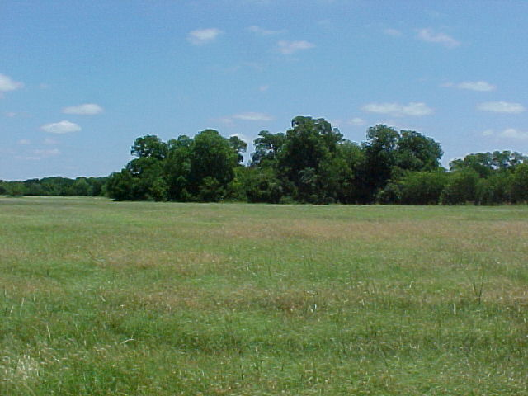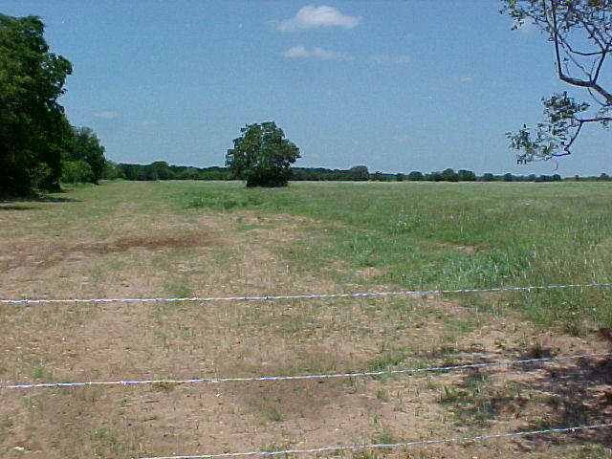

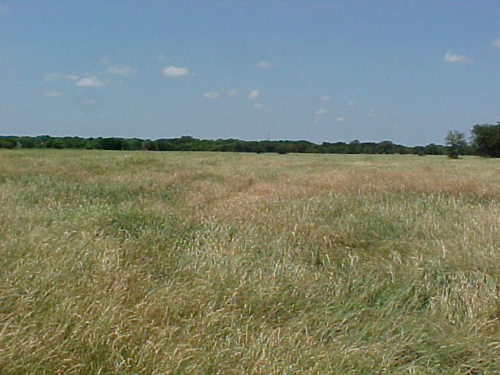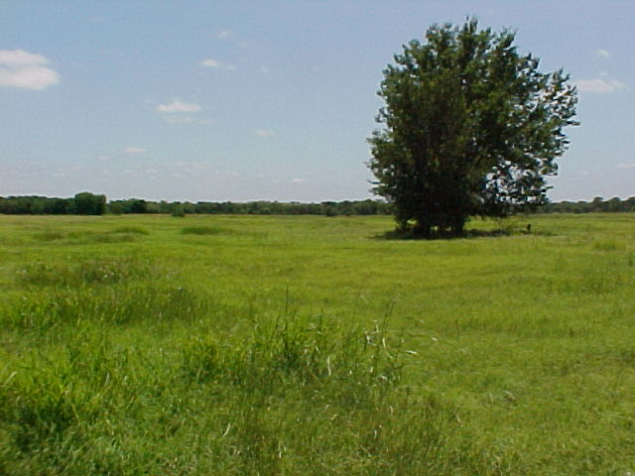

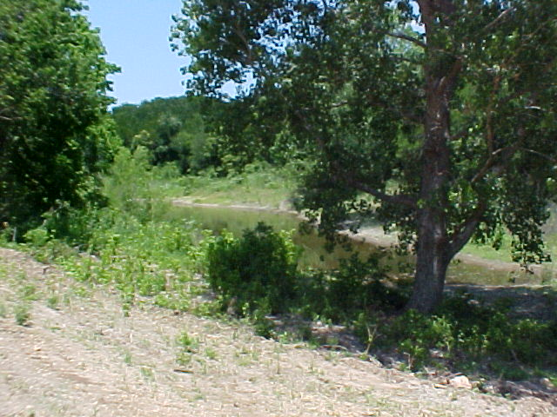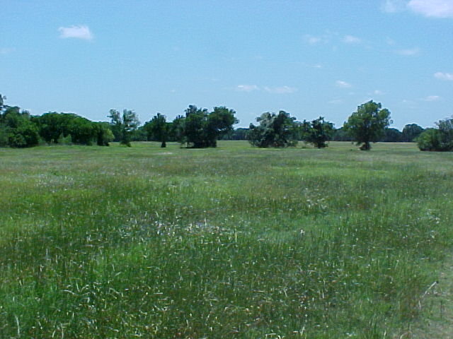

THERE ARE BEAUTIFUL VIEWS ALL AROUND THIS PROPERTY, AND IT ADJOINS THE COUNTRY CLUB GOLF COURSE ALONG THREE SECTIONS OF THE PERIMETER FENCING ON THE WEST SIDE OF THIS PROPERTY. THE COASTAL FIELDS PRODUCE GREAT YIELDS OF HAY EACH YEAR PLUS OFFER A GREAT POTENTIAL FOR DEVELOPMENT OF FUTURE HOMESITES.

