THE HORSE BARN

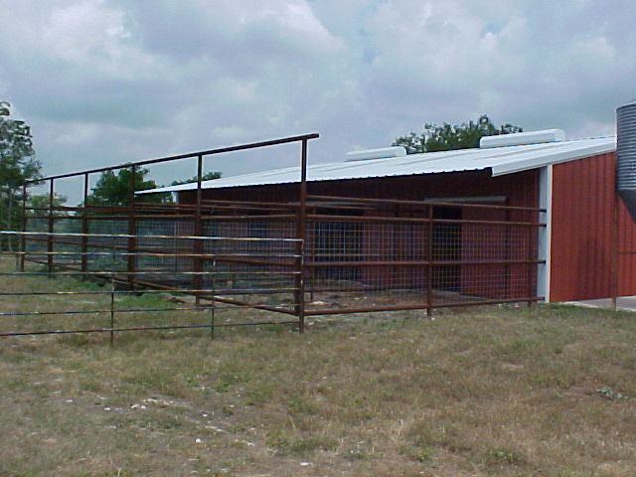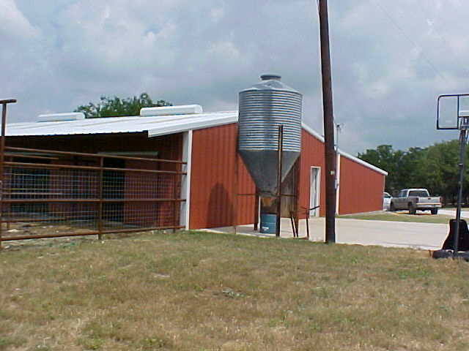

FIVE STALLS WITH RUNS TACK ROOM

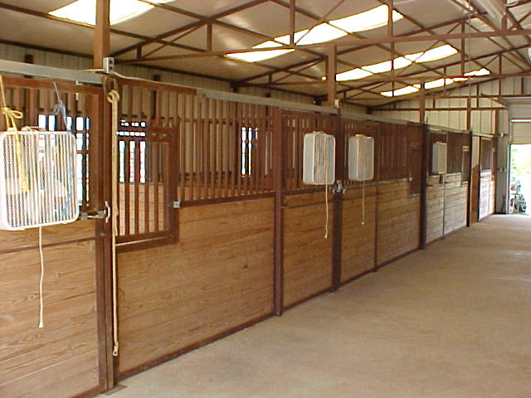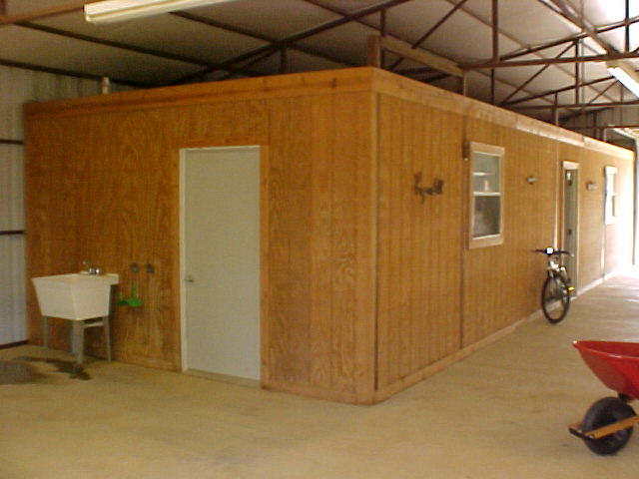

ROOM FOR OFFICE INSIDE TACK EQUIPMENT/HAY STORAGE
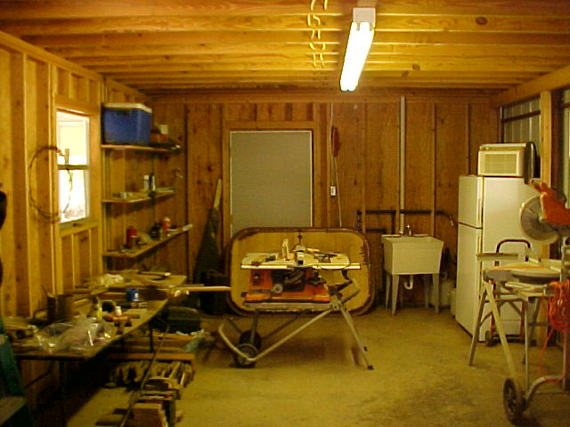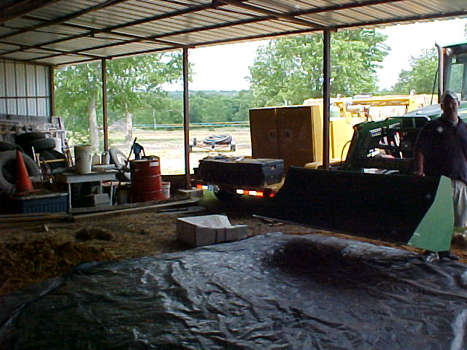

INCLUDES WASH RACK AND A SINK WITH GOOD DRAINAGE AWAY FROM BARN AND ROOM FOR EVERYTHING IN ONE LOCATION WITH 150’ ROUND PEN ACROSS DRIVE FROM BARN AND A LARGE WORKSHOP WITH A SLAB CONCRETE FLOOR AND ELECTRIC AND COVERED RV PARKING

