|  |  |  |  |  |  |  |
| --- | --- | --- | --- | --- | --- | --- |
| *Provided as a courtesy of* Bobbie McLain-Twite  410 Expressway Suite C Missoula, MT 59808  [lnd2sel@montana.com](mailto:lnd2sel@montana.com)  406-544-6153  [http://www.montanarealestate4sale.com](http://www.montanarealestate4sale.com/) | |  | | --- | | https://cdn2.photos.sparkplatform.com/mt/20180723175114918906000000.jpg | | |  |  |  | | --- | --- | --- | | **List Price:**  **Property Type:**  **Property Sub-Type:** | $69,900  Land  Residential | **173 Gong Road**  **Philipsburg, Montana 59858**  **MLS#: 21809414** | | |

|  |
| --- |
| **Property Information** |

|  |
| --- |
| **Public Remarks:** 7.88 acres with 2 cabins located Just outside of the historical town of Philipsburg. Within about 1/2 mile of power. Good access and very realistic to live year around or just use as a recreational get away close to the ski area and public lands to recreate on. Enjoy the shops of downtown Philipsburg and the Brewery in town. Property is wooded and rolling terrain. One cabin is located near the SW corner and the other smaller cabin is located near the NE side. Possible terms with just 20% down, 8.5% interest for up to 20 years. |
| **Days On Market:** 0 |

|  |
| --- |
| **Office Information** |

|  |  |  |  |
| --- | --- | --- | --- |
| **Listing Member:**  **Phone:**  **Address:** | Bobbie McLain-Twite  406-544-6153  410 Expressway Suite C Missoula, MT 59808 | **Listing Office:**  **Phone:** | Twite Realty Corp  406-541-7653 |
| **Email:** | [lnd2sel@montana.com](mailto:lnd2sel@montana.com) |  |  |

|  |
| --- |
| **Contract Data** |

|  |  |  |
| --- | --- | --- |
| **Listing Date:** 07/23/2018  **Status:** Active  **Status Change Date:** 07/23/2018 | **Original List Price:** 69,900  **Selling Office Comm.:** 4%  **Sub. Agency:** No  **REO/Bank Owned:**No | **Commission List Type:** ERS  **Variable Compensation:** No  **Agent Owned:** No  **Owner of Record:** Koehler |

|  |
| --- |
| **General Property Description** |

|  |  |
| --- | --- |
| **Lot Size Estimate:** 5.0-10.0  **Lot Acres:** 7.88  **City Limits:** No | **Corners Marked:** Unknown  **Waterfront:** None |

|  |
| --- |
| **Legal and Taxes** |

|  |  |  |
| --- | --- | --- |
| **Taxes:** 200  **Tax Year:** 2018  **Lot SqFt:** 343,253  **Zoning:** county | **Assessor Number:** 0001451213  **Legal:** S30, T07 N, R13 W, C.O.S. 855, TRACT C | **School District:** District No. 1  **Covenant:** No |

|  |
| --- |
| **Additional Remarks** |

|  |  |  |
| --- | --- | --- |
| **Member Remarks:** Keys coming soon |  | **Hot Sheet Comment:** new |

|  |
| --- |
| **Details** |

|  |  |
| --- | --- |
| **Terms Of Sale:** Cash; Conventional; Owner Financing; Owner Finance % Down: 20  **Documents On File:** Legal Description; Sellers Disclosure; Topography Map  **Utilities:** None  **Mineral Rights:** Unknown  **Trees:** Heavily Wooded  **Terrain:** Rolling  **Views:** Mountains; Trees  **Adjacent Owners:** Private  **Road Surface:** Gravel  **Road Frontage:** Seasonal Access; Unimproved  **Outbuildings:** Cabin(s)  **SID(s):** None | **Possession:** Closing  **Mobiles Permitted:** None  **How To Show:** Vacant |

|  |
| --- |
| **Photos** |

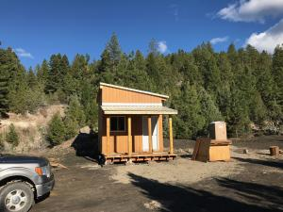  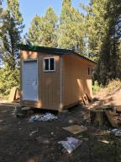  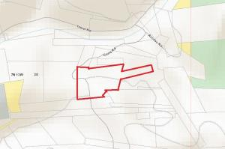  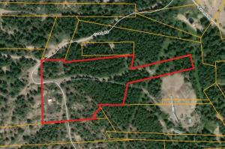  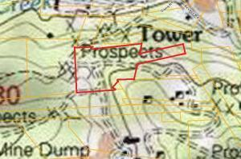  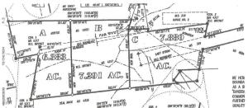

All information is subject to change, is deemed reliable but is not guaranteed, and should be independently verified. The information being provided is for consumers' personal, non-commercial use and may not be used for any other purpose other than to identify prospective properties consumers may be interested in purchasing. © 2018 Montana Regional MLS, LLC and [FBS](http://www.flexmls.com/copyright_notice.html?1). All Rights Reserved. Prepared by Bobbie McLain-Twite on Monday, July 23, 2018 11:59 AM.