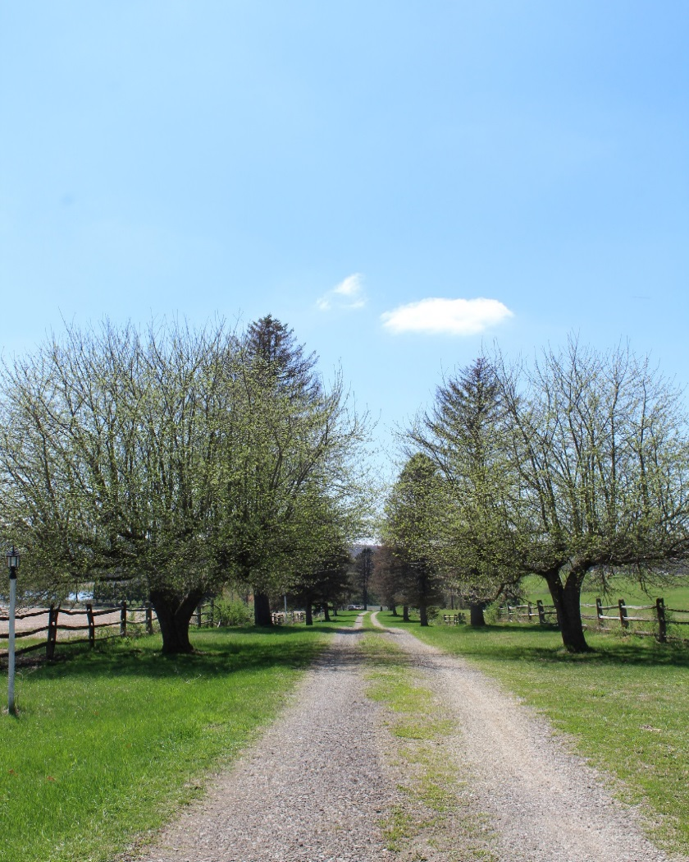

This 132 acre farmett is a rare find, it’s one of a kind property that offers the classic appeal of rolling hills, pastures, woods, ponds, and incredible views of the surrounding countryside. The grounds and structures were used as a private family retreats and entertaining as it boasts an inviting setting and plenty of sleeping and gathering options. The main house crowns the property sited at the top of a hill commanding views from the welcoming front porch. The house has expansive gathering areas and 2 bedrooms and 2 bathrooms. There are 3 more homes including a small A frame set on the quarters; a quaint country Victorian farm house with 2 bedrooms/1 bathroom, and a small cottage on the lower pond. The two barns are vernacular style to be used for storage or converted to highly popular meeting or wedding facilities. And, this is all available just minutes off Rt. 30 and Rt. 219 and destinations in the Laurel Highlands. The popular Quemahoming Recreation Reservoir and State Park is a stone’s throw away with easy access to walking trails, kayaking, fishing, and camping. The area is a 900 acre body of water and new mountain bike trails and other improvements are planned to enhance the park.