**2629 Pine Tree Court Catheys Valley, CA 95306 Keeley** 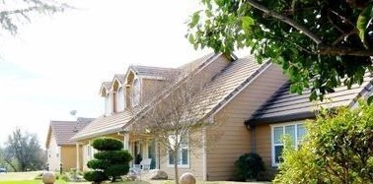

**General:**

**Custom-built 1992; 2800 SF; 4-bedroom; 3 ½ bath home with many other amenities; 360 degree views on 10.5 acres and is located in Whispering Oaks Estates gated community. This large home; 2-car garage,with 2 story barn with finished workshop; horse corrals with pens and pasture for grazing, large garden shed; dog run; porches and historic walls. Hike the property with creeks on two sides and vistas at every turn. Additional storage abounds.**

**Unique overall design: Incorporating the views of the magnificent scenery** by including many large windows, supported by the various angled rooms with vaulted ceilings, designed to maximize the appreciation of scenery, wildlife, meadow, and two seasonal creeks. Also designed to maximize the views of oak, pine, willow trees and beautiful rock outcroppings near and around the home. ***Wildlife is plentiful!***

**Interior maximized for entertainment:** Great Room with open concept kitchen, dining and family room is the home’s hospitality center. Formal Dining area and living room for more entertaining with picture windows to highlight the views. Skylights and 3 dormers add light and let nature shine.

**Large Corral for the love of animals:**

A very large corral with an adjacent pasteur is on property with two animal shelters for horses, alpacas, or cows. Additionally there are enclosures for cats, dogs, and chickens. 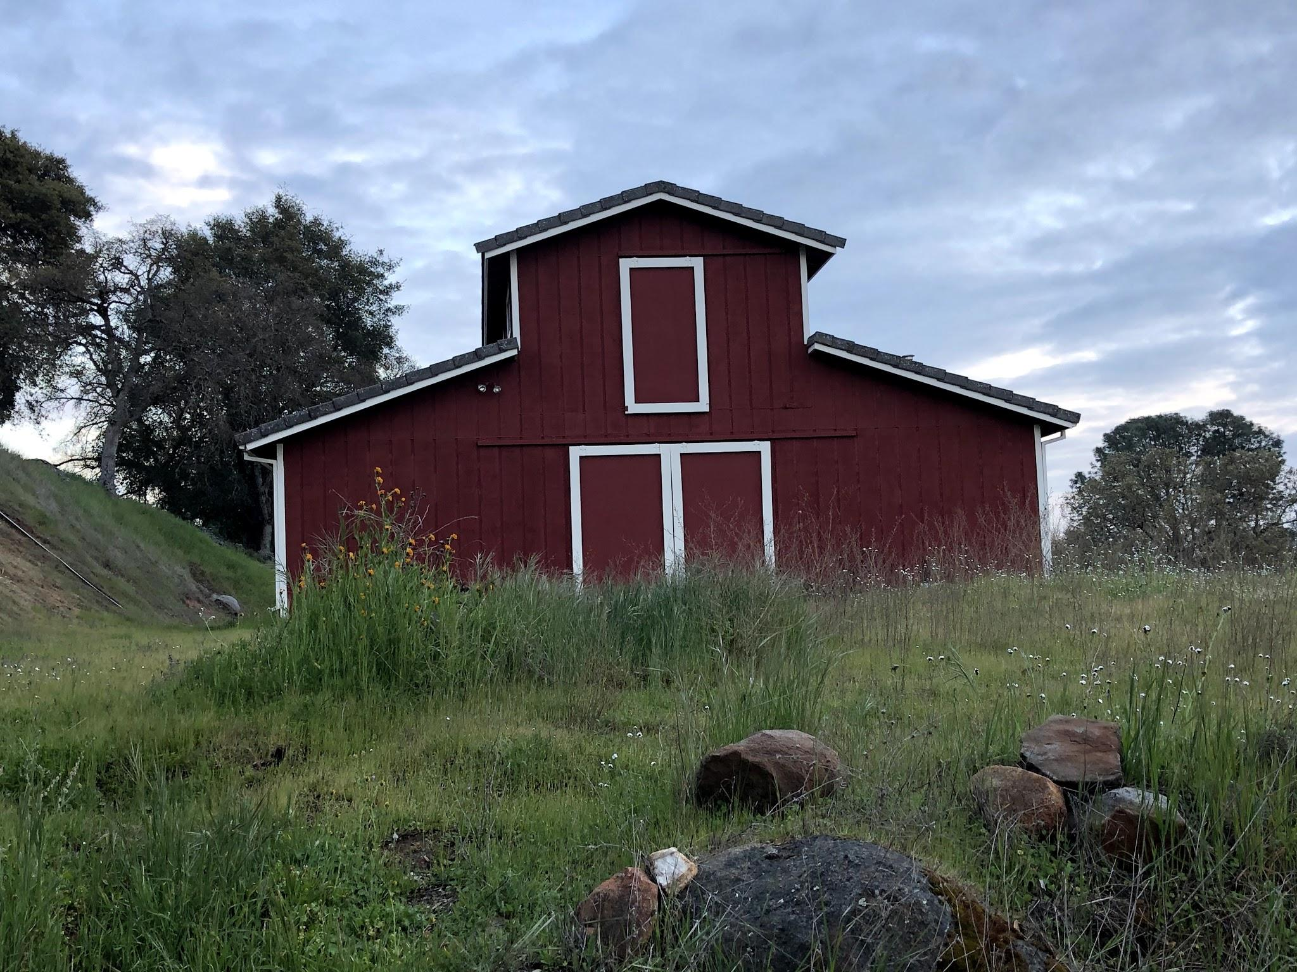

**All American Barn and garden shed:**

The large barn has four distinct rooms. The lower level has storage for cars, quads and machinery on one side, and a finished shop for woodworking, building and tinkering. The upstairs is open for an arts studio. 220 electrical and lots of storage. The additional garden shed is close to the house for convenient seasonal planting projects.

**Master Bedroom**: Large room with vaulted ceiling and fan. En Suite is newly refinished with a soaker tub and glass shower. Walk-in closet is fabulous.

**3 additional Bedroom/Office**: Three more rooms have picture windows for great light, wood floors, built in shelving, and ample closet space. Wonderful for children, guests, and/or an office.

**Kitchen**- Gas stove and electric oven. Built-in microwave. Large peninsula with bar sink. Laundry hookups indoor and in utility room.

**Utility Room**: from the garage is a combination mudroom; 3rd full bath, and area for washer/dryer. Perfect for a quick clean up after gardening.

**Porches and Patio:** Large porches span both sides of the house, The back porch is ideal for sunsets and enjoying night time constellations. It is equipped with an outdoor ceiling fan and awning and is adjacent for easy access to the great room. The front porch is ideal for watching the sunrise and seeing the community of turkeys and deer parade the drive.

**Property consists of 10.5 acres:** Located within the Whispering Oaks Estates (WOE), 28 lot, **gated community**. This home overlooks rock outcroppings, a front meadow with many oak, pine and willow trees, and 2 seasonal creeks...a great view of nature with ***no views in,*** from the neighbors.

***Wildlife abounds***.

**Cooling/heating:**

Heating and air conditioning. House fan for efficient cooling and air exchange. Pellet stove for heating the family room.

**Media and Communications:** Most rooms have "DISH" TV coaxial connections, some with double connections for 2 DVR systems, phone jacks, and the 9 NuTone intercom/radio wall speaker units. Porch, patio, breezeway, shop and RV garage also have TV & phone jacks, and the intercoms including door bells at the front and kitchen doors. Great Room & Family Room are set up with ‘surround sound’ wiring. Extra conduit installed in walls and floor for future wiring needs. Dedicated filtered phone line for DSL internet communication.

**Fire Resistance:** All buildings have cement tile roof and fire safe siding.

**Water system:** 2 wells for the hoe=me and the gardening.

**Propane gas system:** A 500-gallon tank is placed 140 ft. away from the house for fire safety and aesthetics. Propane is used for a new hot water heater and home heater.

**Rain Water Drainage Systems:** Most all of the roof gutters feed into an underground 4-inch piping system to take water away from house pad.

**Septic system:** The septic tank and leach lines are very efficient.

**Outbuildings:** A **Pump House** (actually the water pressure tank house) and cover lid box for well

**Water Well:** The well is 312 ft. deep and the pump sets at 225 ft, water level at 76 ft. Pump and well pipe replaced July 8, 2020. To date, we have never run out of water. The 500-gallon propane tank sits close by, in a fenced enclosure, and is a good distance, 140 ft. from the house, both for safety and aesthetics. The gravel road up the back of the property is used for the propane company and a requirement for fire access from Cal Fire and PG&E.

**Square Footage**

2800 SF House

1800 SF Barn/ 700 SF LOft

144 SF Garden Shed Storage

**The Area:**

**WOE Homeowners Association:** consists of 28 lots of 5 acres or more each, all common area roads are paved, electric coded entrance gates, with personal remotes for the 2 powered entrances, access to the private Bear Creek Lake with small boat launch, picnic, and park area. Association fee of $75/month with active maintenance and ongoing Association meetings. The Association fee is one of the lowest in California with these amenities. Know your neighbors at the weekly social gathering and/or the yearly association general meeting.

**Catheys Valley, (CV):** A rural bedroom community with limited growth, supporting the Central Valley workforce and several of the UC Merced professors and staff. The K-8 Sierra Foothill Charter School (SFCS) is actively supported by both local residents and professors of the UC Merced system. SFCS is focused on science and sustainability and is an integrative, place-based, college preparatory curriculum for all students. School bus pickup/drop-off at our front gate for both the Charter School and Mariposa High School. Merced has both Merced Community College and the University of Merced. The WOE community is 28 miles from Merced and 14.5 miles from Mariposa. The Catheys Valley Postmaster even knows you by name.