

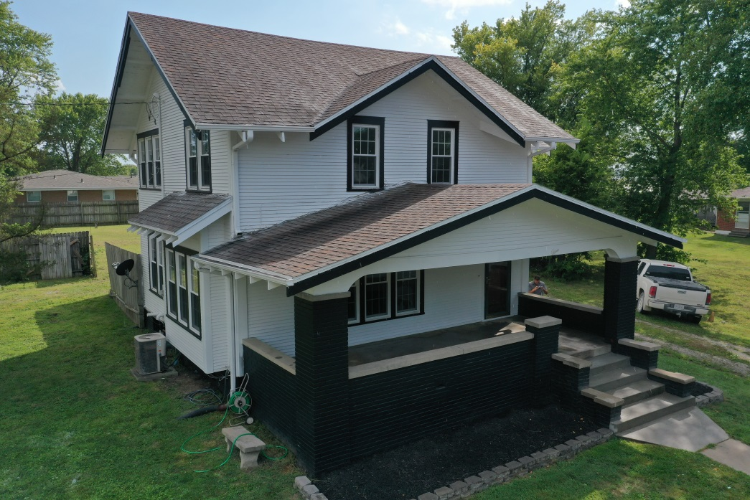

**Listing # 7331**

**Listing Price: $158,900.00**

**Listing Agent:**

**Dylan Heitz**

**816-604-8747**

[**Heitz.ucrealestate@gmail.com**](mailto:Heitz.ucrealestate@gmail.com)

**School District:** South Harrison

**Closest City:**

Kansas City, MO - 90 miles

Des Moines, IA - 95 miles

**Square Footage:** 2169

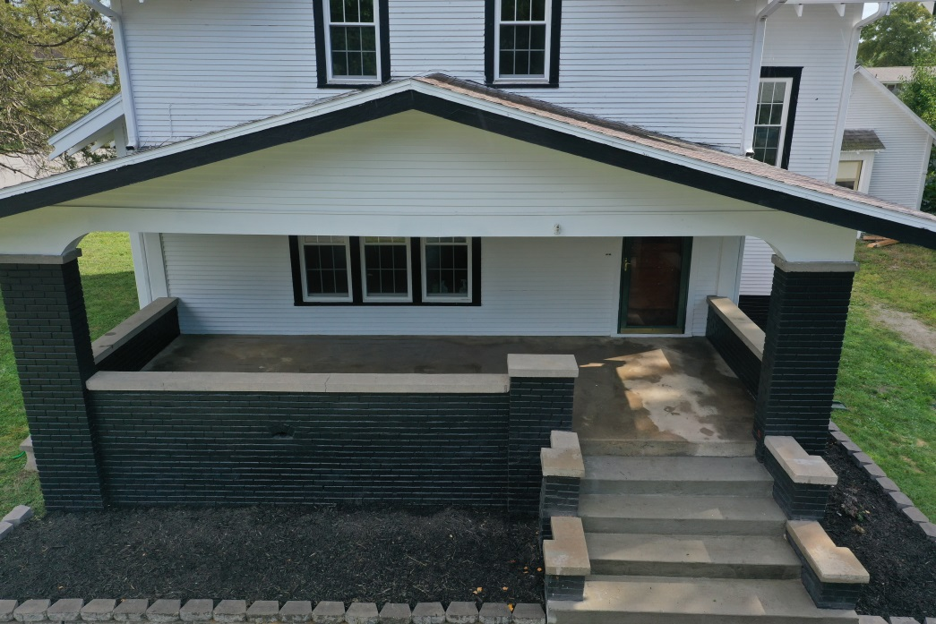

**Acreage:** .4525 acres

**Property Taxes:** $678.59

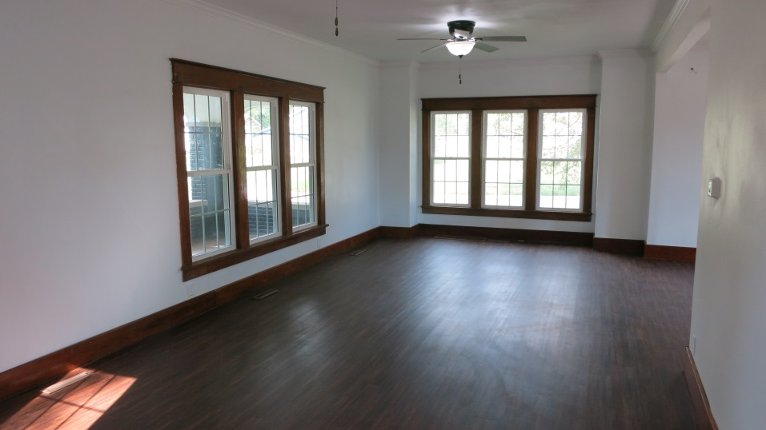**Features of Property:**

* Newer Roof
* New Double Hung Windows
* New Exterior Doors
* Fresh Exterior Paint
* New Interior doors
* New flooring, fixtures, & paint
* Completely remodeled kitchen, laundry & powder room on main level
* Upstairs has undergone updates
* Nice front porch and back deck
* Newer furnace
* 2169 sq. ft. house
* 3 Bedroom 1.5 Bathroom
* Detached 1 Car garage
* 1044 sq. ft. basement

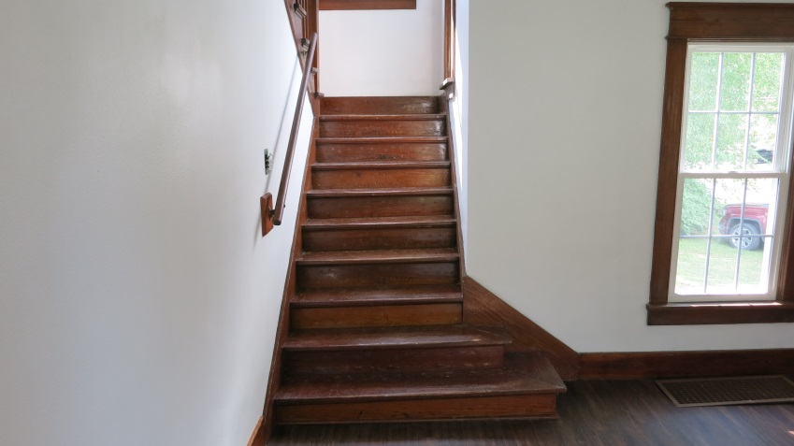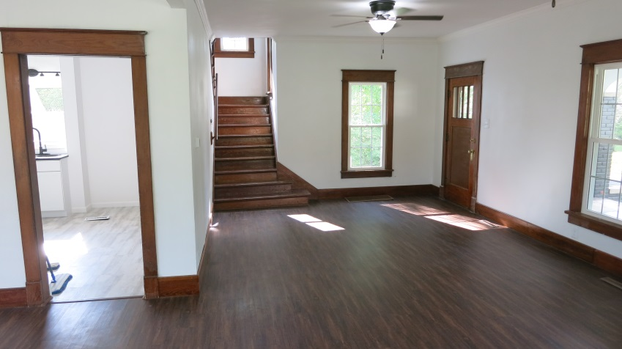

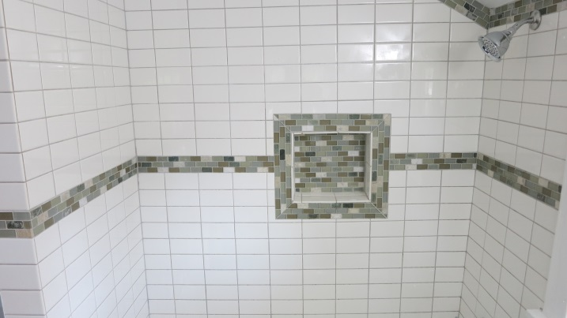 **Main Level Room Sizes:**

* Living Room: 28' x 12.5'
* Dining Room: 12' x 13.5'
* Kitchen: 10' x 11'
* Laundry: 7' x 5'
* Powder Room: 7.5' x 2.5'

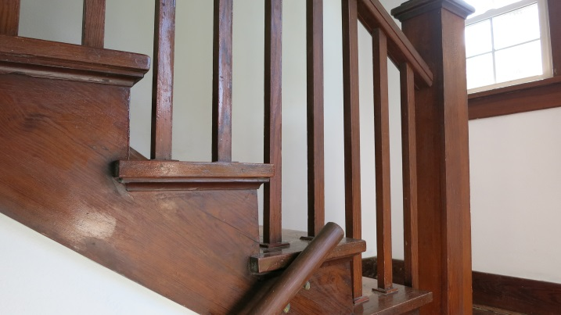**Second Level Room Sizes:**

* Bedroom 1: 12' x 12'
* Bedroom 2: 10' x 12'
* Bedroom 3: 9' x 11'
* Bathroom: 7' x 7'
* Office: 7' x 8'

