

**Listing # 7310**

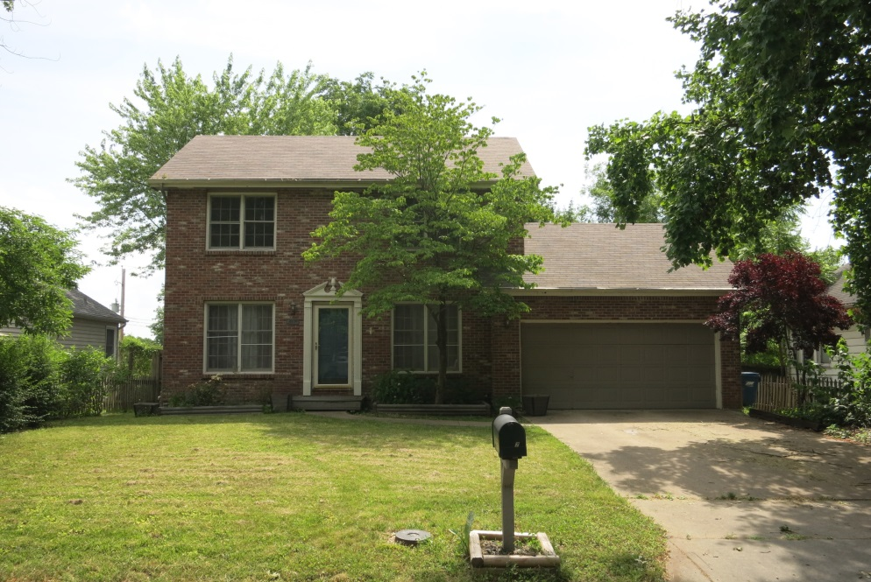**Listing Price: $244,900.00**

**Listing Agent:**

**Dylan Heitz**

**816-604-8747**

[**Heitz.ucrealestate@gmail.com**](mailto:Heitz.ucrealestate@gmail.com)

**School District:** Liberty Schools

**Closest City:**

Kansas City, MO 5 miles

**Square Footage:** 1773

**Acreage:** .21

**Property Taxes:** $ 3,024.37

Looking for a fantastic opportunity to own a property in tremendous area near downtown Liberty? Look no further! This property features tremendous location, just minutes from all the amenities you could need or want!

This 3 bedroom, 2.5 bathroom house offers boundless potential. It boasts a colonial look and vibe. It has an attached 460 sq. ft. 2 car garage and a 546 sq. ft. basement. It has a nice fenced in back yard with a handy shed to store your tools. There is what could be very cool patio just outside the back door. This could be brought back to life and become a fabulous entertaining area.

The inside is in need of some TLC. Flooring, fixtures & paint would take this place a long ways. There are a number of other small things that need replaced/fixed. The house features a large open living room area with good light and electric fireplace. Also on the main level are a formal dining area, office, laundry, and half bath. The house is being sold in "As Is Condition." Call today to set up your showing! $244,900.00

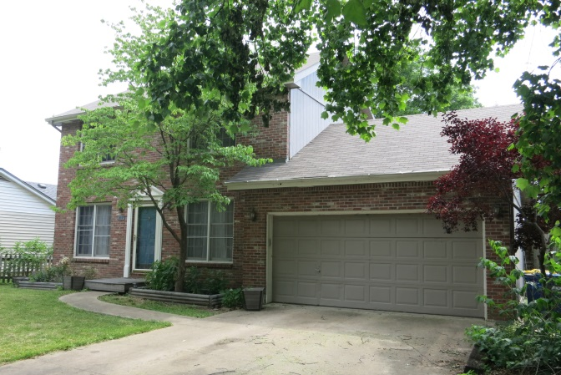**Features of Property:**

* Colonial Style House
* Fenced in backyard
* 460 sq. ft. attached two car garage
* Tremendous location & neighborhood
* 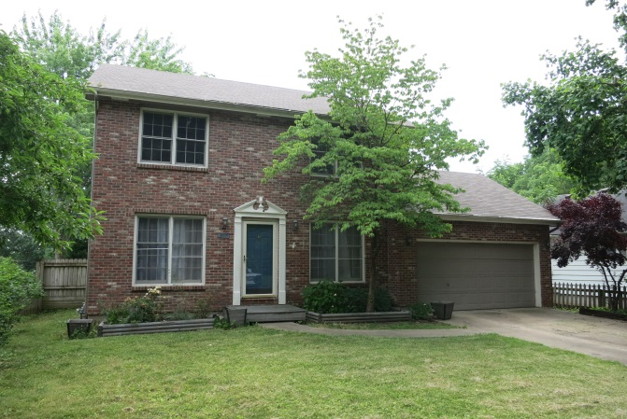Patio in the backyard perfect for entertaining
* 546 sq. ft. basement

**Main Level Room Sizes:**

* Living/Dining: 27.5'x19'
* Kitchen: 13'x8'
* Formal Dining Room: 11'x12'
* 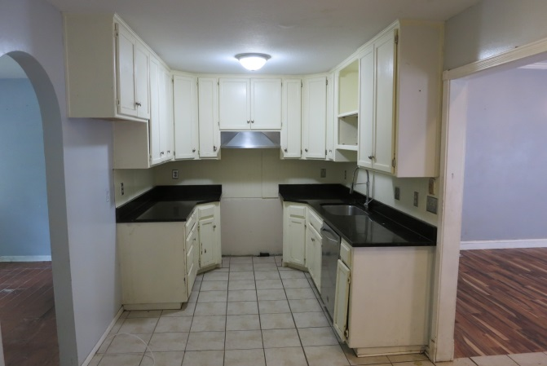Utility Room: 3'x15'
* Bathroom: 3'x5'

**Upper Level Room Sizes:**

* Bedroom #1 (Master): 13'x13'
* Master Bathroom: 8'x4'
* Master Closet: 3'x4'
* 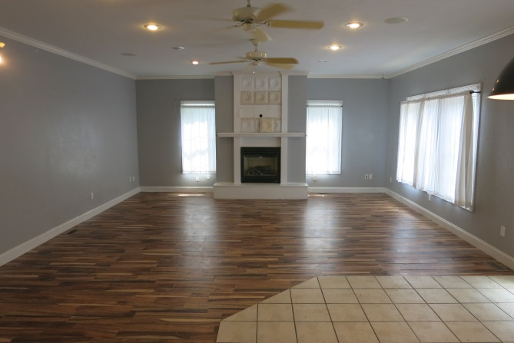Bedroom #2: 9'x11'
* Bedroom #3: 8.5'x10'
* Bathroom: 4.5'x3'