LAND AUCTION
Monday, February 28th, 2022
TIME 5:00 P.M.
LOCATED: On 500 E, just south of 400 S, in Hartford City (Millgrove)

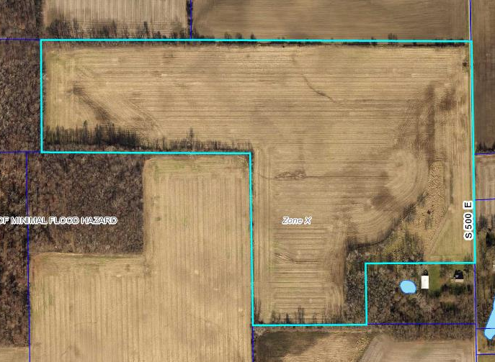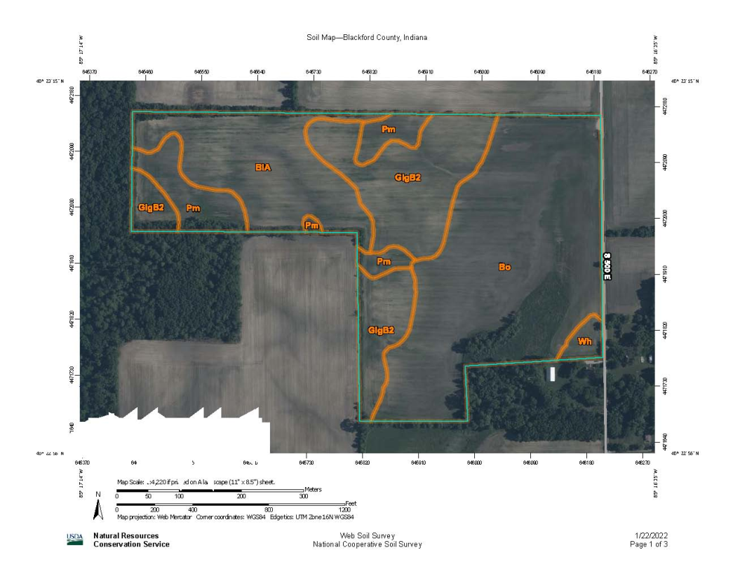
(Map Legend: BlA – Blount-Glynwood, Bo – Bono Silt Clay, GlgB2 – Glynwood Silt Loam, Pm – Pewamo Silty Clay, Wh – Whitaker Silt Loam)

REAL ESTATE

Land consists of 60 acres located in Section 4 of Jackson Township, Blackford County, Indiana. Land is practically all tillable and buyer will have possession at closing. Drive overs are welcome dependent upon the weather. Auction will be held on site. For any questions, contact the auctioneers!

TERMS ON REAL ESTATE: CASH WITH 10% NON-REFUNDABLE DEPOSIT DAY OF AUCTION. BALANCE DUE AT CLOSING. SALE NOT SUBJECT TO BUYER OBTAINING FINANCING. ARRANGE FINANCING IF NEEDED PRIOR TO AUCTION. FINAL SALE SUBJECT TO OWNER CONFIRMATION.

OWNER: Rodney K. Weesner Estate
by Katelyn Weesner (Executor)

STATEMENTS MADE SALE DAY TAKE PRECEDENCE OVER WRITTEN AD

SHAWVER AUCTIONEERING AND REAL ESTATE
AC31800004
AUCTIONEERS

Pete D. Shawver Zane Shawver
Lic# AU19700040 Lic# AU10500168
260-726-5587 260-729-2229
More Photos available at www.auctionzip.com & www.auctionsoft.com

