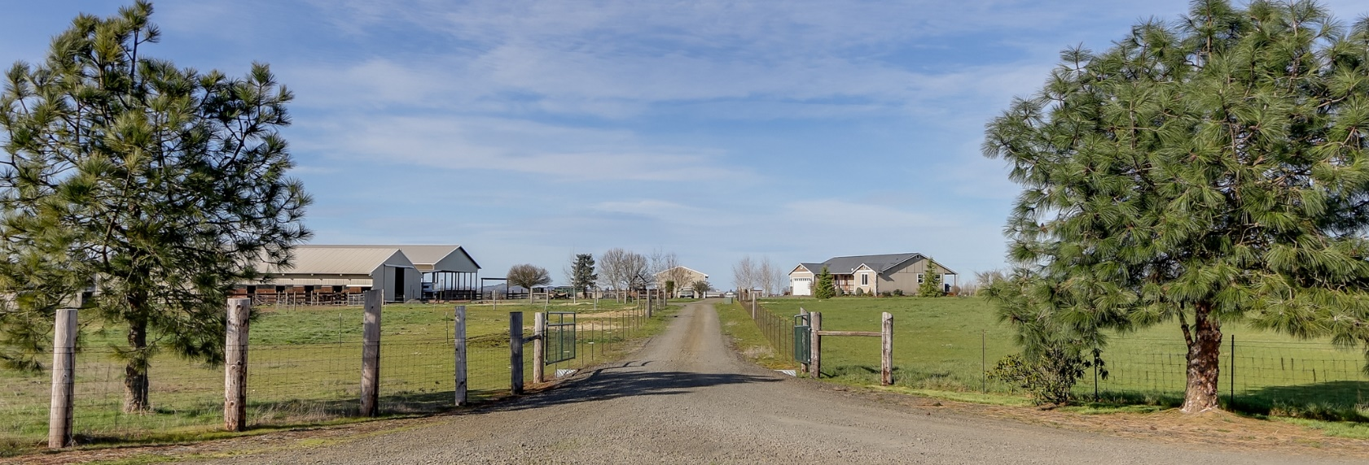27511 Sanborn Ln, Junction City, OR

THAT HORSE PROPERTY YOU'VE BEEN WAITING FOR! Beautifully located and easily accessible for big trailers, this 17.5 use-able acres offers an 80x168 covered arena, 140x250 outdoor arena, 10 stall barn, turnouts, hay pasture, covered trailer parking, and a 30x70 shop w/concrete floor. When you’re done working horses enjoy the hot tub and above ground pool complete with palm trees and a beach! Dog runs, garden area with raised beds, great well flow, & RV dump. NICE home built in 2011 w/3 bedrooms, 2 baths, AND 2 offices. Great room floor plan, vaulted ceilings & incredible sunrise & sunset views. Hi speed internet by XS Media.

Location: Conveniently located just NW of Eugene and just 7 miles from the Eugene Airport. It’s 44 miles to the Oregon Coast at Florence, and the University of Oregon is just 12 miles away in downtown Eugene. Oregon State University at Corvallis is a beautiful 29 mile drive through the country.

Acreage Description: Fenced and cross fenced, this amazing piece of land is level with a gentle slope. Beautiful farmland and sunrise views over the Coburg Hills and spectacular sunsets to the west.

Home: Built in 2011, this 2,000 sf home offers a great room floor plan and 3 bedrooms and 2 full baths. Two additional rooms are perfect for use as office space, home schooling, or work out space. The current workout room has beautifully crafted double sliding barn doors. The home has beautifully rustic hickory cabinets and all wood doors and trim. Granite countertops in the kitchen and many of the rooms have been freshly painted. Wood flooring in the kitchen and entry way, higher grade laminate in the bathrooms and wall to wall carpet in the rest of the home. Large bay windows in eating area offer beautiful sunrise views over the Coburg Hills.

Outdoor Entertainment Area: Outside the living spaces you’ll enjoy a large concrete back patio with beautiful rock steps. The yard is beautifully landscaped and offers great relaxation with a hot tub, fire pit, and 15x30 aboveground pool with a small beach area complete with palm trees. A rock pathway connects to wooden deck off master bedroom with glass sliding door. The backyard has a perimeter above ground PVC manual sprinkler system that covers a portion of the large yard.

Livestock Barn: 60x72 barn with 16ft eves. 6 – 12x24 stalls with 12x24 runs. All have access to larger turnout areas. 4 – 12x12 matted stalls. 3 with small turnouts, one without. 12x12 area with workbenches. 12x12 Heated tack room with concrete floor. 12x24 Loft above tack/workbench area. 24x72 Hay loft above stalls. One 12x24 area is enclosed with door for storage. 3 fields behind barn have covered sheds. Small cattle shed in back field.

Shop: 30x70 with Concrete Floor. 2 - 10ft wide and 14ft high roll up doors. One with a concrete pad. Separate electric panel inside.

Covered Arena: 80x168 covered arena with lights and natural footing. Covered area for trailer parking between barn and covered arena.

Outdoor Arena: Approximately 140x252 outdoor arena. Good footing for any discipline. Small sand area that is no longer used would make great area for a round pen.

Negotiable Equipment: 2 stripping chutes, indoor roping chute, and hay elevator are negotiable outside of the sale.

Soils & Production: Sellers have grown grass hay for years on approximately 11 acres with an average yield of 18 tons. The field was seeded years ago with a pasture mix and has been fertilized most years.

Fencing: Perimeter and cross fenced with field mesh and T-posts.

Utilities: Electricity: EPUD - 541-746-1583
Internet: XS Media – 541-338-9000
Garbage: Ecosystems 541-935-2655

Domestic Water: We have a well log on file #31810 that we believe is associated with this property. The well referenced in this paperwork was drilled in 1999 and estimated flow at time of installation was 47gpm.

There are no irrigation rights for the property but there is a main line through the center of the pasture.

Septic: Standard septic system. Tank is located in the playground area and the drain field heads north under the dog pens.

Ranch Roads & Driveways: Sanborn Rd is a short gravel drive owned by subject property. The neighbors to the west have an access easement and there is a joint maintenance agreement in place.

Wildlife & Hunting: Sellers have enjoyed viewing elk, deer, hawks, bald eagles, and owls.

Horsepower Real Estate represents the Seller of this property. This information is derived from sources deemed reliable but not guaranteed by the brokerage or broker and should be verified by potential Buyers. Buyers are urged to seek independent verification, thorough professional inspections and personal review of the condition of the property and the information contained herein.

