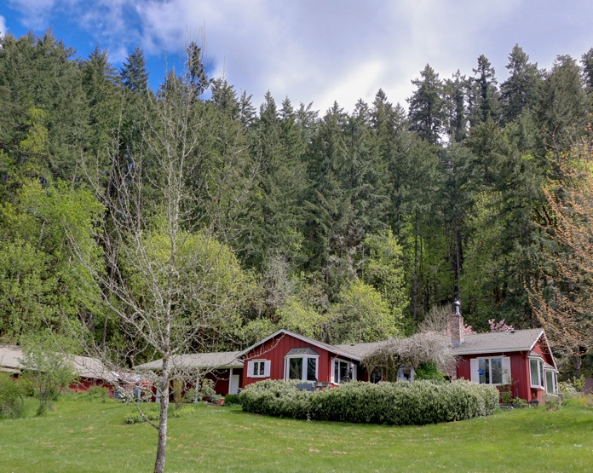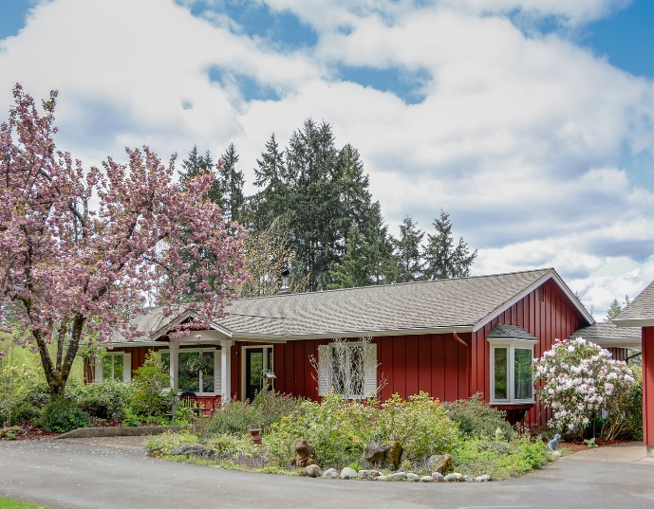

81627 Territorial Hwy Eugene, OR. 97405

Location:
* Minutes to local Wineries
* 21 miles to the Eugene Airport (30 minutes)
* 19 miles to the University of Oregon (30 minutes)
* 62 miles to Florence, Oregon (1 hour 12 minutes)

Home: On the market for the first time in 46 years! This property has been lovingly maintained with care. The house itself was remodeled in 2000 and additional improvements have been made more recently (see below) Nice open concept and good separation of space for formal or informal entertaining. Special features include a bread making station on the kitchen island and 5 bay windows throughout the house. Gated entry with electric opener leads to a paved area in front of the house and garage.
Recent Improvements:
- Barn & garage roofs 2019
- Pressure tank 2021
- Luxury vinyl plank flooring 2017
- Water heater 2019
- Woodstove insert and chimney liner 2021

Outdoor Entertainment Area: There are multiple options for enjoying the outdoors year-round. The back deck has a beautiful wisteria and looks out over the pastures below. The covered walkway behind the garage offers another spot to relax and enjoy the views. The front entry is also covered and a wonderful spot for your morning coffee.

Garage: The 2-car garage is attached by a breeze way with access to the back entry of the home. The garage is wired for a type 2 electric car charger and has additional finished spaces currently used as a craft room and a workshop.

Livestock Barn and Outbuildings: A 40x32 barn with 4 stalls, ally way, tack and feed storage area is currently used for storage and is home to 2 barn cats who would like to stay if a Buyer would like to keep them. There is also a 12x10 composting shed built to USDA specifications for manure management and lawn and garden waste composting. Another 30x12 shed can be used for a multitude of purposes from storing wood to equipment. An 18x12 carport that was used to park a tractor. Lastly, an 18x8 shed that was built to house a canoe and additional firewood.

Farm Equipment: Available outside of escrow the Seller has a hydraulic wood splitter, DR brush mower, DR grader, gas powered pressure washer and a rototiller.

Utility Providers:
Electricity – Lane Electric 541-484-1151
Internet – The Sellers currently use ATT Cellular however Douglas Fast Net (DFN) is moving into the area and they have been out and marked the driveway with flags for the proposed install-Please contact them directly for details. 541-673-4242
Starlink may be another option. www.starlink.com
Satellite-
Garbage service available / Sellers currently haul their own garbage to the dump.

Domestic Water: Well log #021119 on file. Water quality test done 4/21/2022 with no issues.

Septic: Standard septic. System was pumped 4/18/2022

Acreage Description: A combination of 4 lots totaling 48.56 +/- acres. The Sellers had horses previously and there are woven wire cross fenced pastures. They also have hayed a portion of the property in the past yielding 5-6 tons. There is a designated garden area with deer height fencing. The property is beautifully landscaped and has many mature rhododendrons.

Timber: Approximately 40.5 +/- acres have merchantable timber. A Timber Cruise was completed in May 2022. Please ask Listing Brokers for the Timber Packet for more information.

Wildlife: The property is currently under a wildlife habitat conservation management plan which puts it in a specific tax deferral program. A copy of the plan is on file. Over the years the Sellers have seen deer, elk, bear, fox, coyote, bobcat and once they saw a ______weasel. There are also lots of birds for bird watching.

What the Sellers love the most and will miss is the tranquility of the property, the wildlife that live there and the support of the Lorane community where neighbors still help neighbors!

Horsepower Real Estate represents the Seller of this property. This information is derived from sources deemed reliable but not guaranteed by the brokerage or broker and should be verified by potential Buyers. Buyers are urged to seek independent verification, thorough professional inspections and personal review of the condition of the property and the information contained herein.

