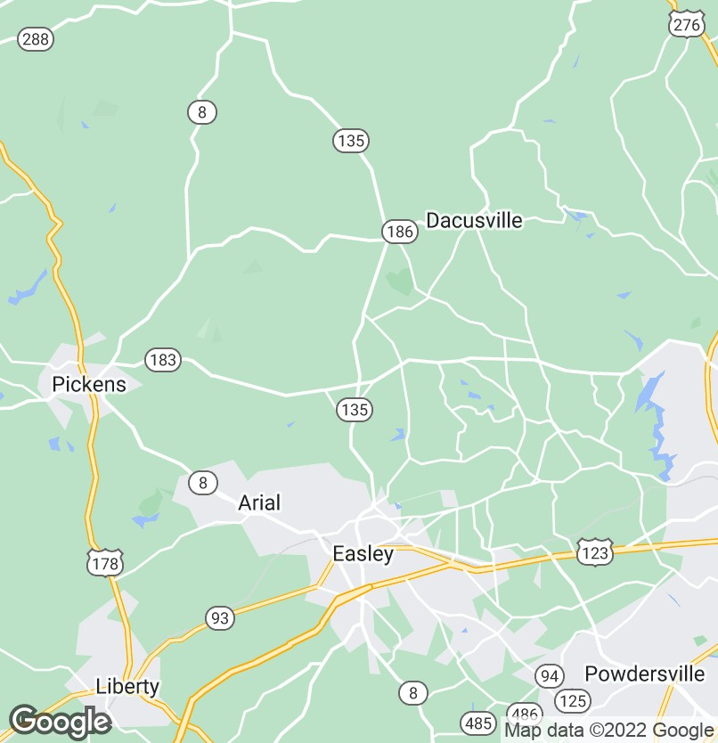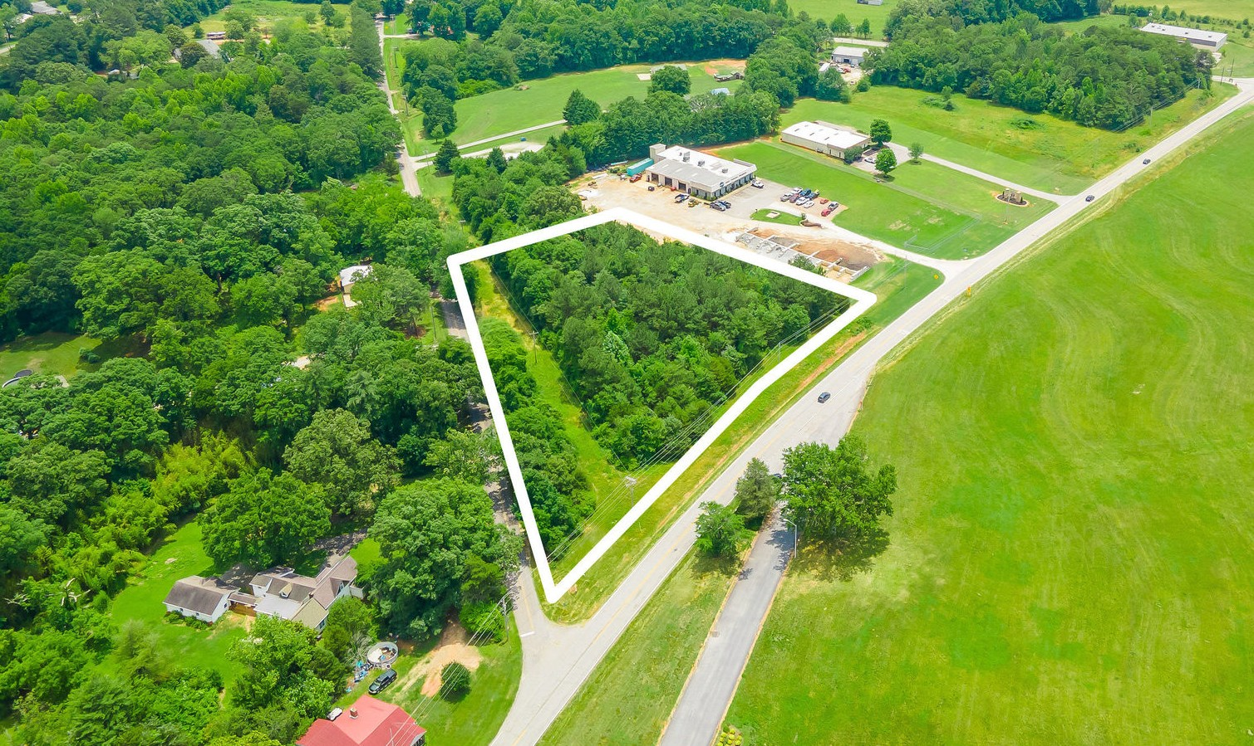
Land | ±2.75 Acres
Pickens County Tax Map # 5111-00-94-5600

±2.75 Acres corner lot with Commercial Opportunity on Dacusville Highway
Road Frontage:
±500 Linear Feet on Dacusville Highway
±500 Linear Feet on Yeoman Drive

Level Topography with Excellent Visibility

Pickens County 01 School District: Dacusville Elementary School Dacusville Middle School
Pickens High School

Utilities: Power, Water & Gas Available 2019 SCDOT Traffic Count – 4,000VPD
*Acreage and Utilities to be verified by Buyer or
Buyer's Agent
Anderson Drake
+1 864 546 0342
adrake@naiearlefurman.com
No Warranty Or Representation, Express Or Implied, Is Made As To
The Accuracy Of The Information Contained Herein, And The Same Is Submitted Subject To Errors, Omissions, Change Of Price, Rental Or Other Conditions, Prior Sale, Lease Or Financing, Or Withdrawal Without Notice, And Of Any Special Listing Conditions Imposed By Our Principals No Warranties Or Rep- resentations Are Made As To The Condition Of The Property Or Any Hazards Contained Therein Are Any To Be Implied.
101 E Washington St
Greenville, SC 29601 naiearlefurman.com

FOR SALE
Dacusville Hwy Commercial Development Opportunity

$99,950

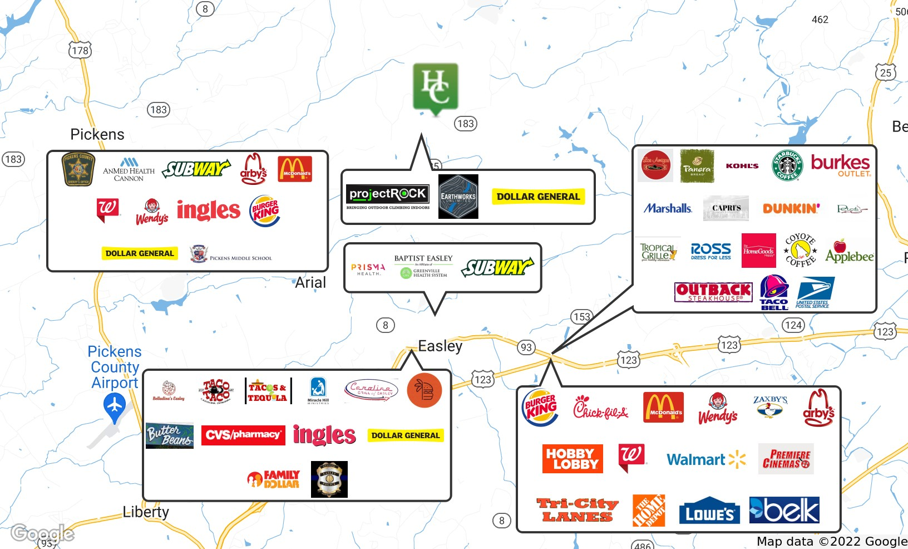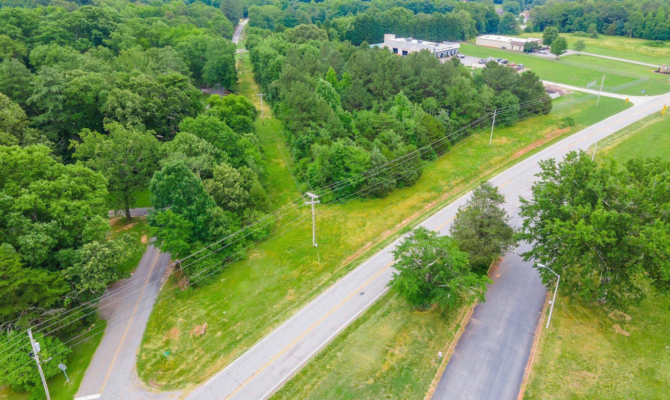FOR SALE
Yeoman Drive & Dacusville Hwy Easley, SC 29640

RETAILER MAP

Dacusville Highway Commercial Development Opportunity

No Warranty Or Representation, Express Or Implied, Is Made As To The Accuracy Of The Information Contained Herein, And The Same Is Submitted Subject To Errors, Omissions, Change Of Price, Rental Or Other Conditions, Prior Sale, Lease Or Financing, Or Withdrawal Without Notice, And Of Any Special Listing Conditions Imposed By Our Principals No Warranties Or Rep- resentations Are Made As To The Condition Of The Property Or Any Hazards Contained Therein Are Any To Be Implied.

Dacusville Hwy Commercial Development Opportunity
Dacusville Hwy & Yeoman Drive | Pickens County

Property Description
This ±2.75-acre Investment located along Dacusville Highway in Easley, SC. This corner lot is potentially a superb commercial location with water, power and gas available. With double road frontage, this site is easily accessible and conveniently situated less than ±5 miles from the center of downtown Easley, ±10 miles from Calhoun Memorial Highway/123, Easley’s main retail corridor, ±13 miles from Powdersville, another growing grocery, retail, and restaurant artery, and less than ±14 miles to Interstate 85 and the Southern Connector. Surrounding commercial and retail sites include Dollar General, Earthworks Unlimited and ProjectROCK with a SCDOT traf c count of 4,000.
DEMOGRAPHICS
Stats Population Avg. HH Income
2 Miles | 3,294 | $65,374
6 Miles | 44,927 | $66,283
10 Miles | 139,228 | $65,861

± 7 Minutes from Easley
± 9 Minutes from Pickens
±12 Minutes from Berea
±16 Minutes from Powdersville
±18 Minutes from Travelers Rest
±21 Minutes from Greenville

For more information
Anderson Drake
O: 864 546 0342
adrake@naiearlefurman.com

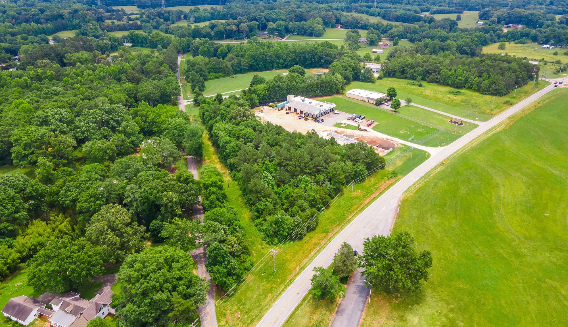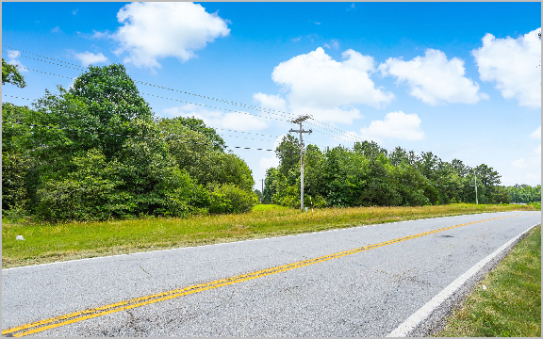

Huff Creek Properties | 101 E Washington St, Suite 400, Greenville, SC 29601 | 864 232 9040
huffcreekproperties.com

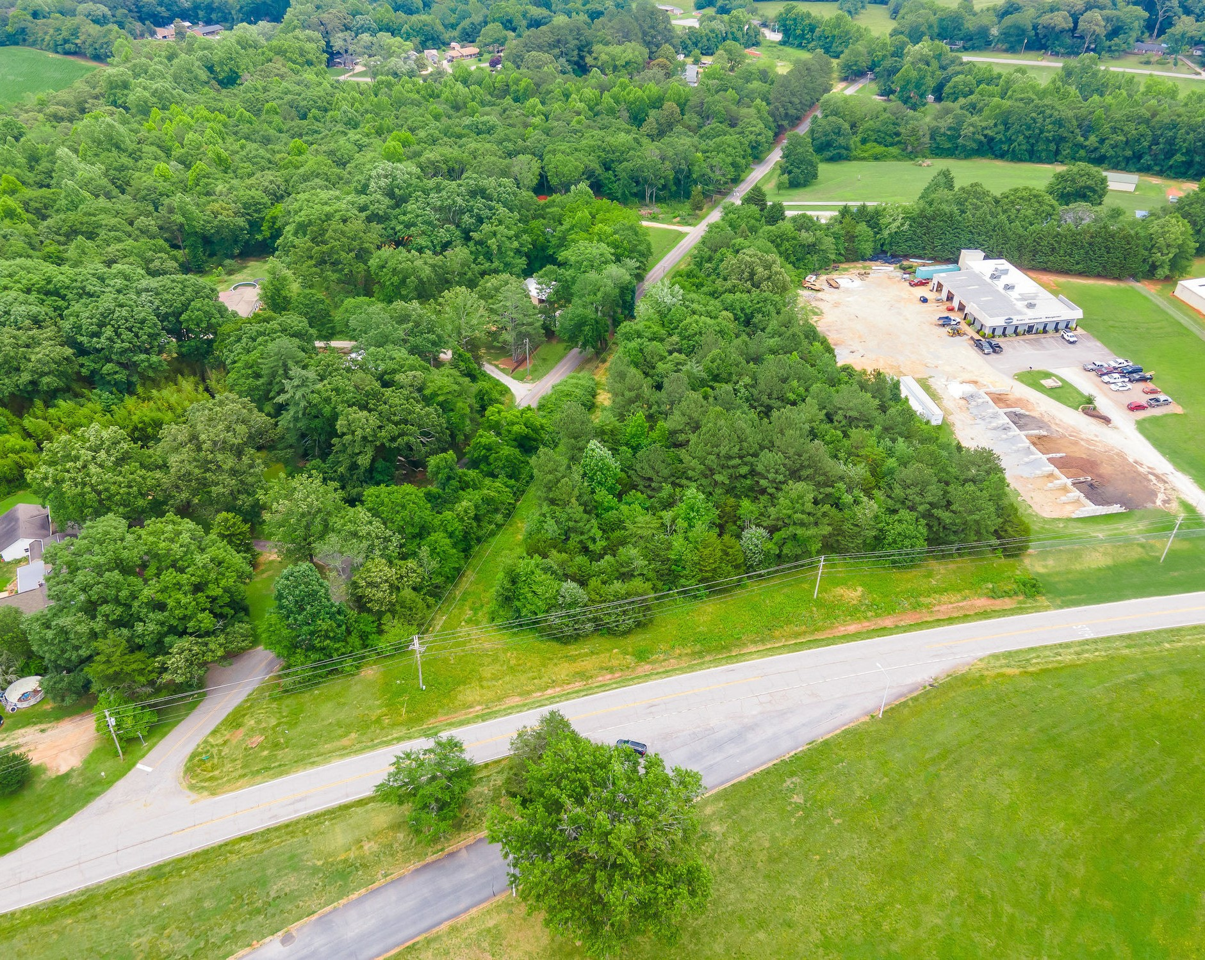

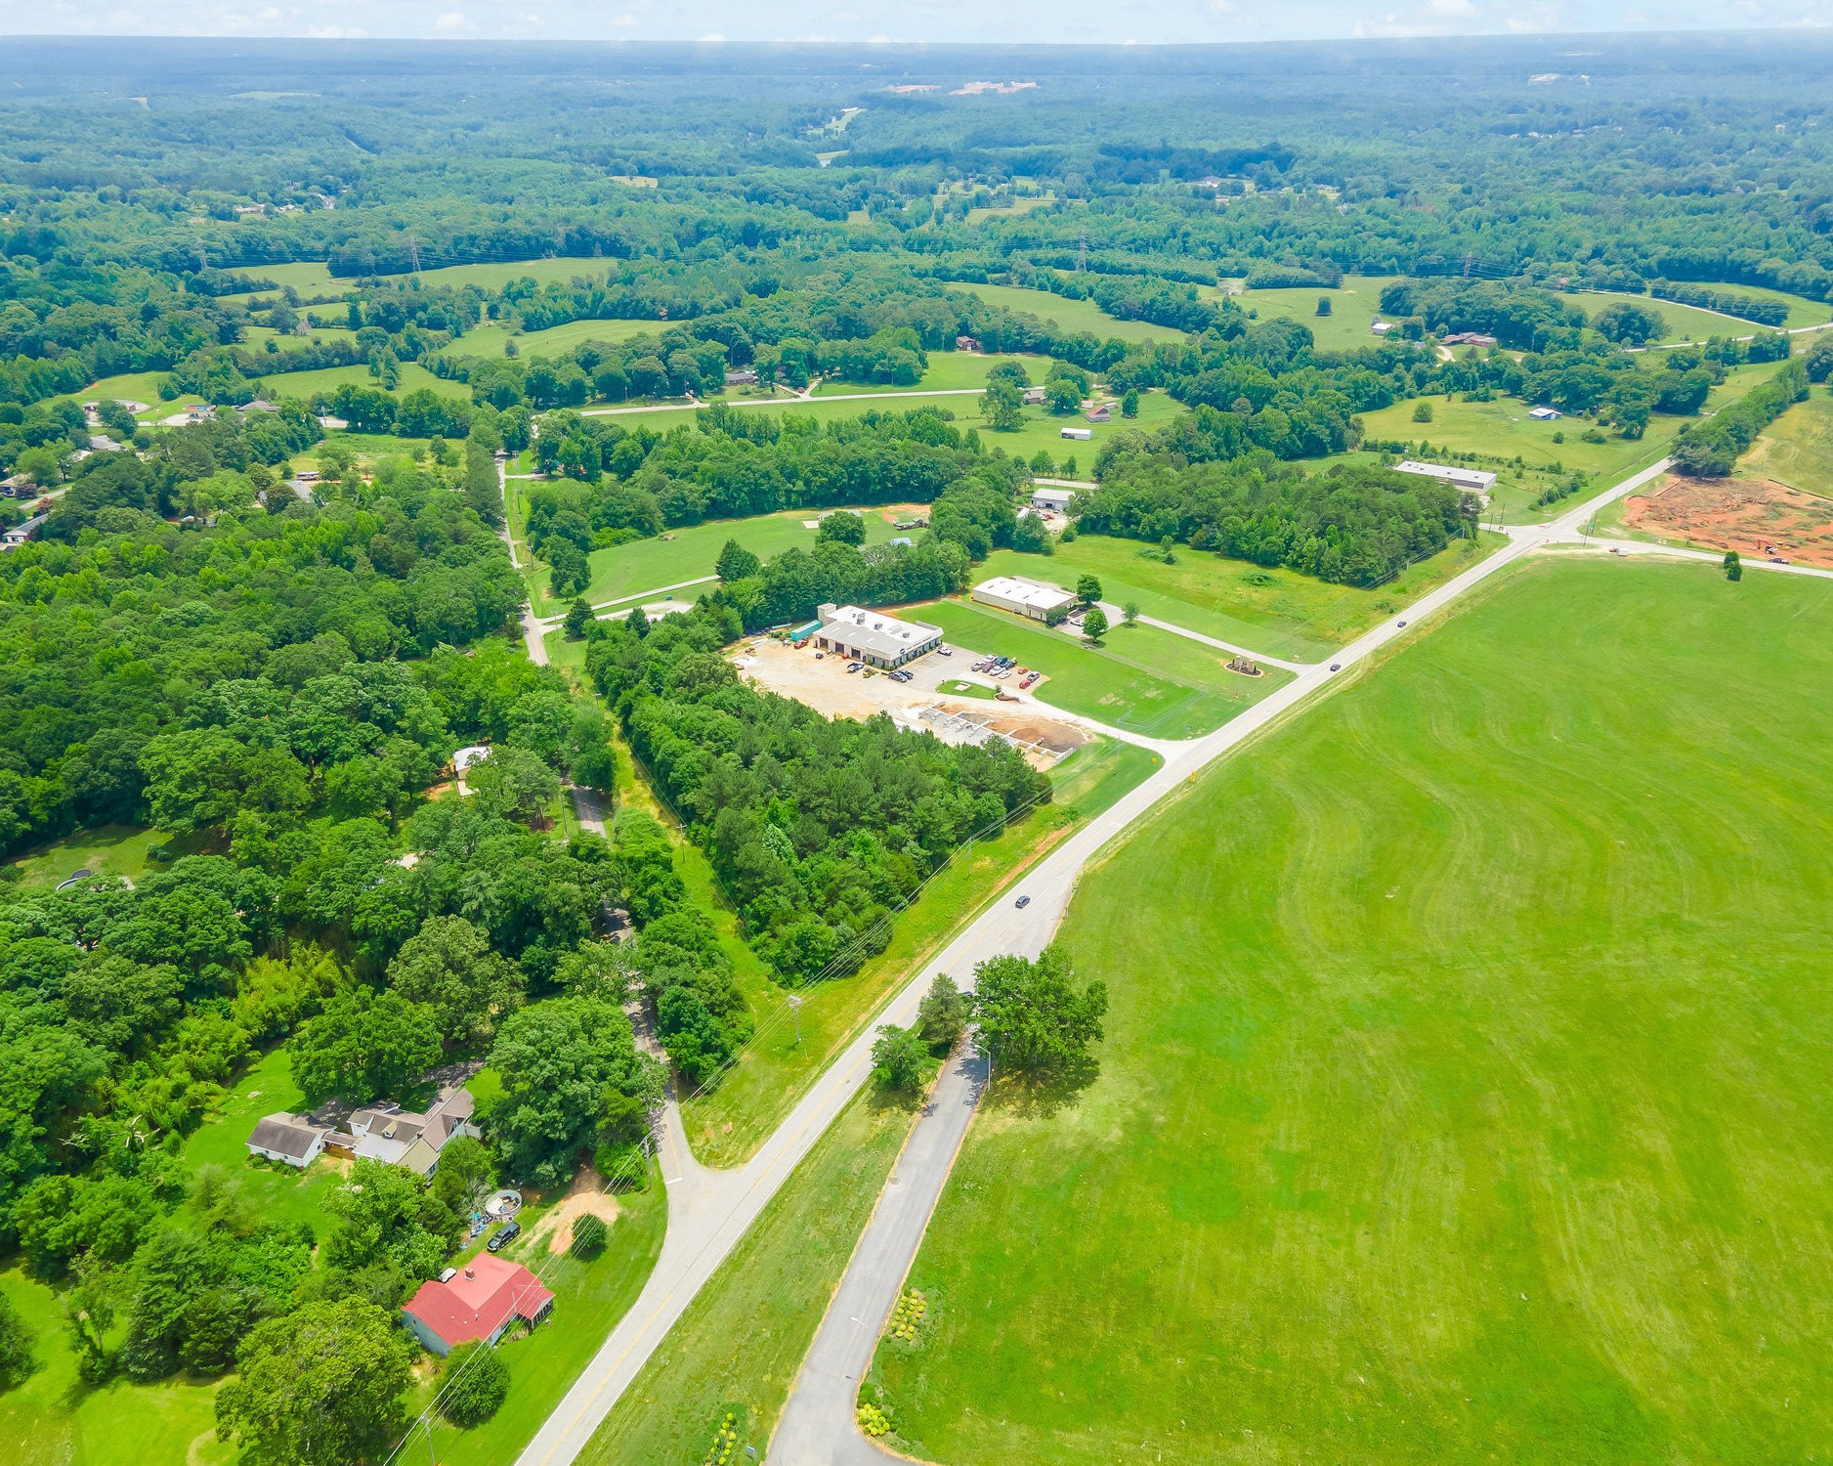
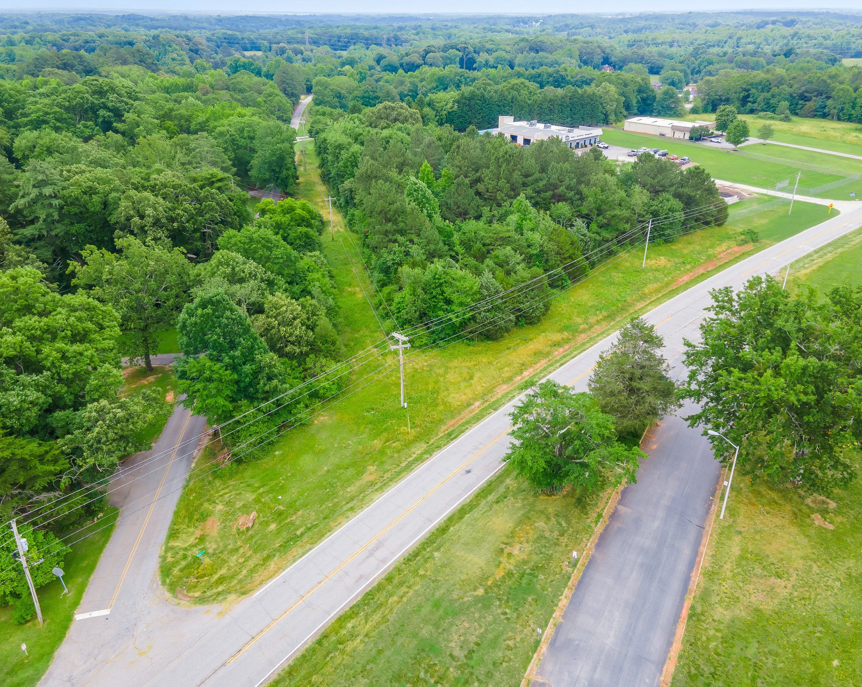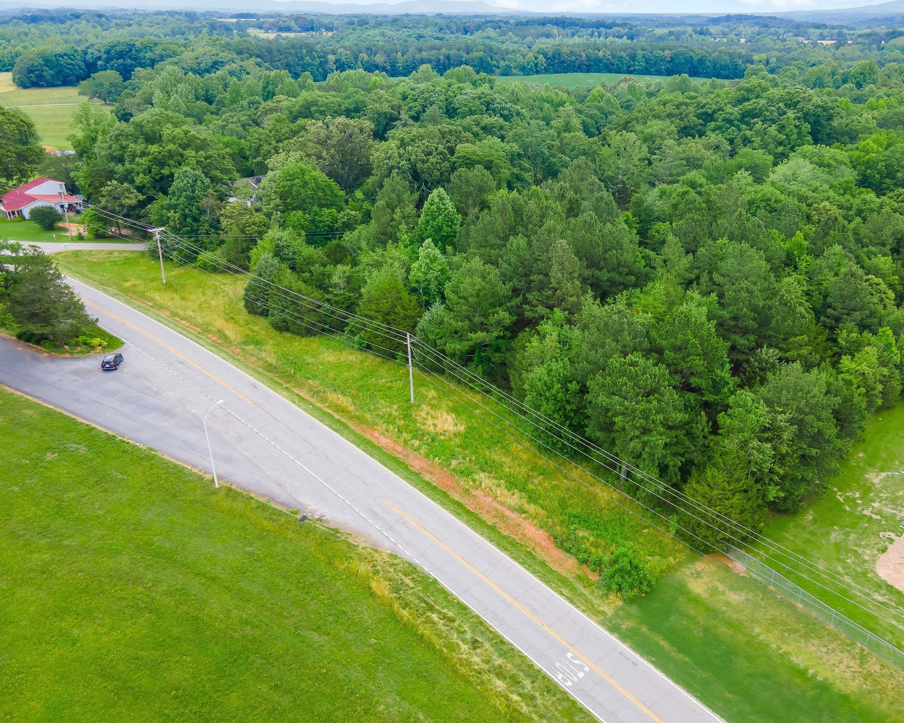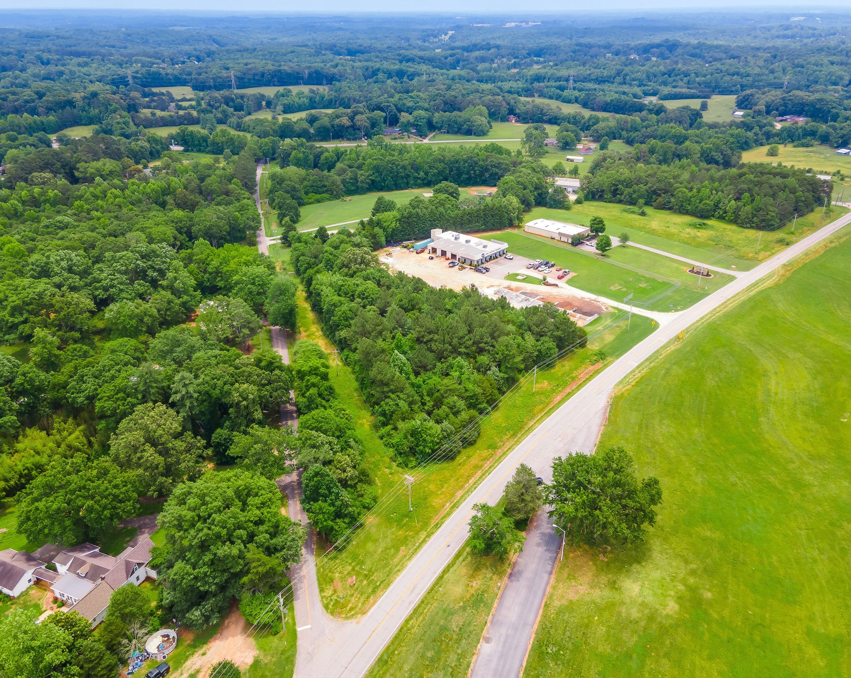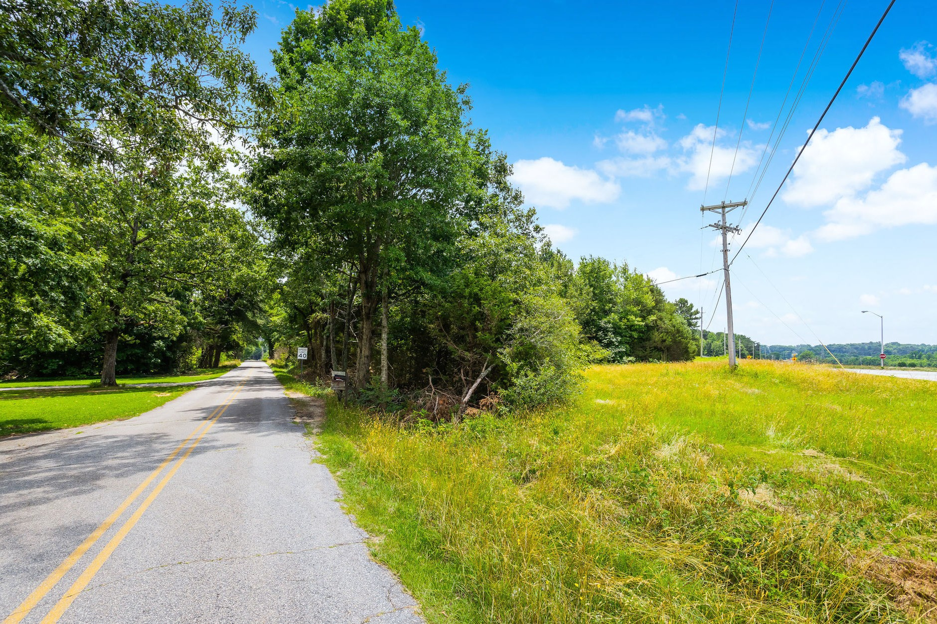Anderson Drake
FOR SALE
Yeoman Drive & Dacusville Hwy | Pickens County
+1 864 546 0342
adrake@naiearlefurman.com

No Warranty Or Representation, Express Or Implied, Is Made As To The Accuracy Of The Information Contained Herein, And The Same Is Submitted Subject To Errors, Omissions, Change Of Price, Rental Or Other Conditions, Prior Sale, Lease Or Financing, Or Withdrawal Without Notice, And Of Any Special Listing Conditions Imposed By Our Principals No Warranties Or Rep- resentations Are Made As To The Condition Of The Property Or Any Hazards Contained Therein Are Any To Be Implied.
101 E Washington St Greenville, SC 29601 naiearlefurman.com

