

Schlegel Farms
2241 Schlegel Rd
Olney, Texas

Schlegel Farms will attract both the avid wildlife enthusiast and cattle producer. The contiguous parcels provide the perfect alternation of cultivation and mesquite cover with an abundance of natural water supporting both wildlife and cattle operations.

Location: 10 Miles West/Southwest of Olney, TX

Directions: Dropped Pin at Homesite Dropped Pin at Self Rd Entrance

From Wichita Falls, TX 58 min (55 miles)

Take TX-79 S and State Hwy 79 N to Self Rd in Young County. 51 min (51.1 mi)
Continue on Self Rd. Drive to Schlegel Rd. 6 min (2.5 mi)

From Fort Worth, TX 2 hr 5 min (109 miles)

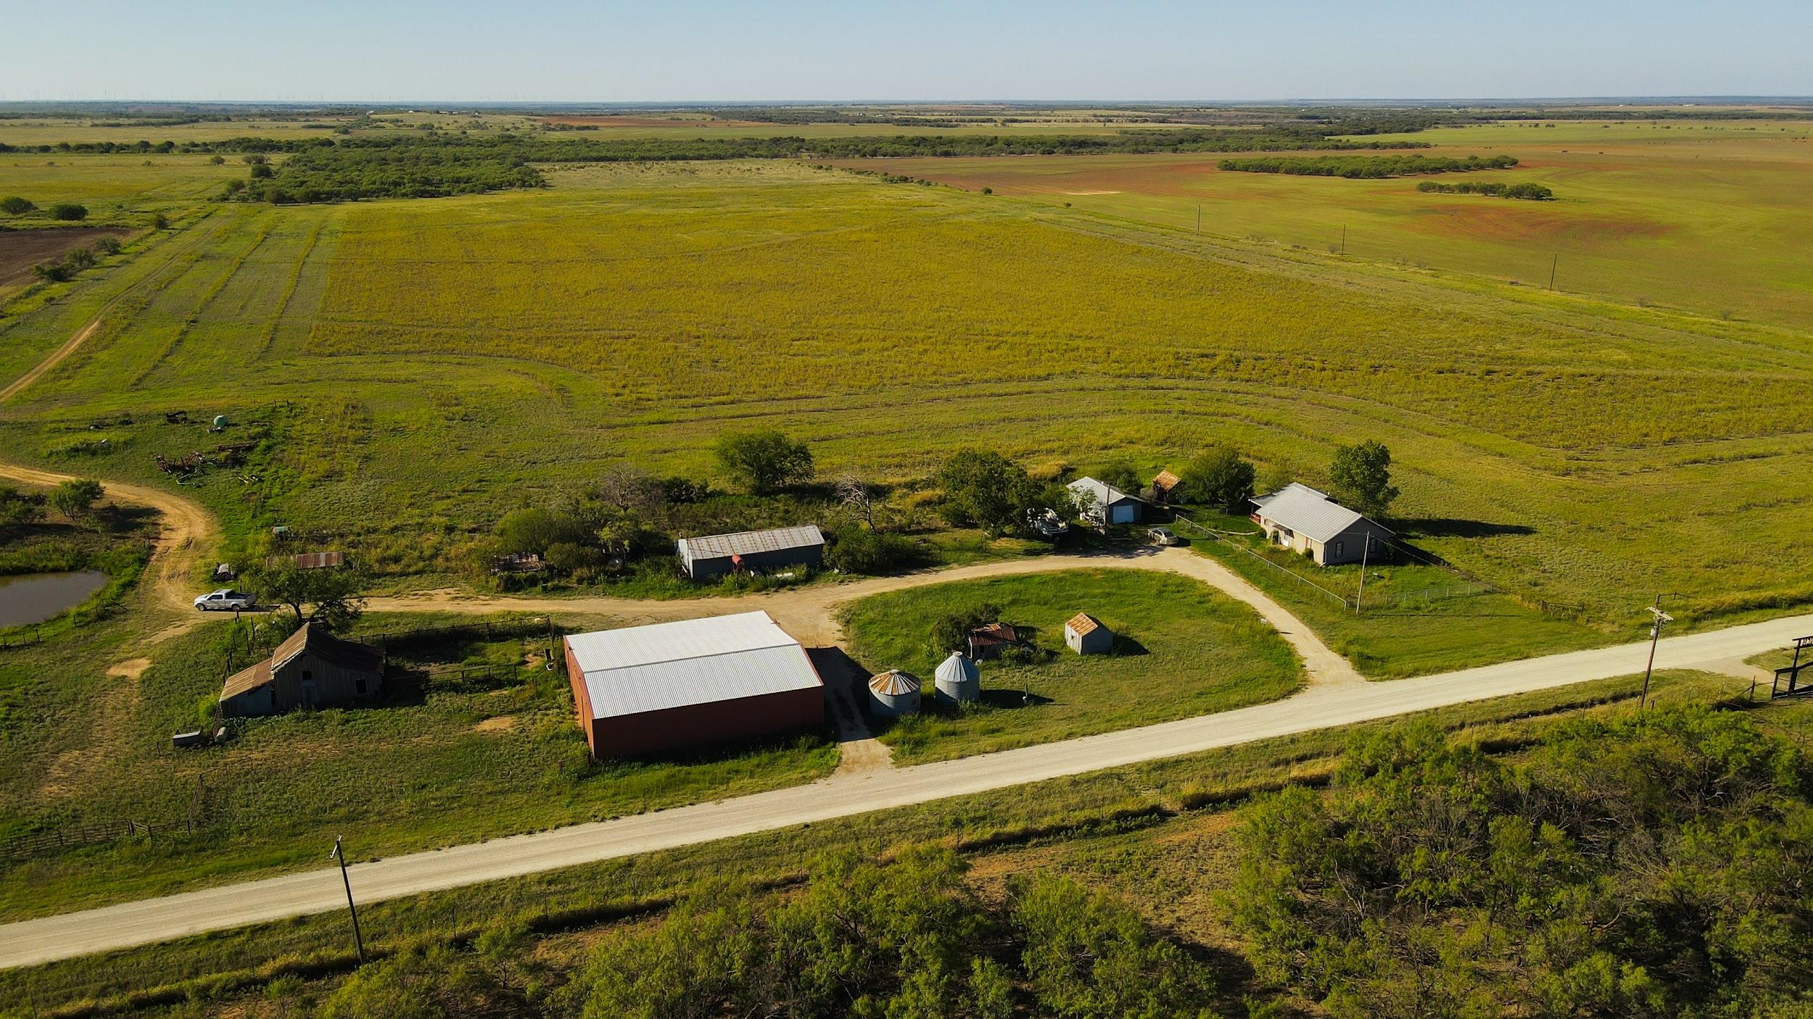
Take TX-114 W to Self Rd in Young County. 1 hr 53 min (106 miles)
Continue on Self Rd. Drive to Schlegel Rd 6 min (2.5 mi)

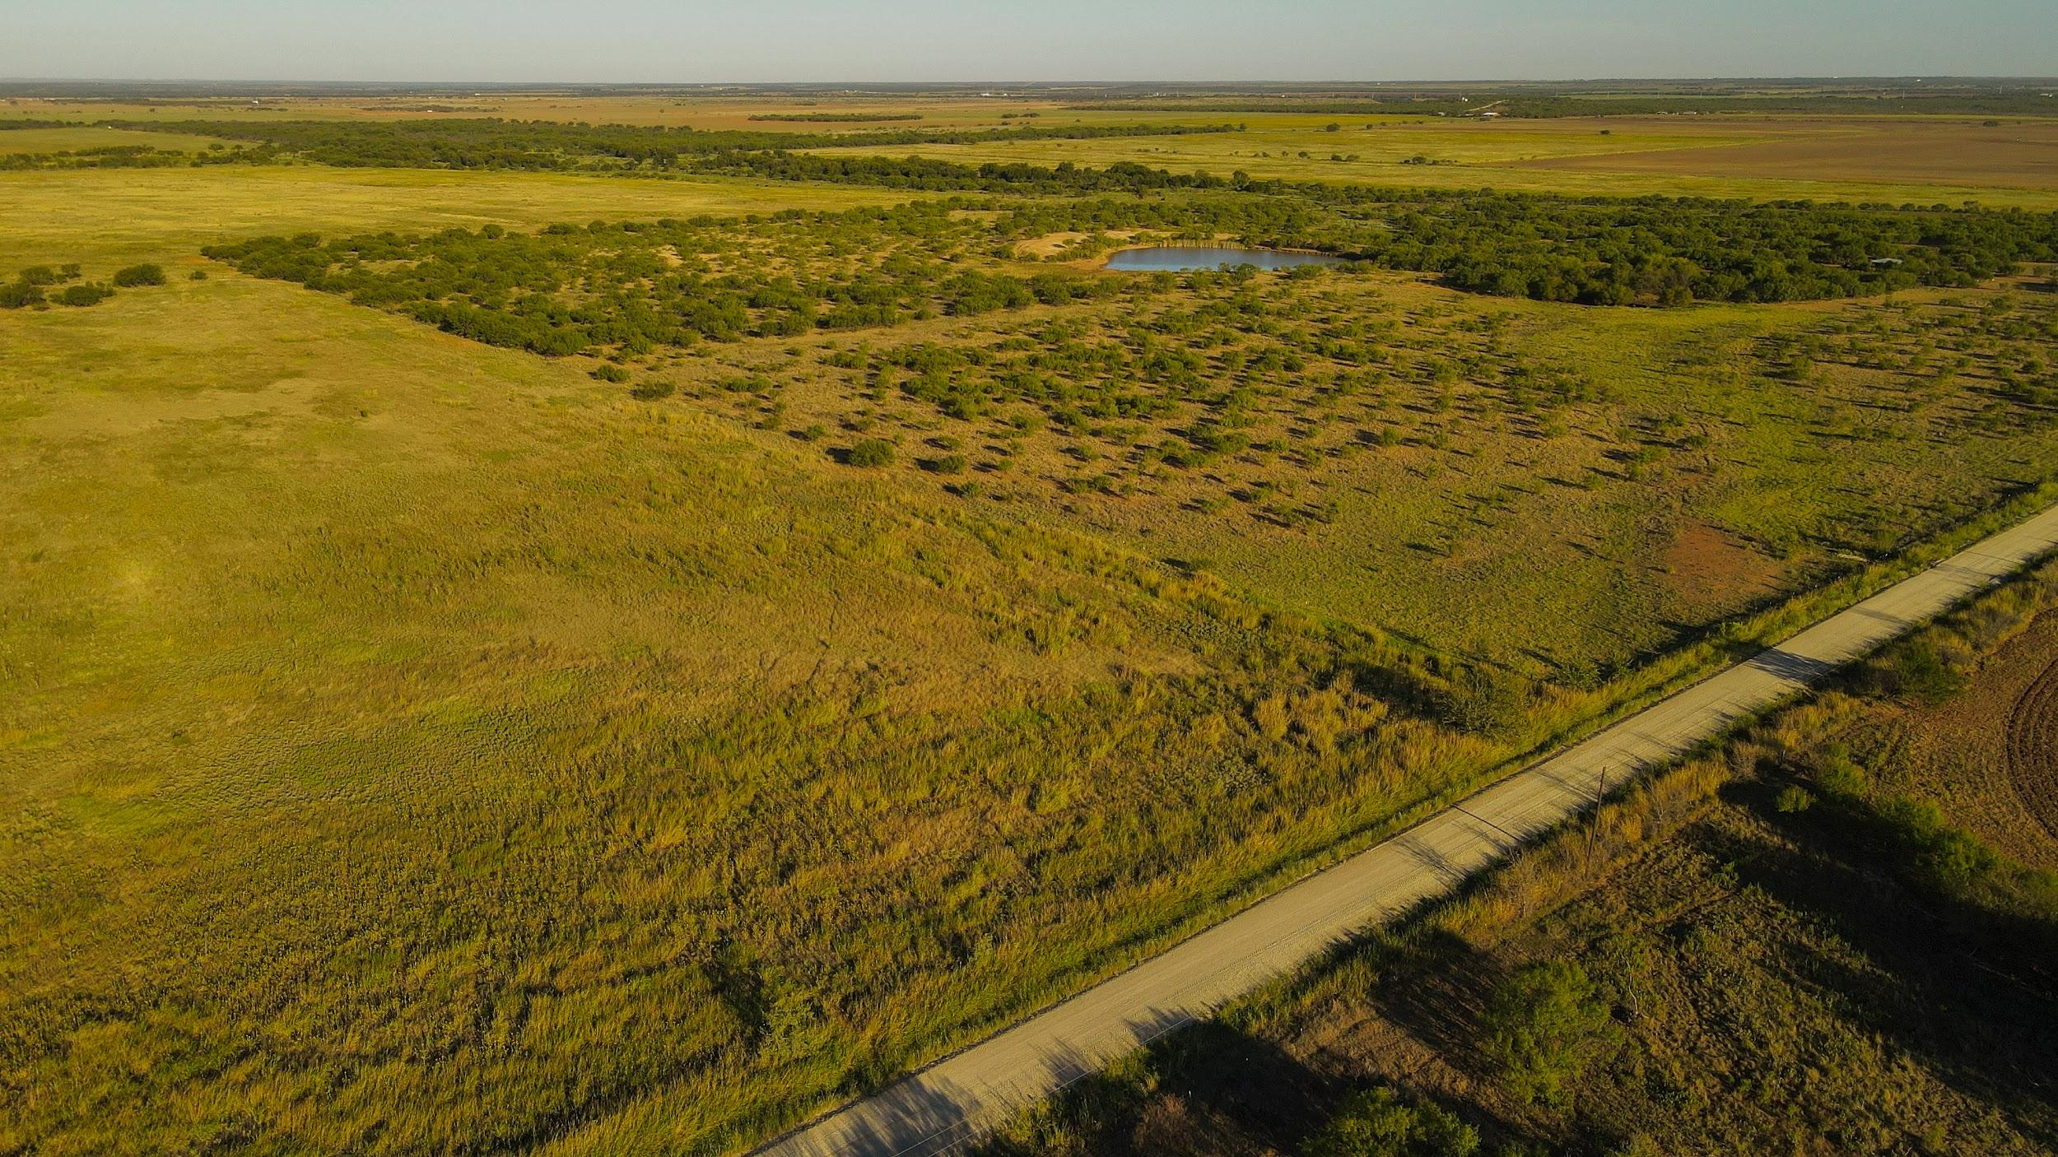
Terrain: Slight elevation variations with a good mix of small to medium size mesquite, elm and oak cover and cultivated areas plus ample water supply create a perfect habitat for wildlife and cattle operations. Property contains a total of approximately 368 acres cultivation and 138 acres of grass/pasture. (See Cultivation Map) A Soils Map is provided showing Sagerton loam, Deandale loam and Bluegrove fine sandy loam the predominant soil types.

Vegetation: Native grasses with mesquite, oak and elm hardwoods plus wheat pasture. Previous coastal seeding.

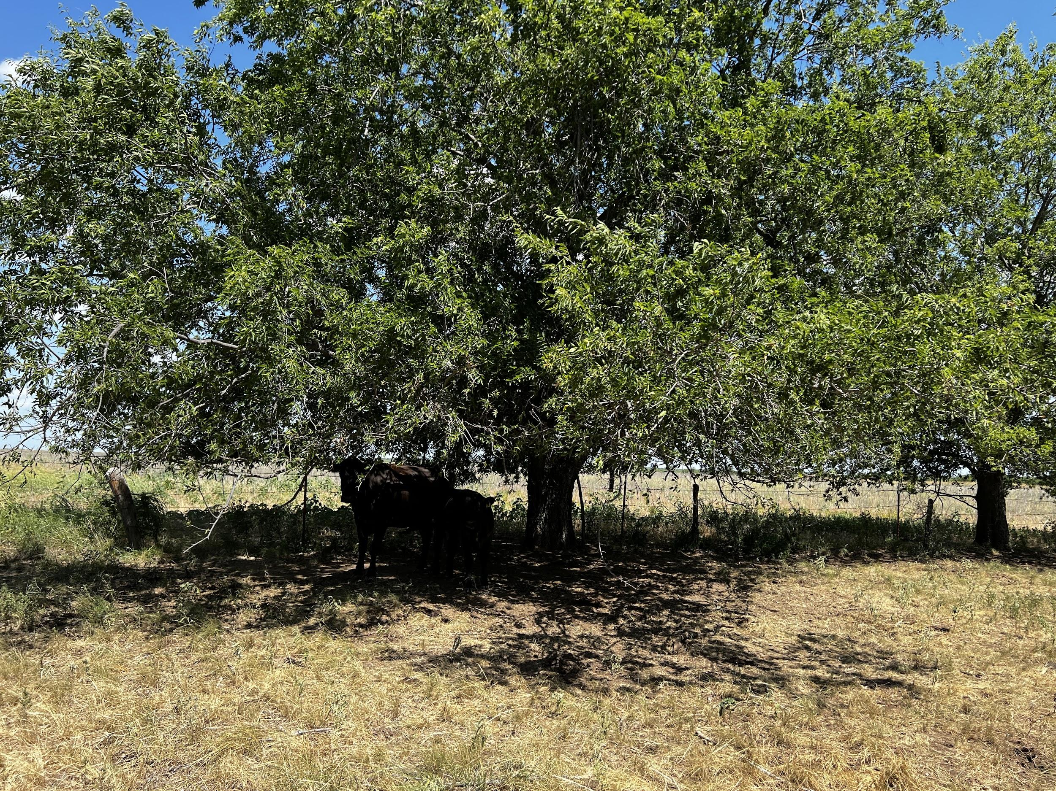
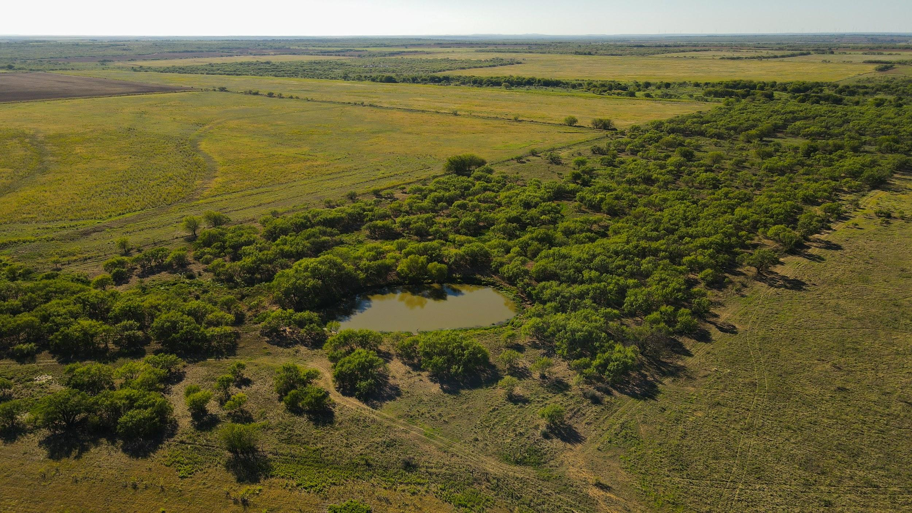

Water: 6 stock tanks plus a large area of meandering water draws connected to the Bitter Creek-Brazos River watershed provide ample water for livestock and wildlife. The homesite is connected to Baylor County SUD. There is a second Baylor County SUD meter box located near the Self Road entrance for future water service expansion.
Baylor Water Supply Corporation (940) 888-3800

The 2 ponds with perimeter fencing just east of the homesite were previously used as the water source for the home and barns. The home has a cistern system once collecting runoff from guttering.
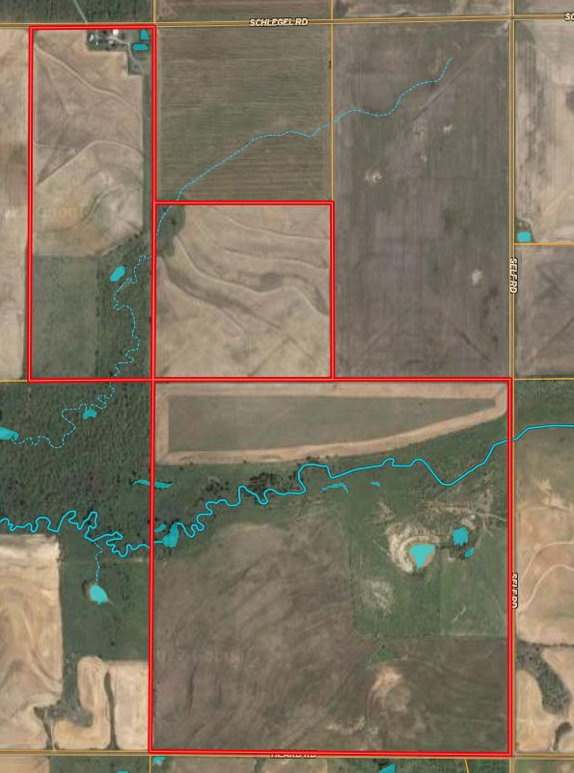
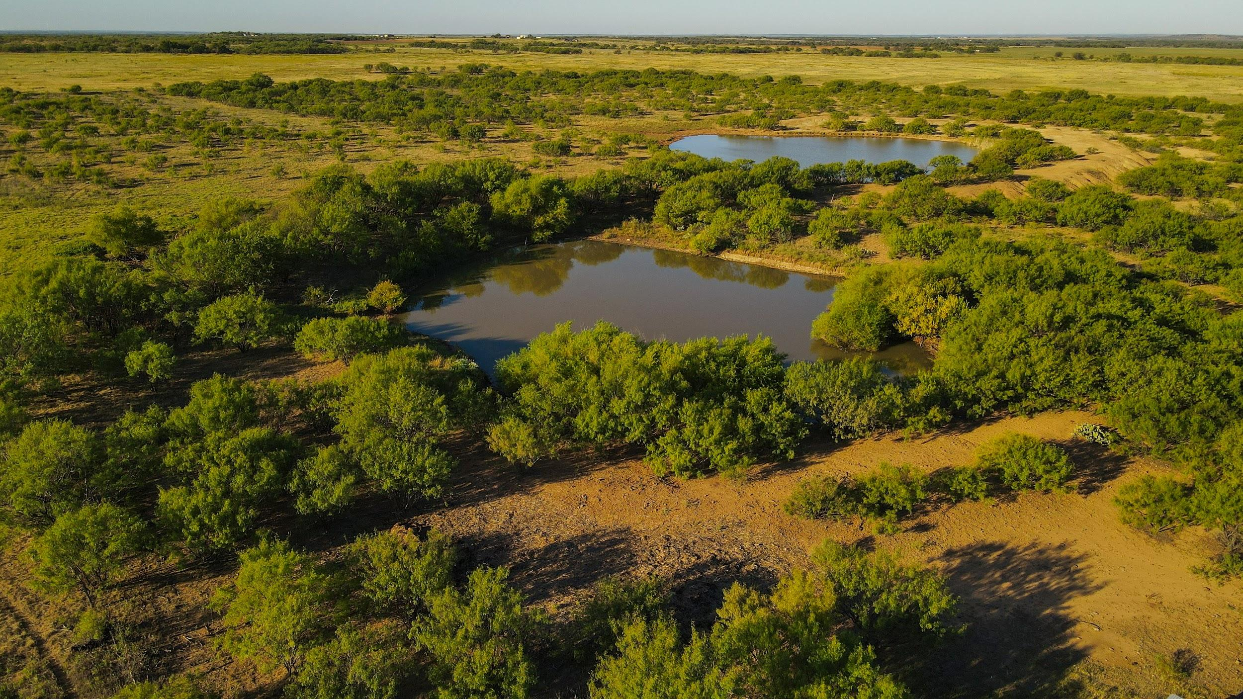

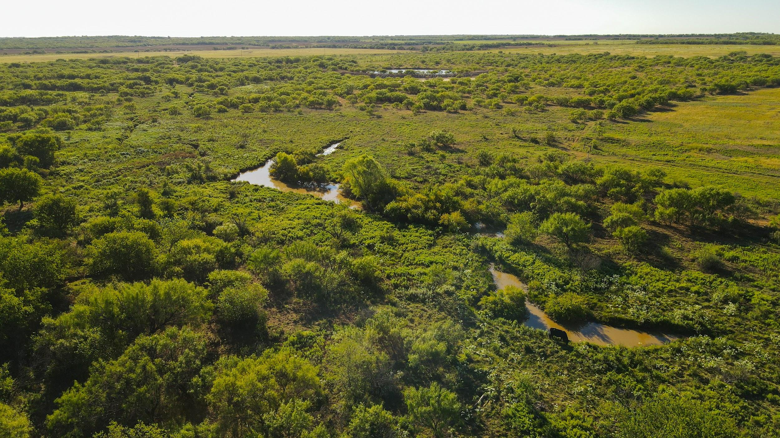

Electricity: JAC Electric Cooperative (www.jacelectric.com)

Wildlife: Whitetail Deer, Wild Hog, Wild Turkey, Quail, Dove, Waterfowl, Fishing

Fencing: Working cattle pens at both north and south ends of property. Most boundary fences are 6-wire barbed wire with iron t-post construction and have secure pipe gated entrances.

Internal Roads and Access: 1.72 miles of county road access on 3 sides of property provides easy access to all areas. Schlegel Road (north) Self Road (east) Heard Road (south).

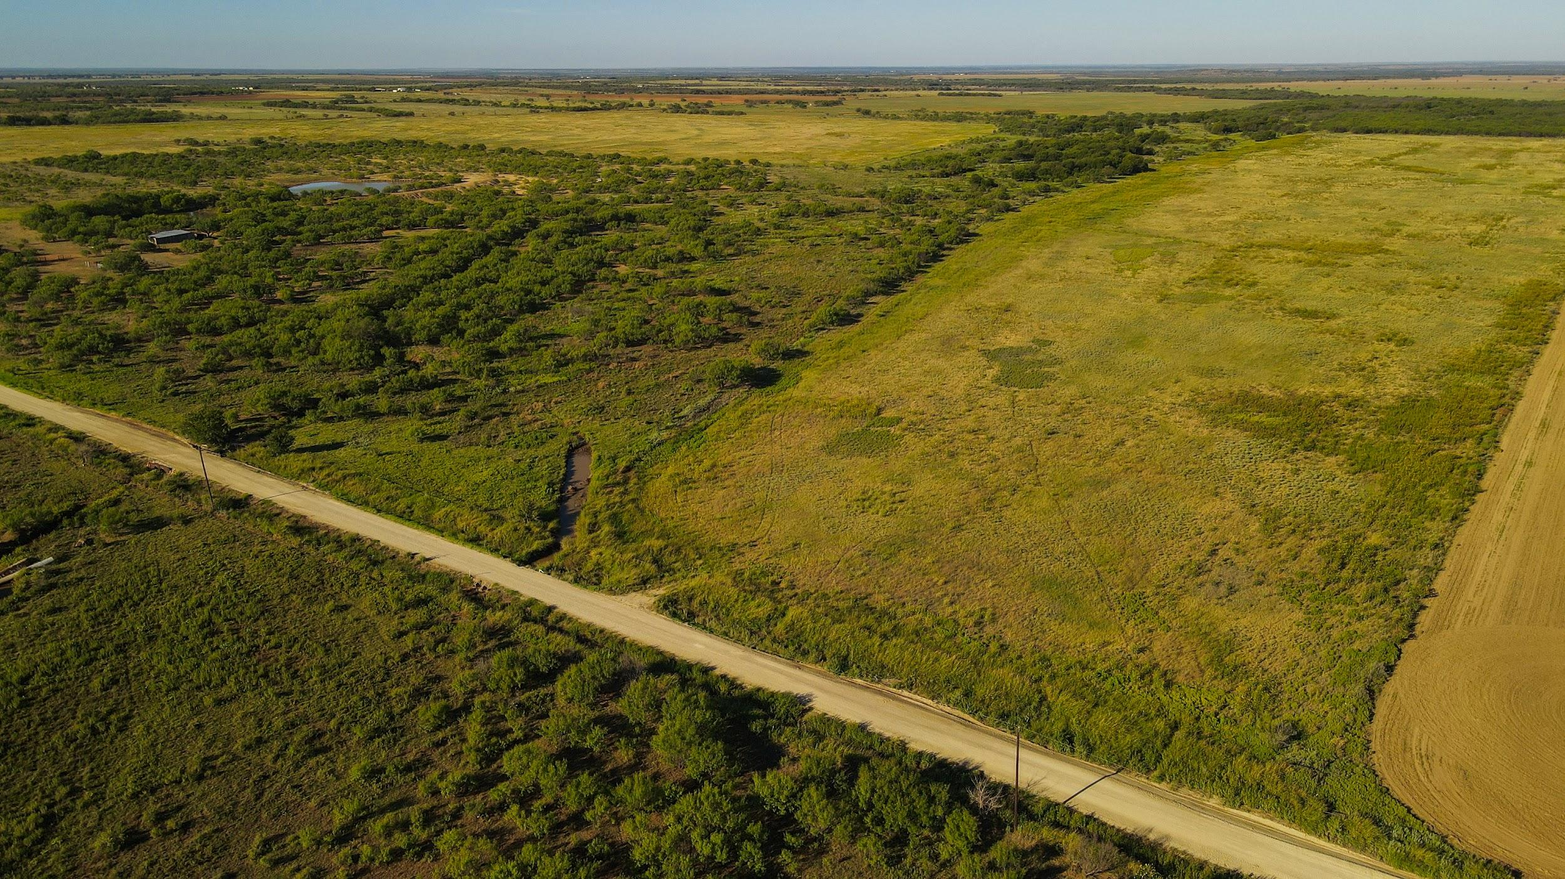

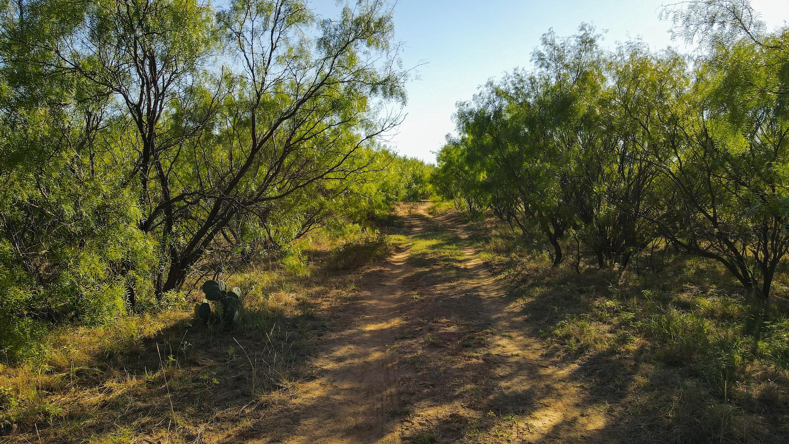

Surface Leases: Limited bird hunting lease through fall 2022 only. No other leases. No oil leases, production or debris.

Minerals: No minerals offered. No current production or debris.

Taxing Jurisdiction Info: Olney-Hamilton Hospital District, Olney ISD, Young County Appraisal District

School District: Olney ISD www.olneyisd.net

Homesite: Home built in 1950 has 1424 square feet, 3 bedrooms and 2 baths. Window units for air conditioning and propane wall heaters. The home has original hardwoods in some rooms, the perfect country kitchen with Montgomery Ward metal cabinetry and formal dining area with built-in server. The primary bedroom has a large walk-in closet with washer/dryer connections and updated bath with walk-in shower. The home has coop water with Baylor County SUD.
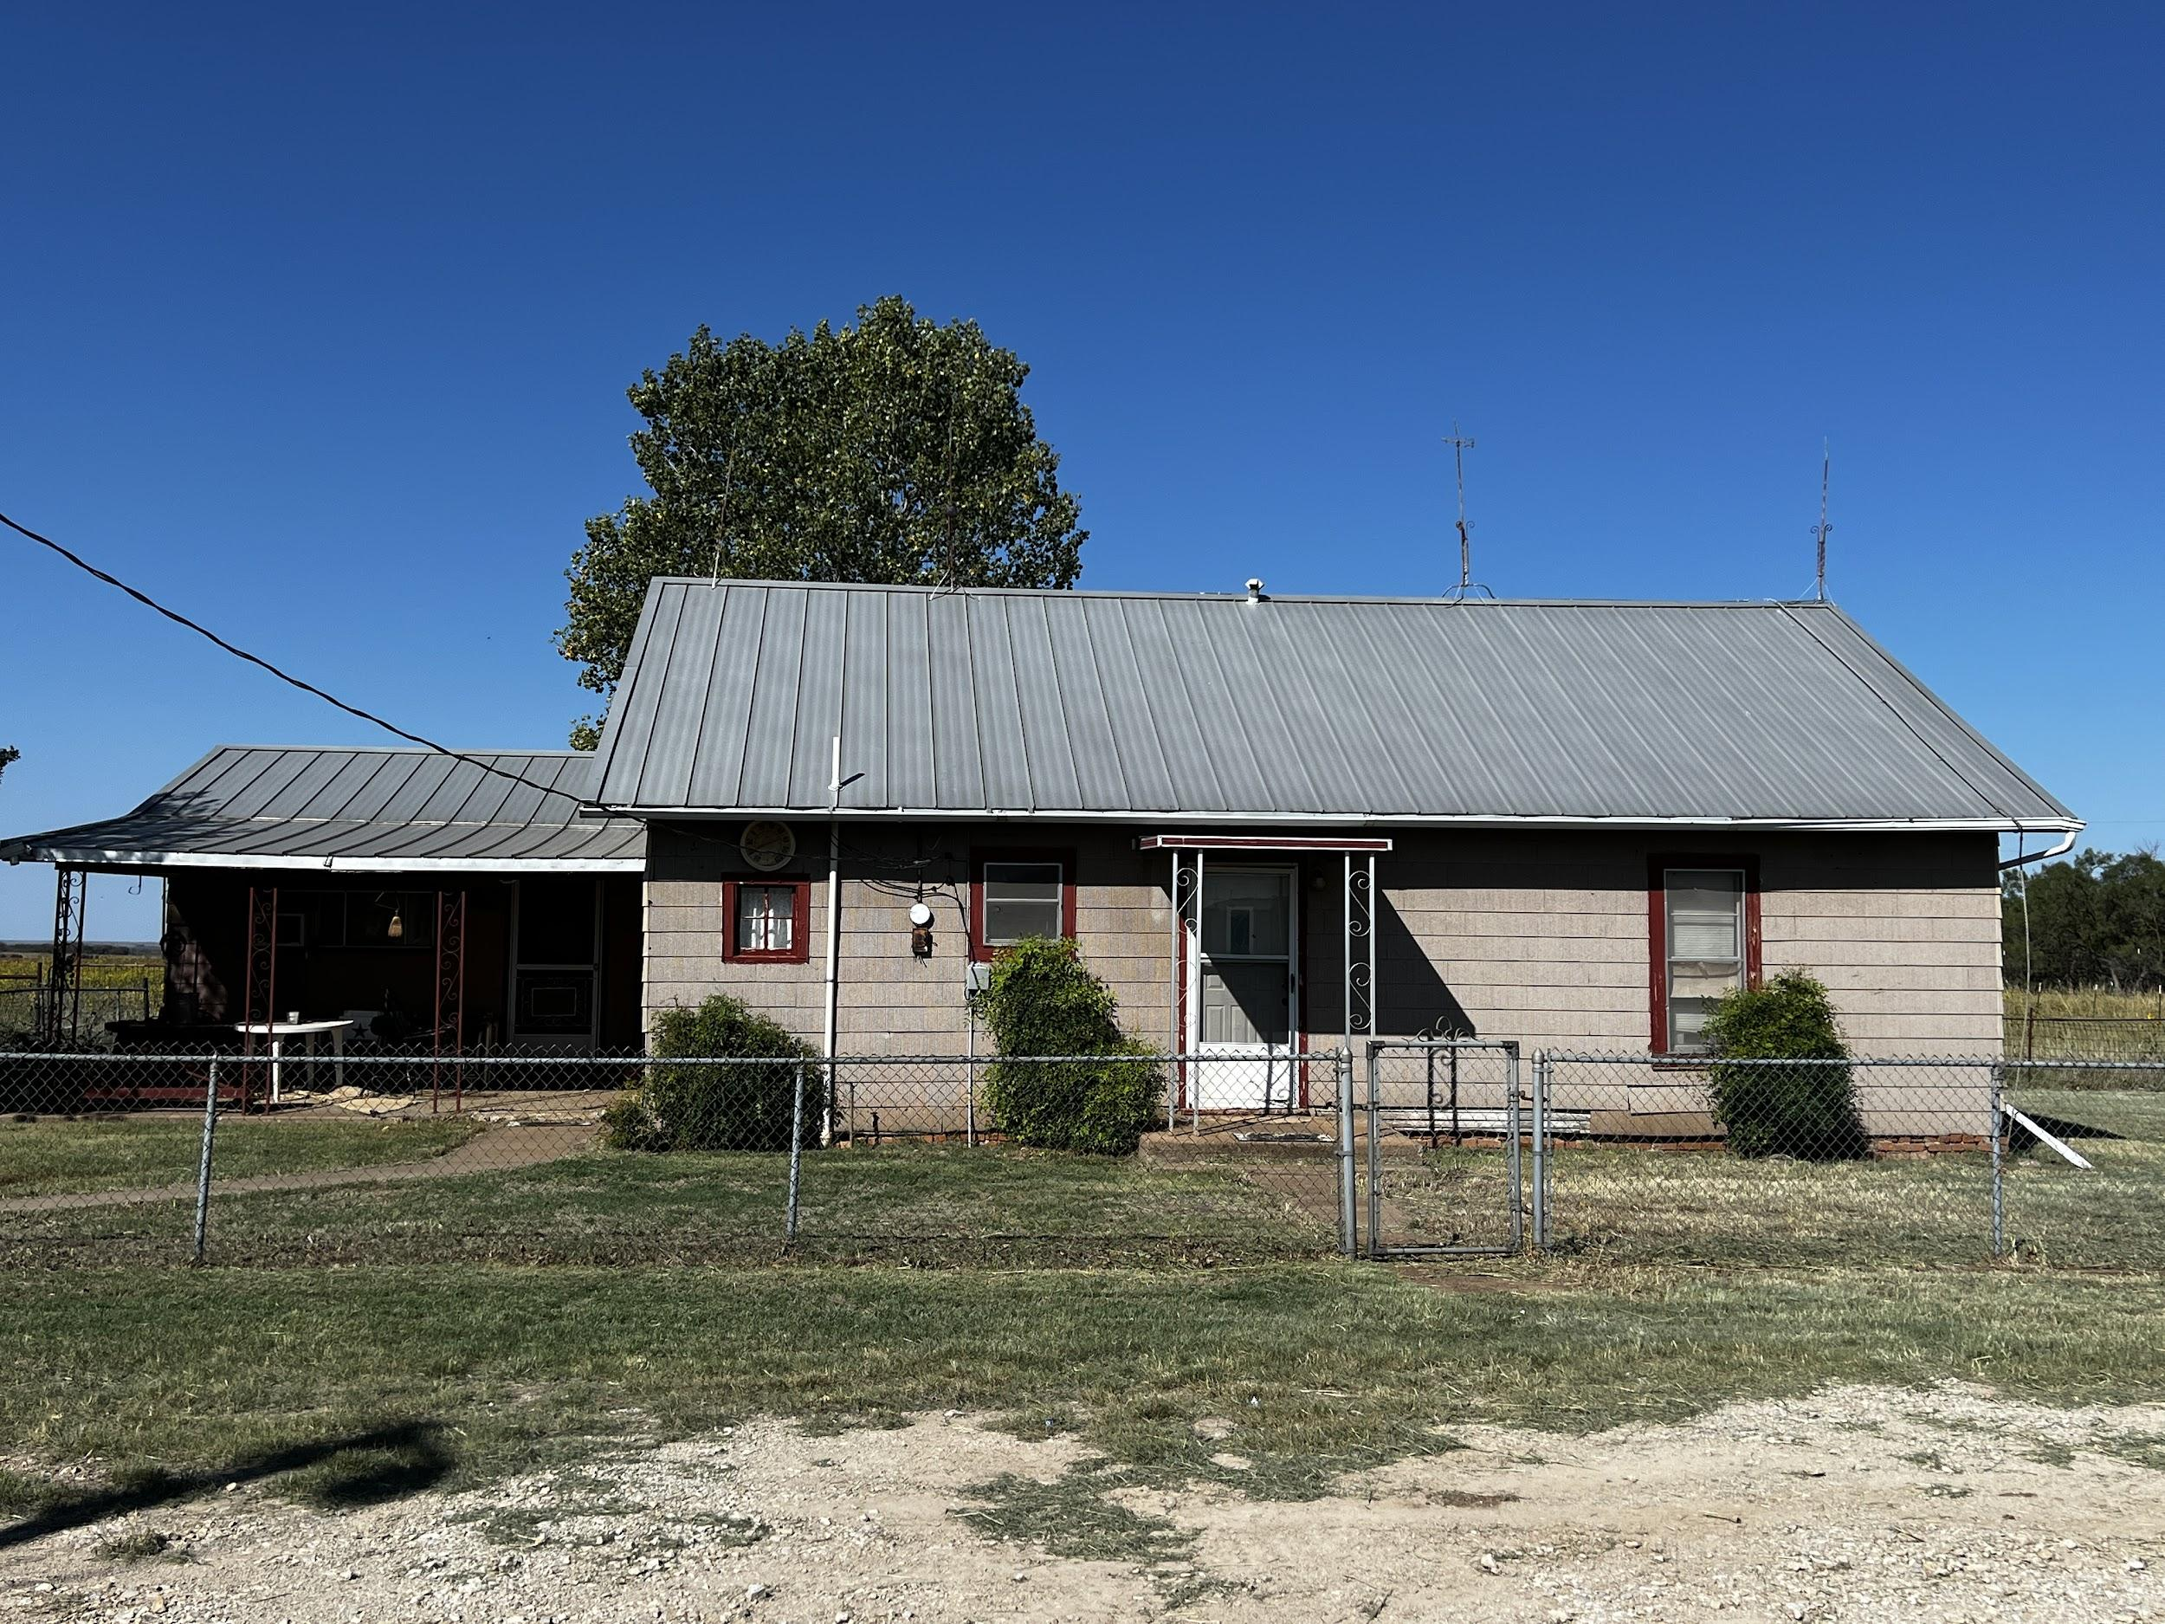

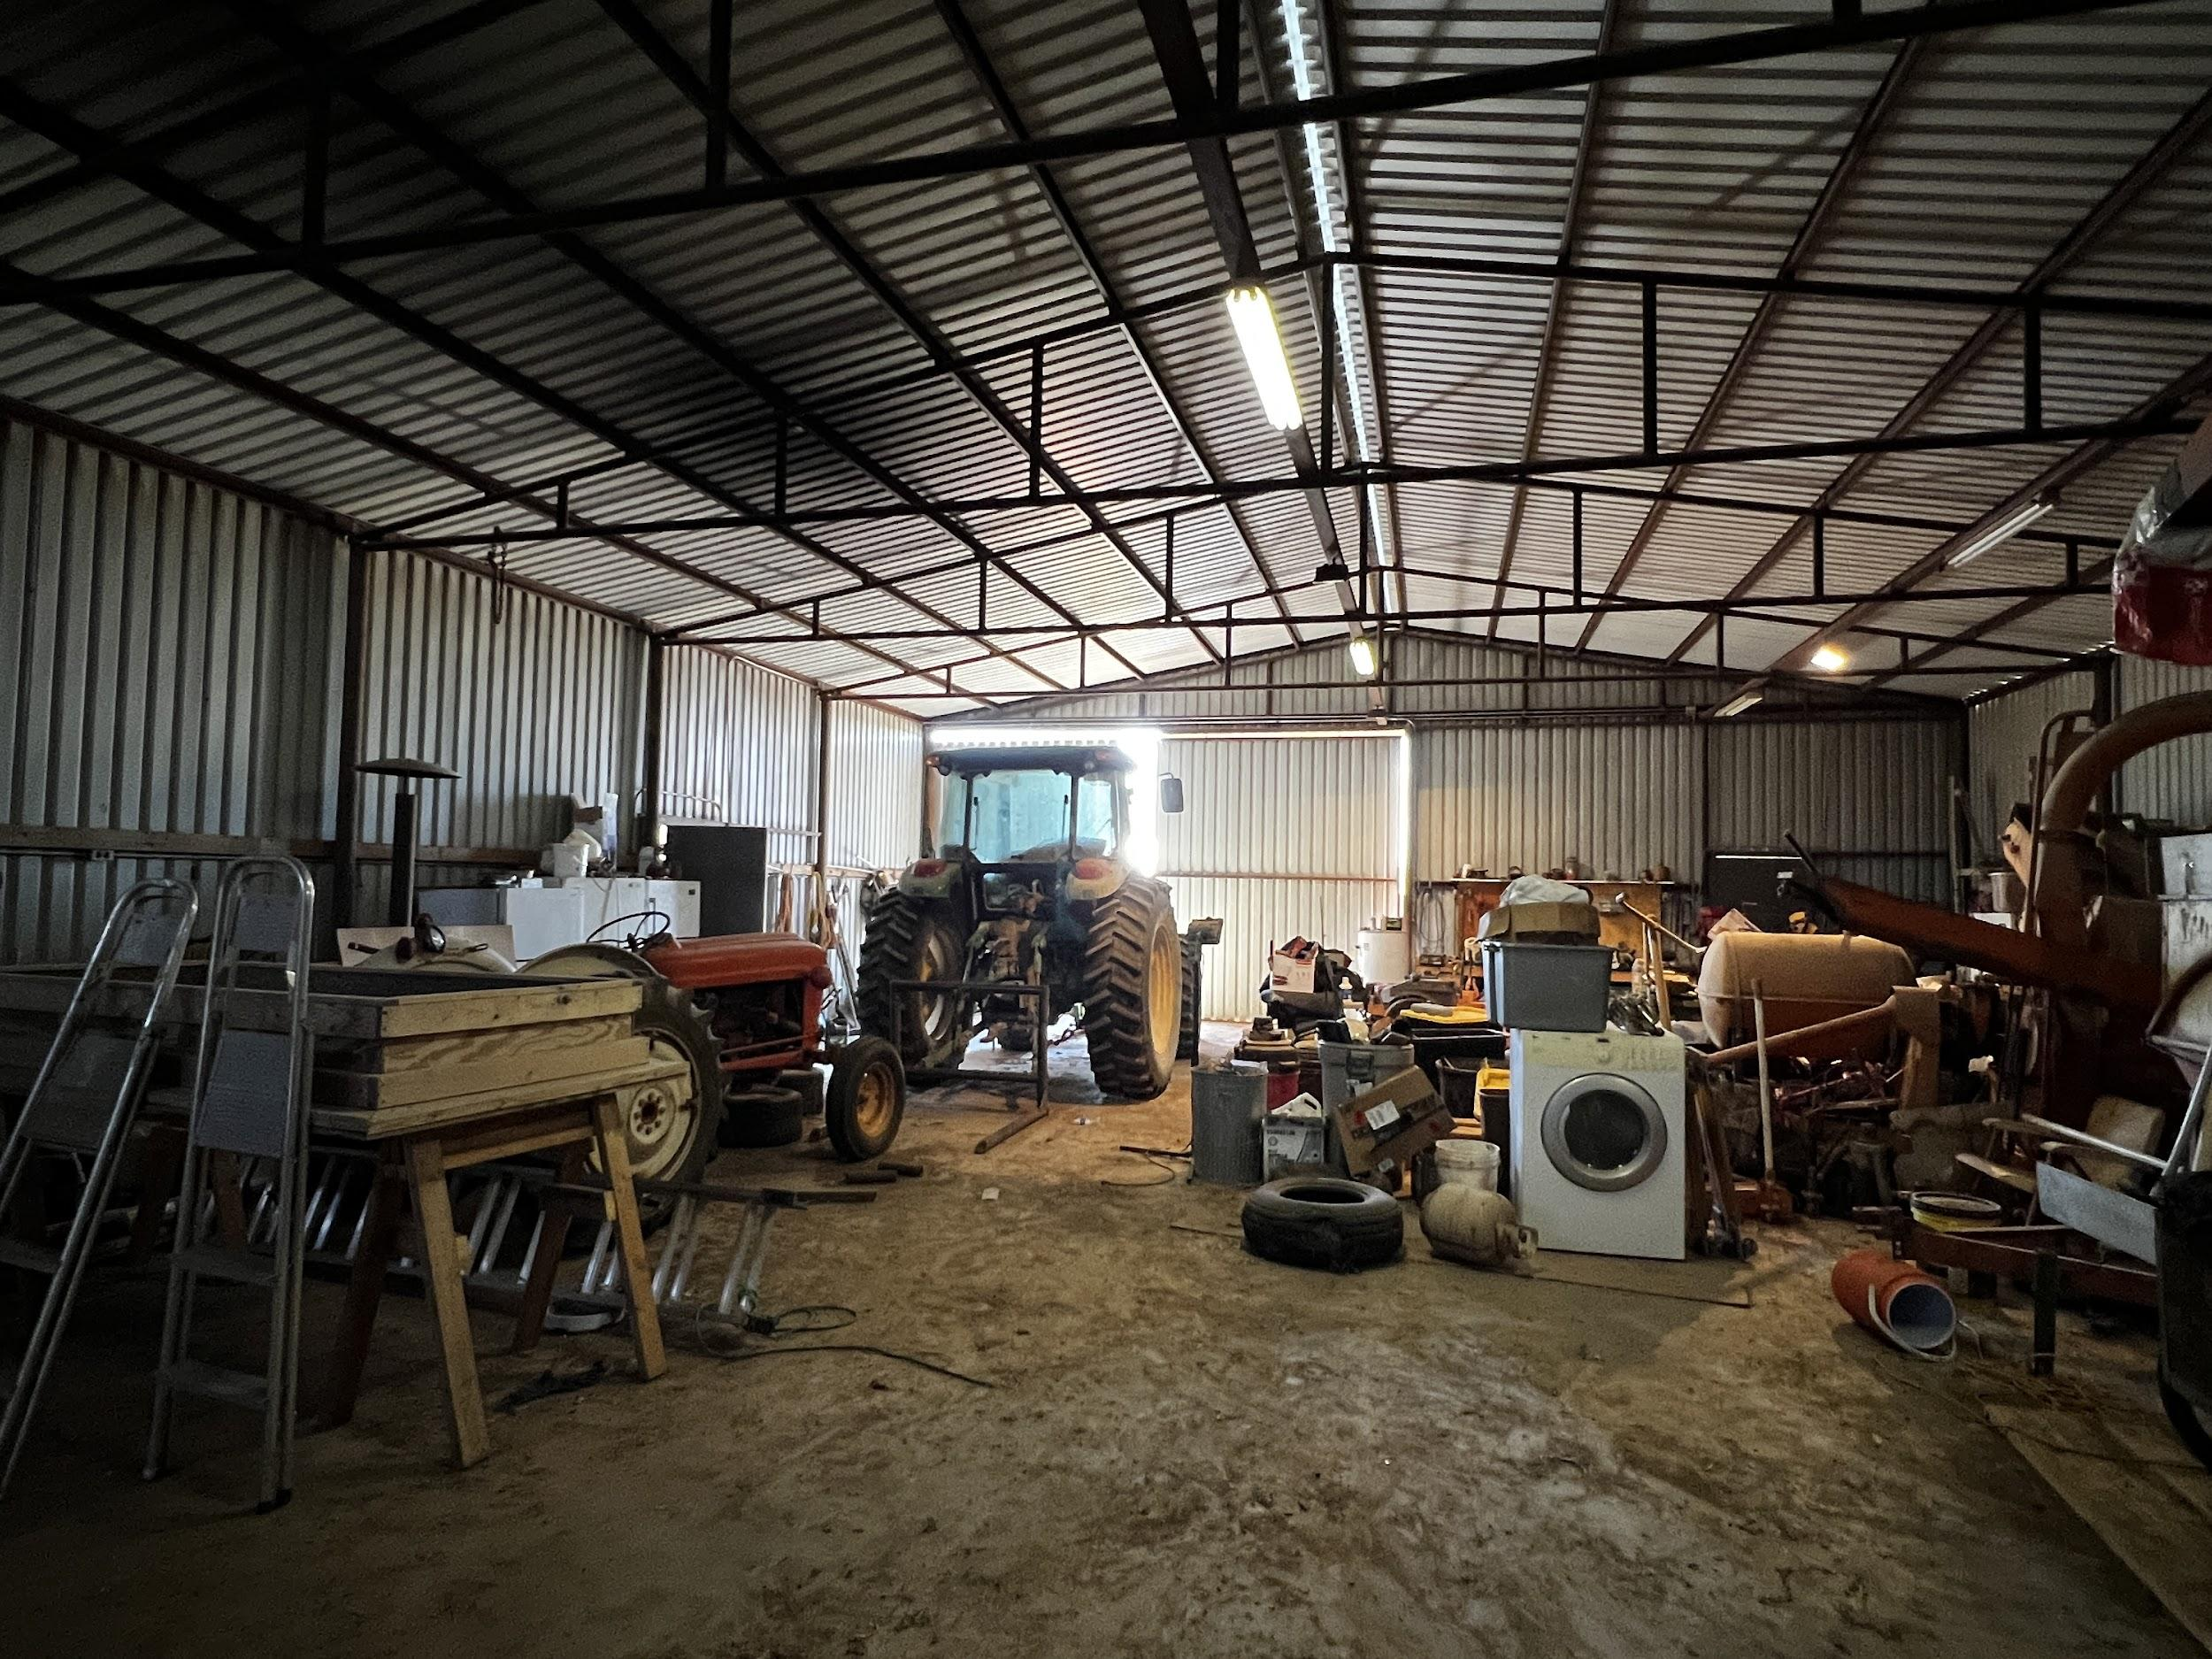

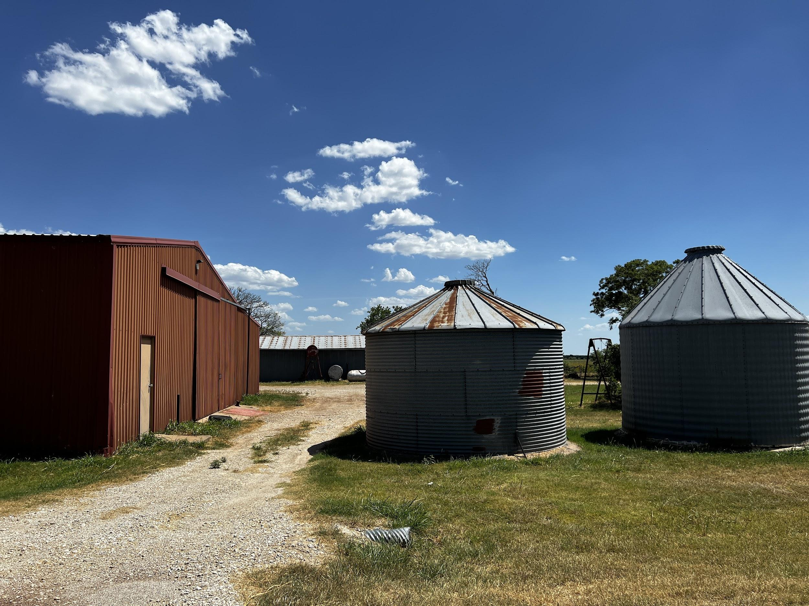

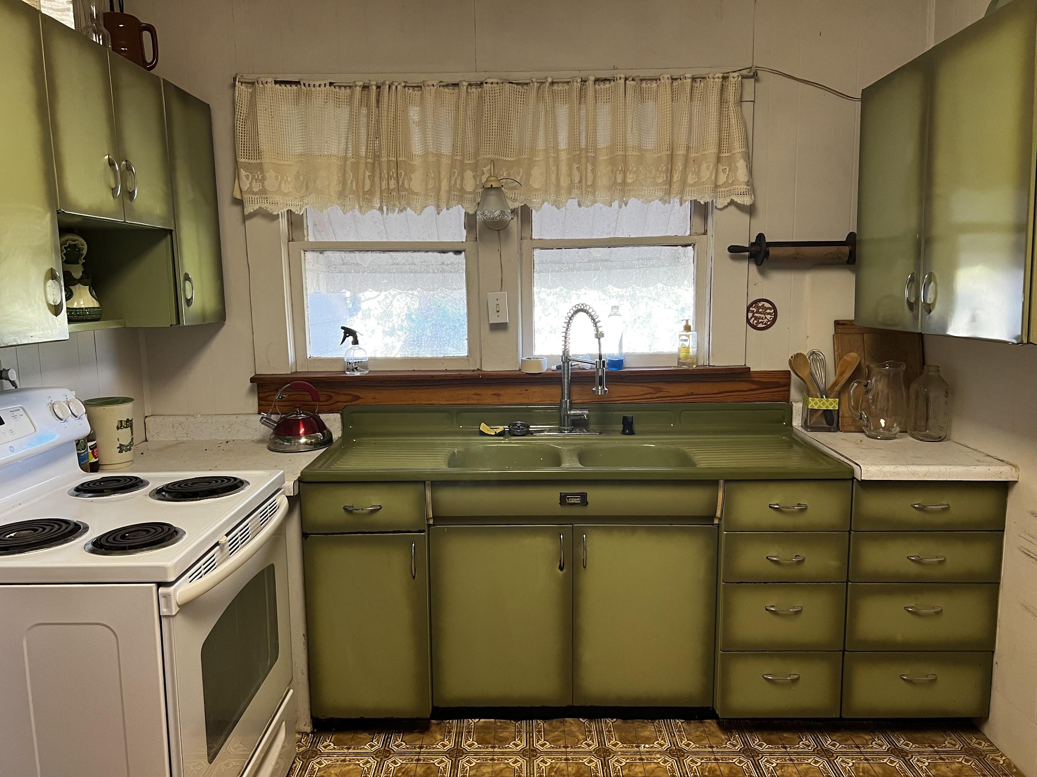

Other Homesite Improvements: Several barns, livestock sheds and storage buildings are located at the homesite. Two grain bins sit close to Schlegel Road for easy access. A 2400 sf metal shop constructed in 1970 has concrete floor, overhead sliding doors on each end to accommodate large machinery, covered storage with electricity and lighting throughout. Several structures previously used for chickens and two additional large storage barns measuring 1200sf and 1500sf are positioned with easy access from the home.

Working Barn with Livestock Cover and Storage: A large shed (1856 sf) with covered area situated near the working pens off Self Road supports a variety of uses including cleaning fish, dressing wildlife, cattle care, recreation with storage and a covered area for livestock feeding. This shed is located near the 2 largest stock tanks on the property as well providing a great place to cool off and enjoy cold refreshments.
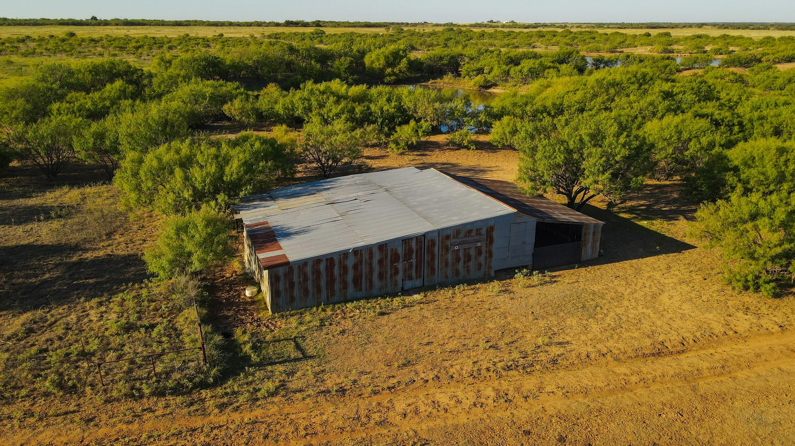

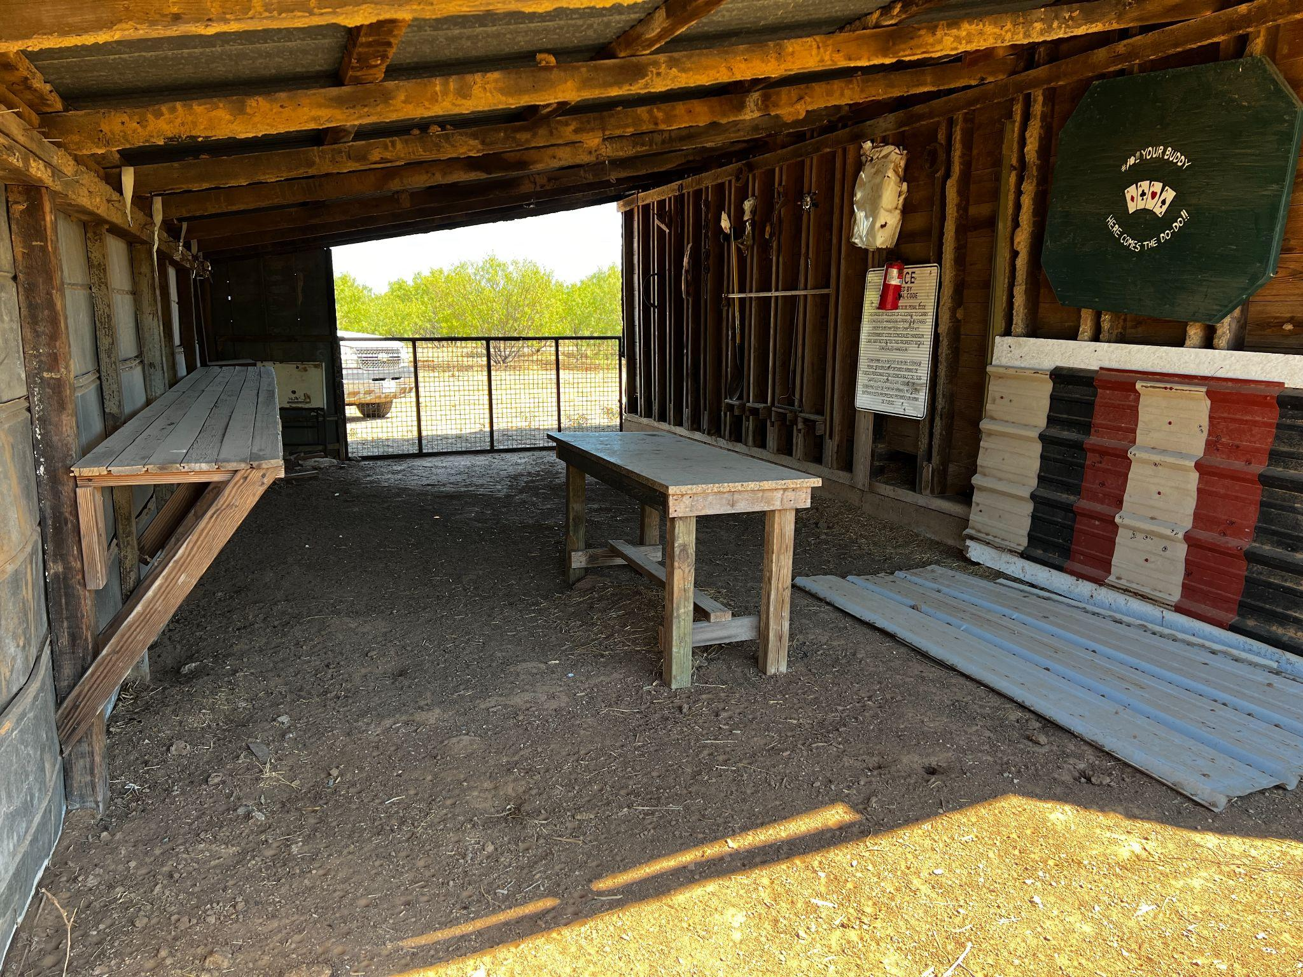
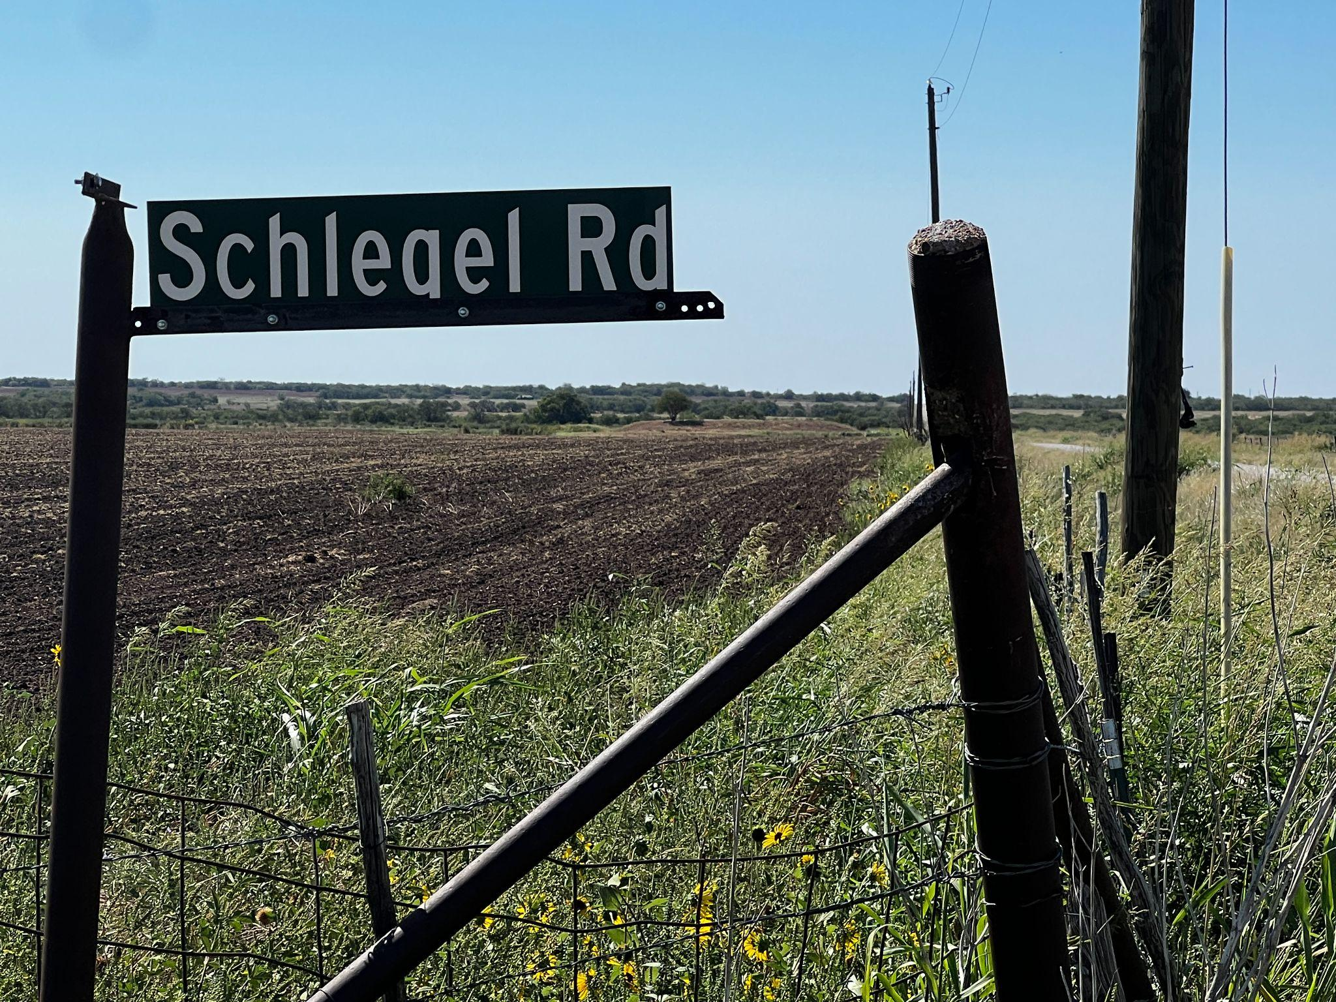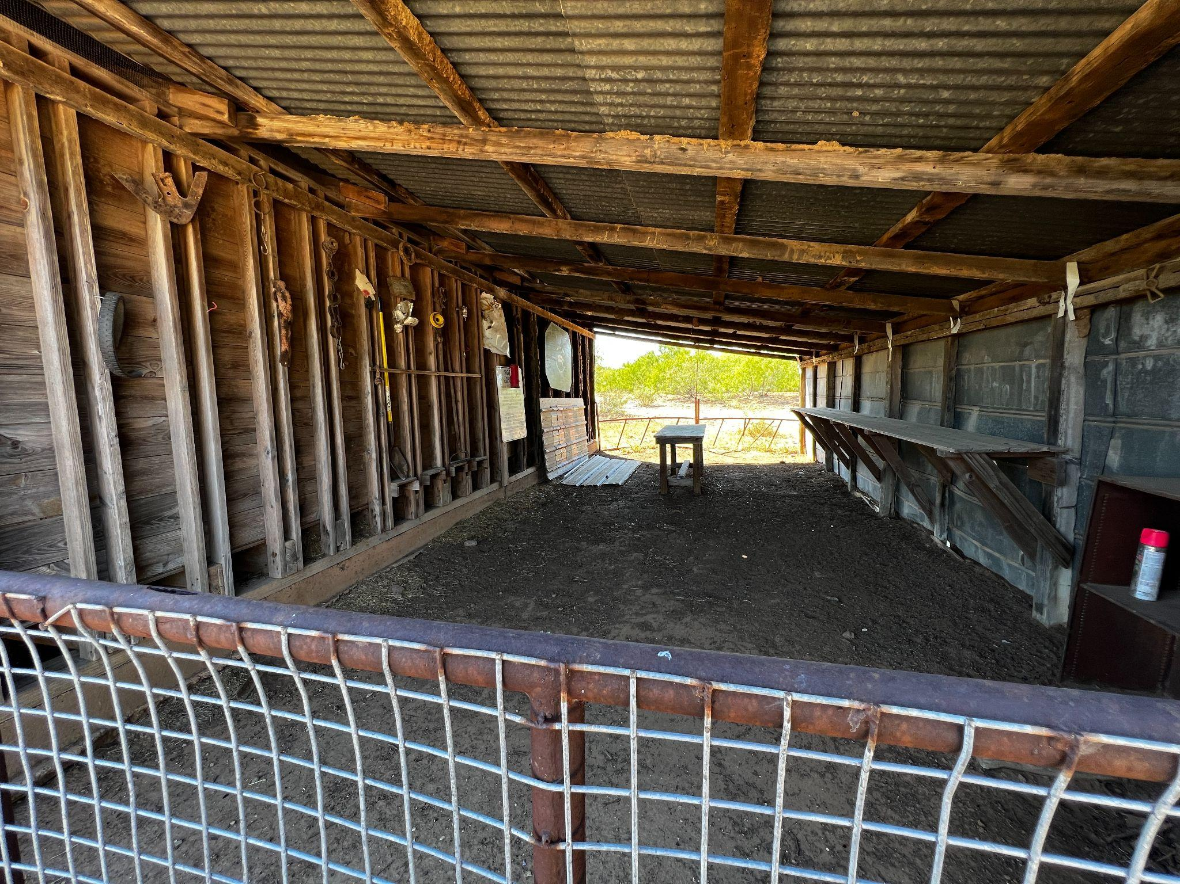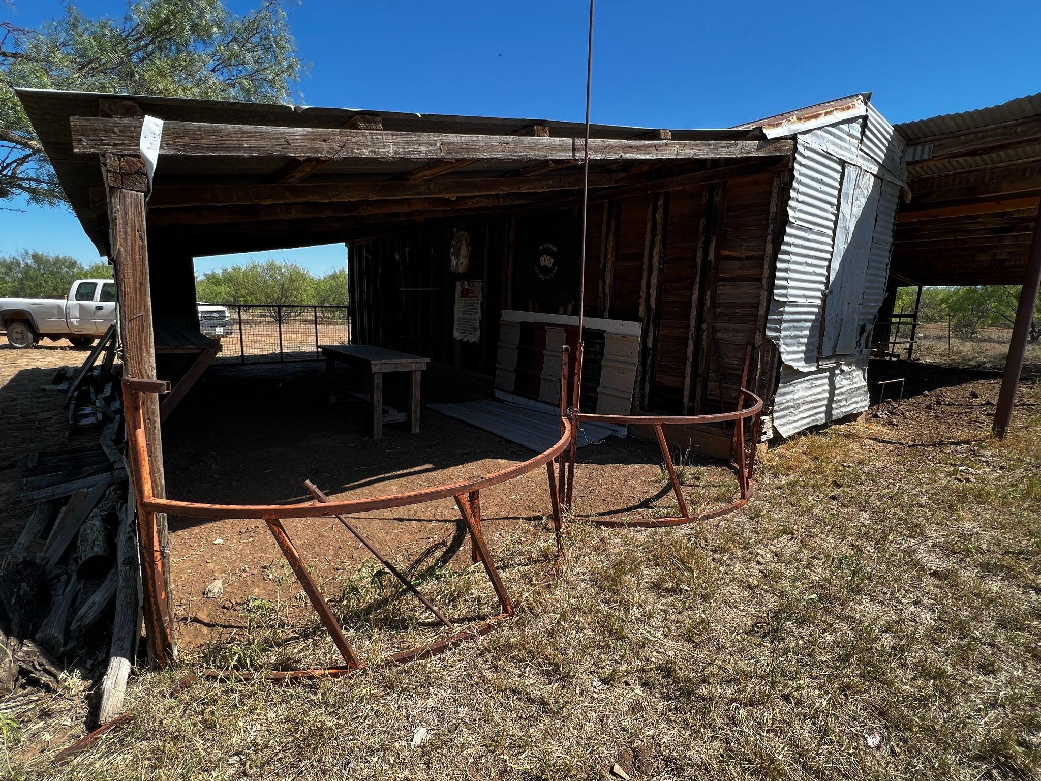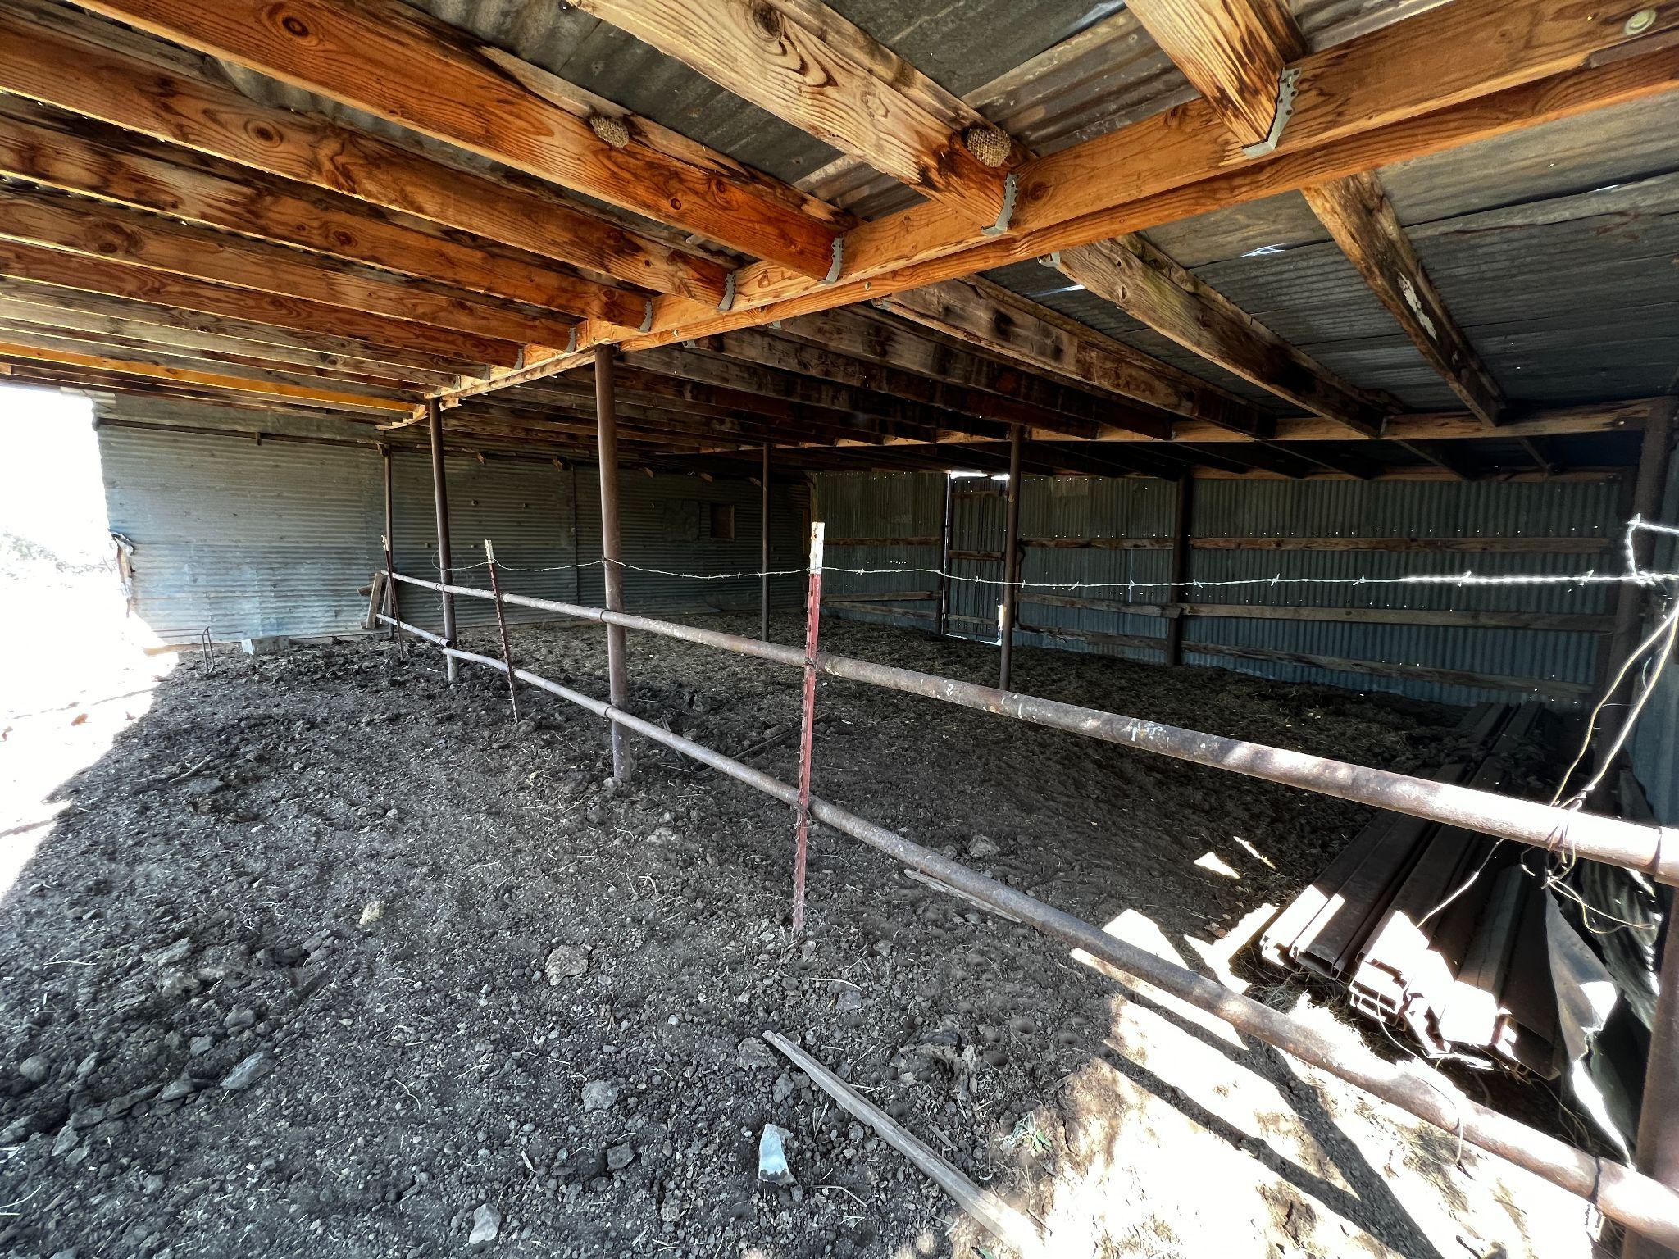

Broker & Commission Disclosure: The Bishop Realtor Group welcomes all Cooperating Agents and Brokers. Cooperating Agents and Brokers must make first contact and be present at all showings to fully participate in a commission split. The listing agent may request proof of financial ability to purchase property from buyer and/or buyer’s agent prior to scheduling a showing.
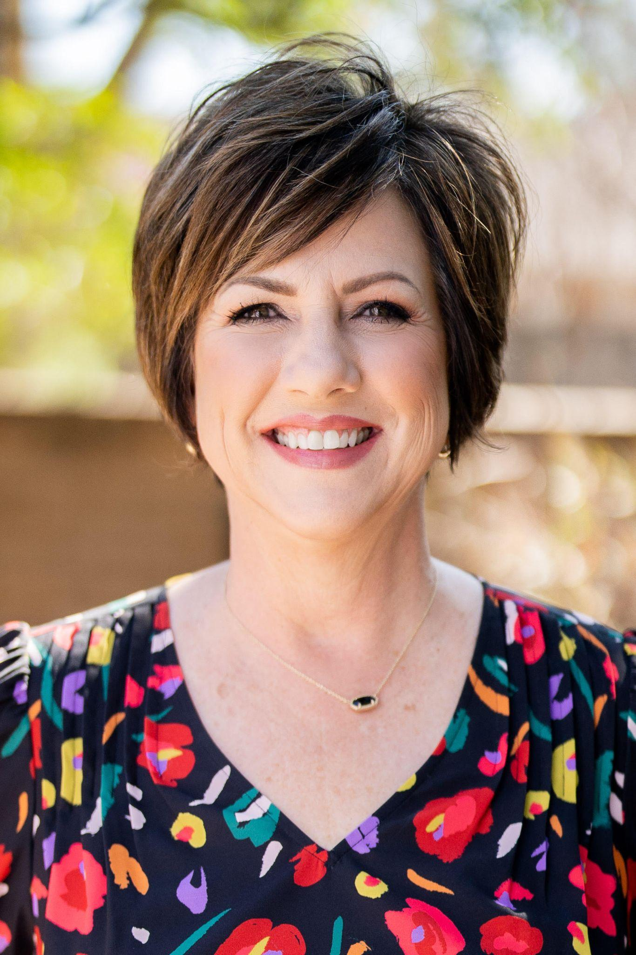
Price: $4500/acre ($2,279,250) including all improvements.

Listing Agent/Broker: Bethann Oswald, Bishop Realtor Group
1916 Elmwood North Ave
Wichita Falls, TX 76308
Cell: 940-631-4290
Office: 940-691-7355
bethann@bishoprealtors.com

Disclaimer: This information is understood to be accurate and reliable, but it is not guaranteed. All buyers and buyers’ agents should verify all information.

