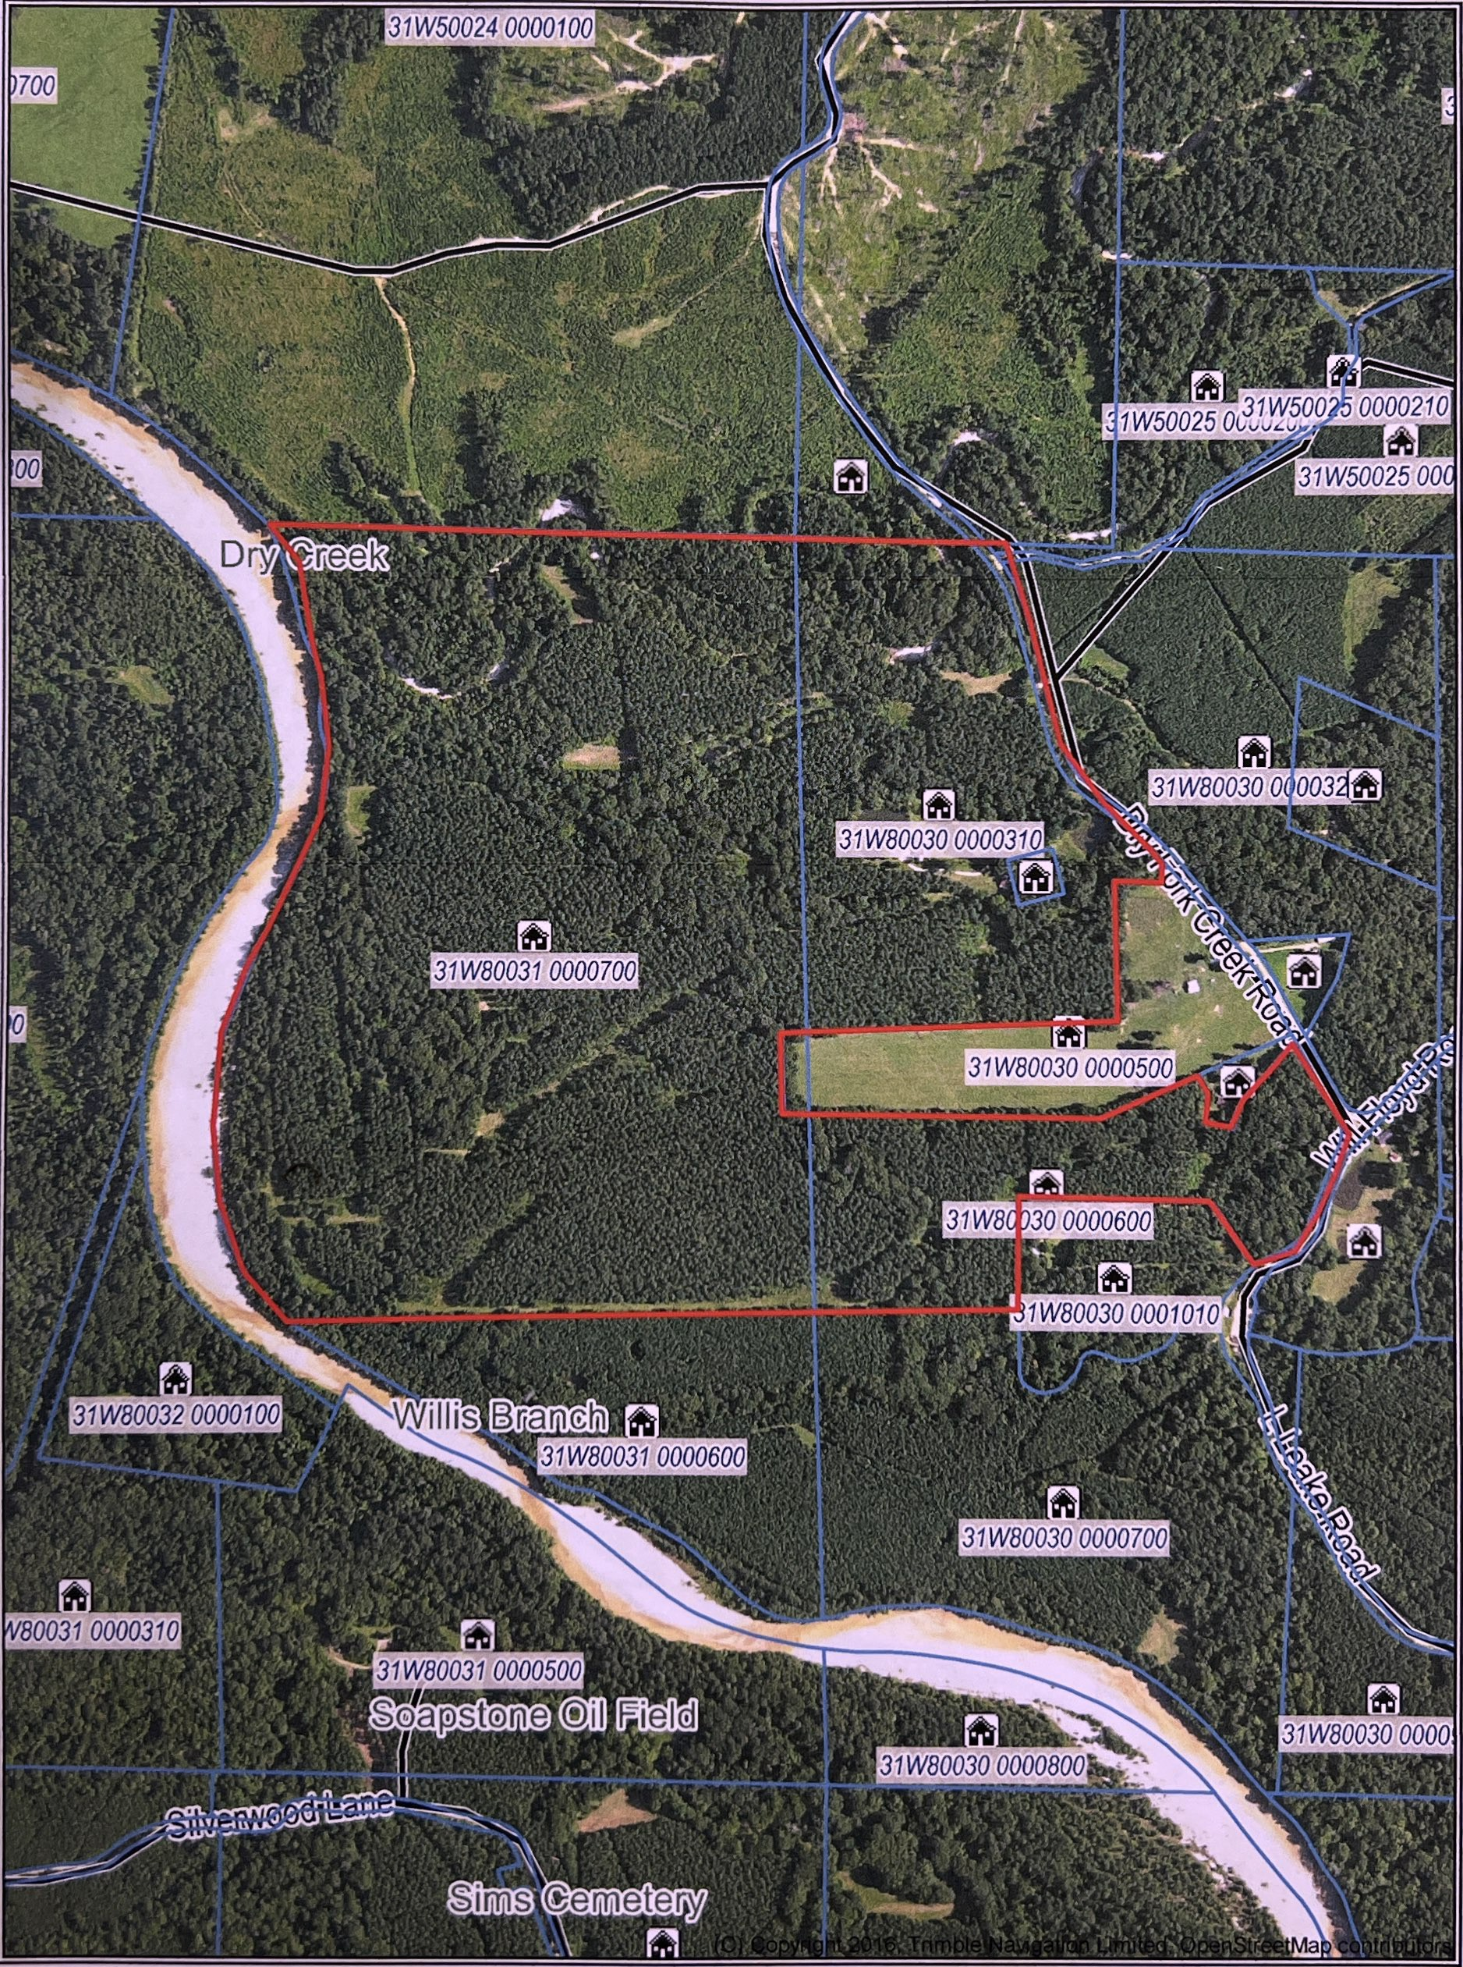

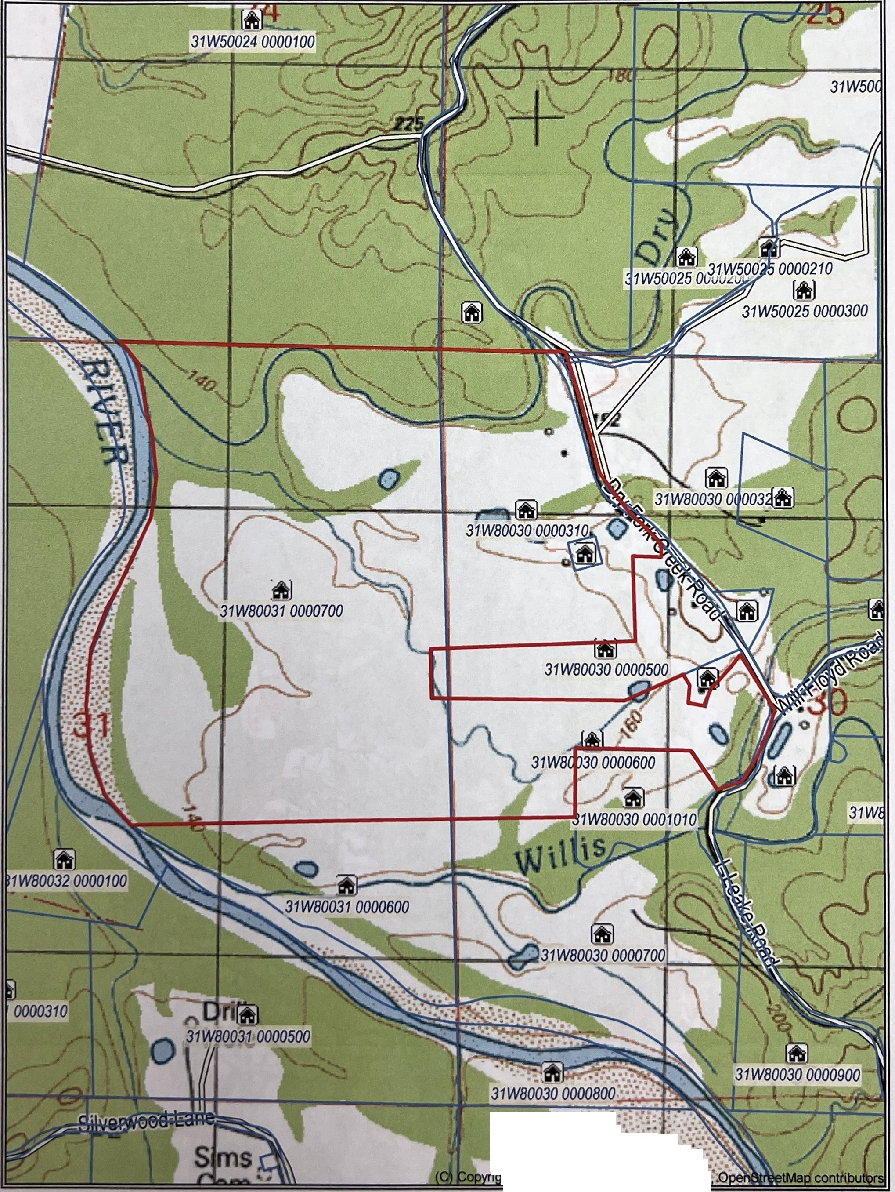

.......

•• *•*• *.*•• *.*.*-*<t *:*.... ..... ..

. ·*:*-*-*:*..*•*•*.*,*.*:*.*·:*

*...*

. ht2016,Trlmble D°mited

