HOUSE MOUNTAIN, MASON COUNTY
THIS CAN BE SEEN in the SE FROM 3623 Hedwigs Hill Rd., Art; Mason, TX
Owned by Cynthia Thomas- Broker/Owner.
15.1 +/- acres

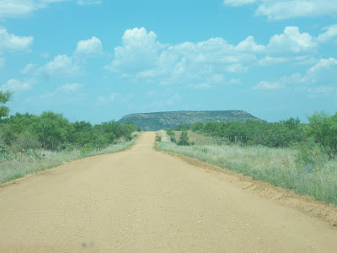

On Texas 87 between Mason and Fredericksburg, look to the east, and you'll see a huge, flat hill in the distance.

